Mathematics Department
William Perkin CofE High School

An introduction to
A level Mathematics and Further Mathematics

This induction booklet is for students intending to begin studying A level Maths or A level Further Maths in Year 12 from next September.

It is important that you are able to work at this standard – read the introduction carefully, and spend time working through the exercises before you start in September.

All questions are GCSE standard and it is expected all students are familiar with the techniques covered.

Introduction to A level Maths at William Perkin
Thank you for choosing to study Mathematics in the Sixth Form at William Perkin High School.

If you are studying Mathematics on its own, you will sit two internal exams at the end of Y12, which will assess a combination of three areas: Pure maths, Statistics and Mechanics. At the end of Y13 you will sit 3 external exams that will assess content covered during both years with the same combination of Pure maths, Statistics and Mechanics. If you have chosen to study Further Mathematics as well, you will sit two internal exams at the end of Y12, which will assess a combination of Pure maths, Decision maths and Mechanics. At the end of Y13 you will sit 3 external exams that will assess content covered during both years with the same combination of Pure maths, Decision maths and Mechanics.

The Mathematics Department is committed to ensuring that you make good progress throughout your A level course. In order that you make the best possible start to the course, we have placed this booklet on our website. It is important that you spend time working through the topics in this booklet over the summer, as you need to have a good knowledge of these topics before you commence your course in September. You should have met all the topics before at GCSE. The answers to the exercises are at the back of the booklet. You will need to be organised about your approach to this, so keep your work in a folder and note any queries you have, so that you can ask about them at the beginning of term. You will notice that there is a heavy focus on algebraic manipulation in this booklet, as you must have a strong grasp of this in order to cope with the level of difficulty that the Mathematics and Further Mathematics courses demand. There are also sections on indices and surds, which too form an integral part of these courses.

In the second week of term, you will take a test in class to check how well you understand these topics, so it is important that you thoroughly understand the content of the booklet by then. If you do not pass this test, this will be considered a serious concern, and it will beg the question as to whether you should be taking this subject. In particular, please note that there is a practice test provided at the back of this booklet, which is similar in style to the test that you will be given in class, and which you must submit in your first lesson.

Use this introduction to give you a good start to your A level work so that you enjoy, and benefit from, the course. The more effort you put in, right from the start, the better you should do.

Mr V Bhardwaj
Head of Mathematics

CONTENTS

Section 1 Algebra page 3
Section 2 Indices page 12
Section 3 Surds page 16
Section 4 Proof page 19
Section 5 Coordinate Geometry page 22
Worked solutions to Section 1-5 page 25
Practice test – this must be submitted page 37

Y12 Maths and Further Maths induction task
Work through all of these questions to ensure you are familiar with all of the content.
Written solutions are provided at the back of this pack for you to mark your work.
If you get stuck on a question please use the answers, but please make sure you re-learn this content.
Section 1 - Algebra
1 | 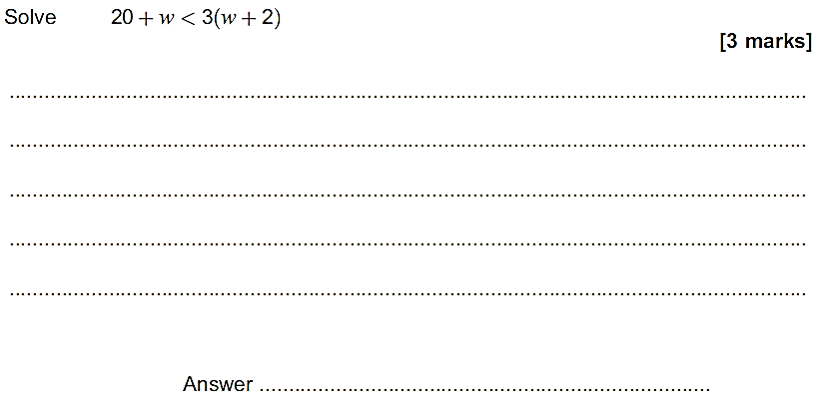
2 | 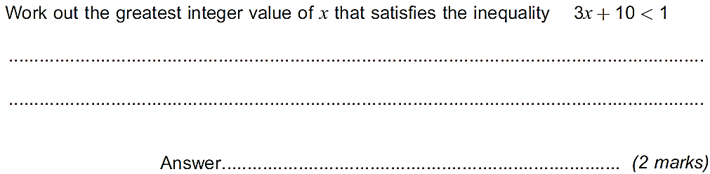
3 | 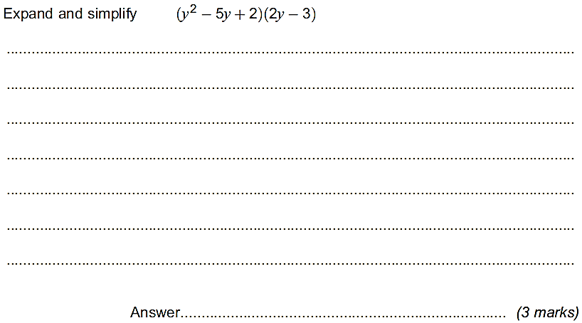
4 | 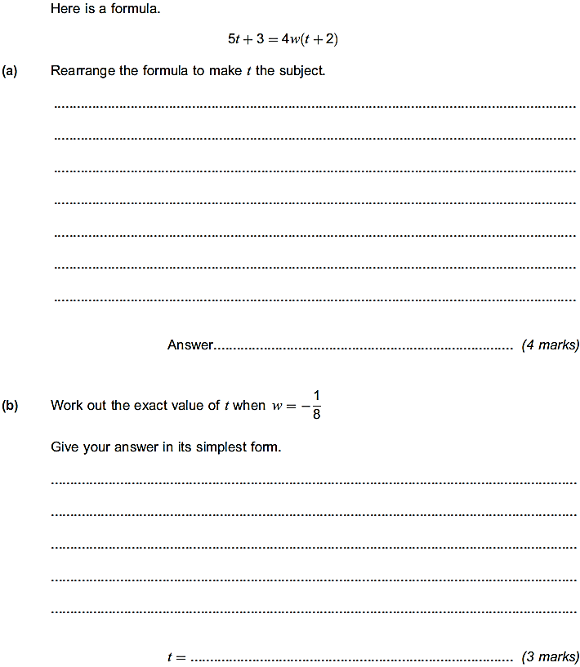
5 | 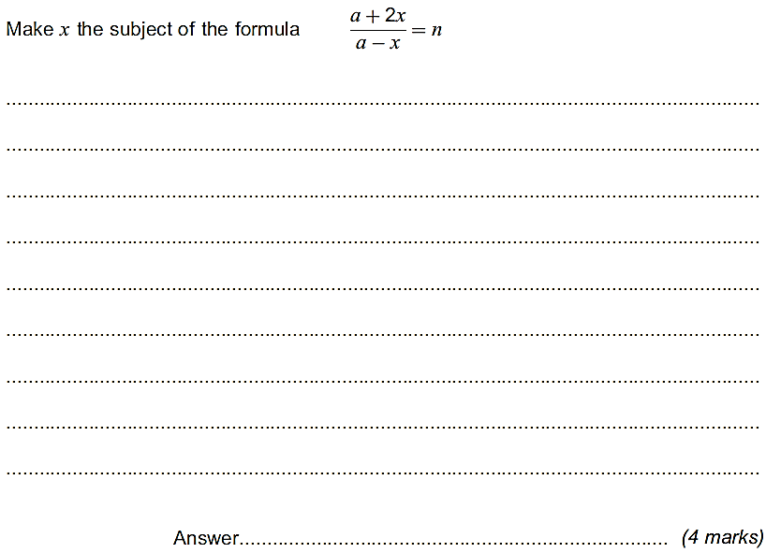
6 | 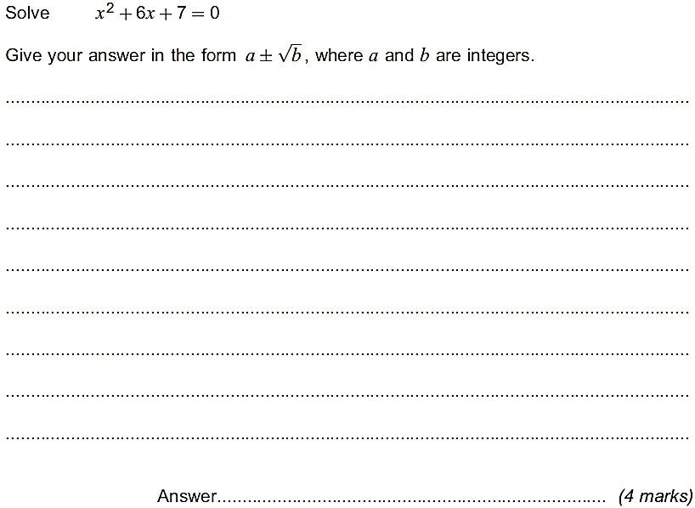
7
8 | 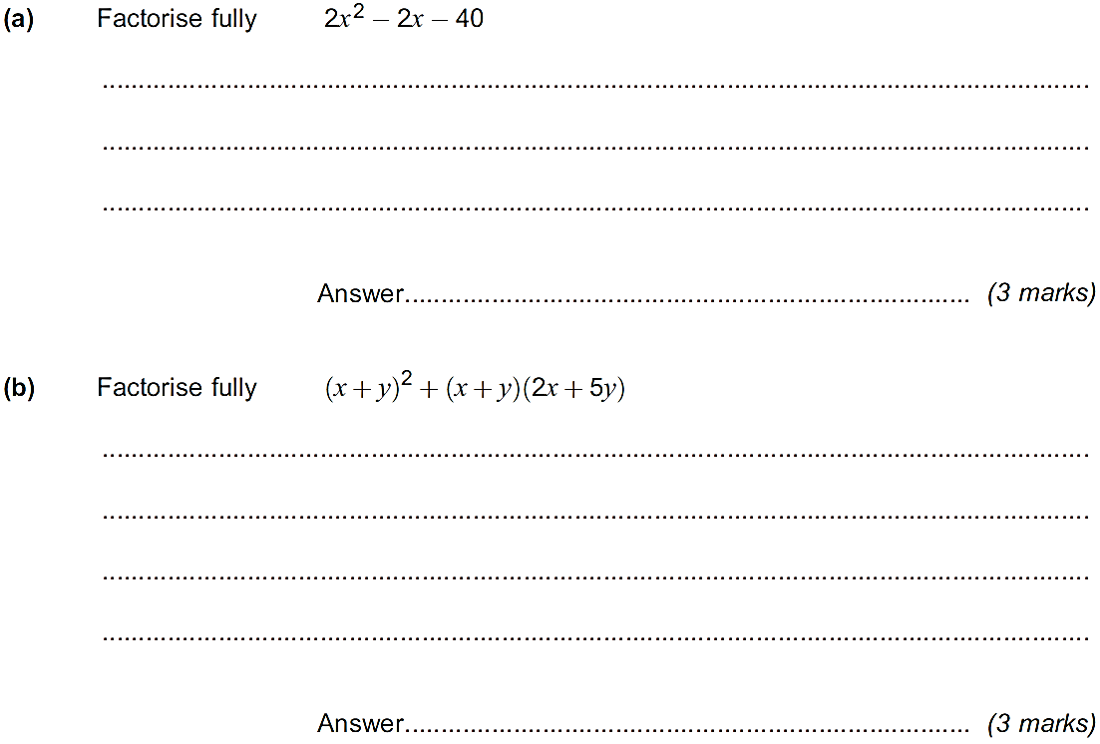
9 | 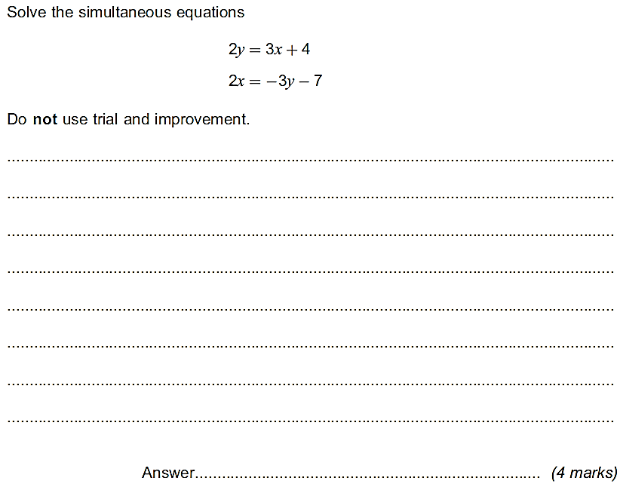
10 | 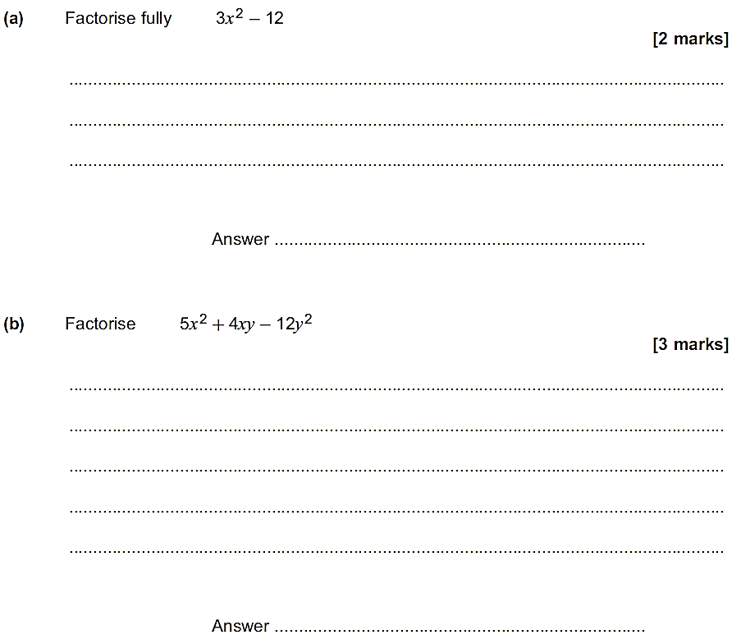
11 | 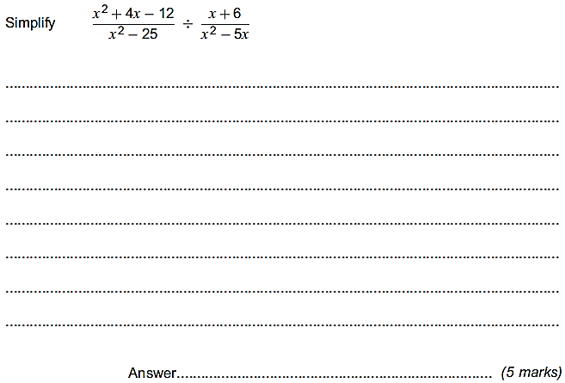
12 | 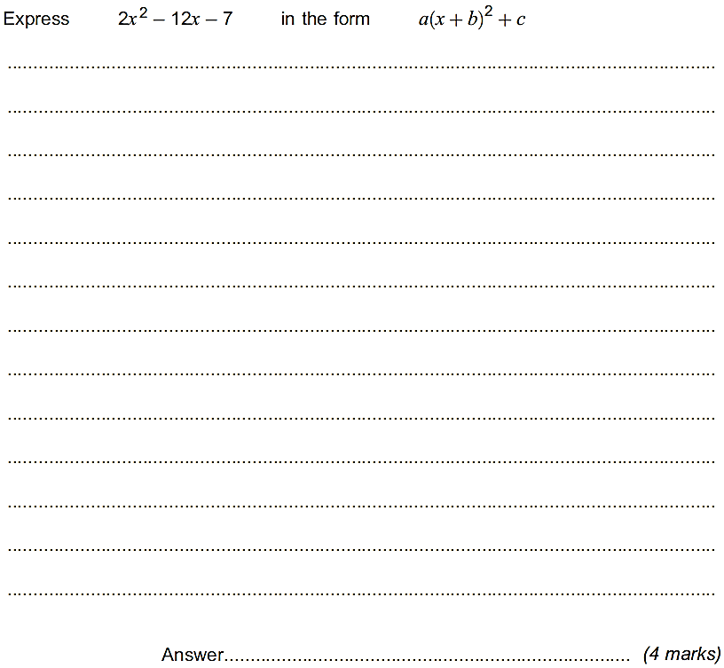
13 | 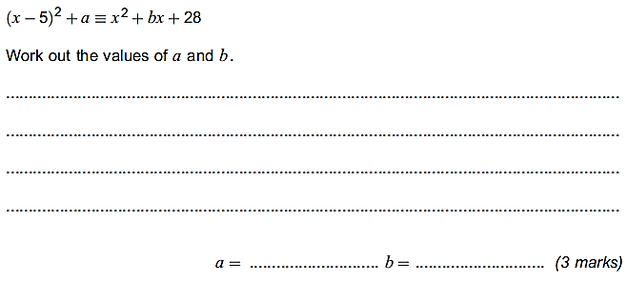
14
15 | 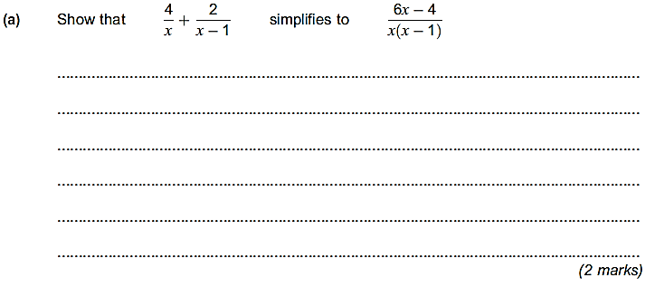  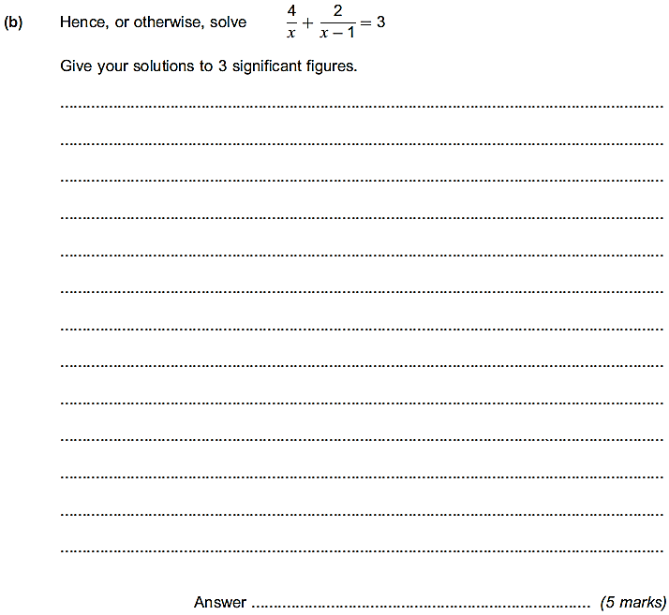

Section 2 – Indices - DO NOT USE A CALCULATOR - YOU ARE EXPECTED TO SHOW YOUR WORKING CLEARLY
1
2 | 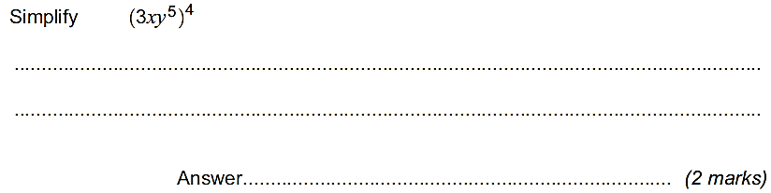
3 | 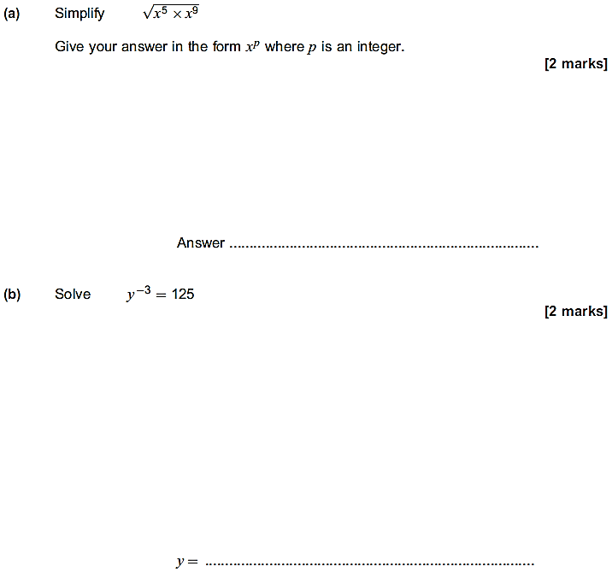
4 | 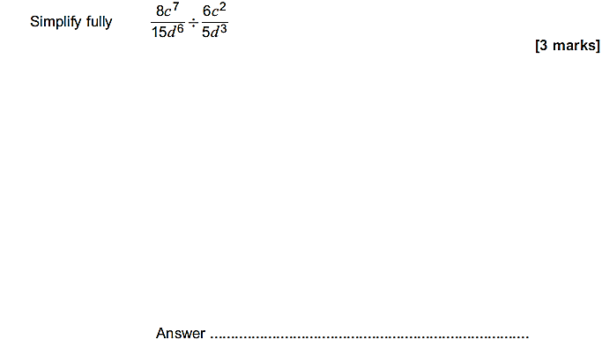
5 | 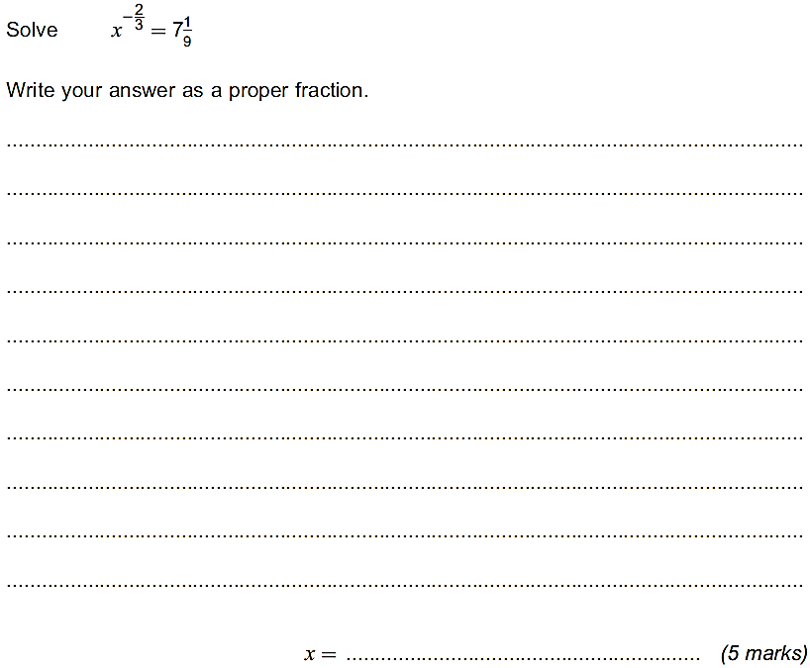
6 | 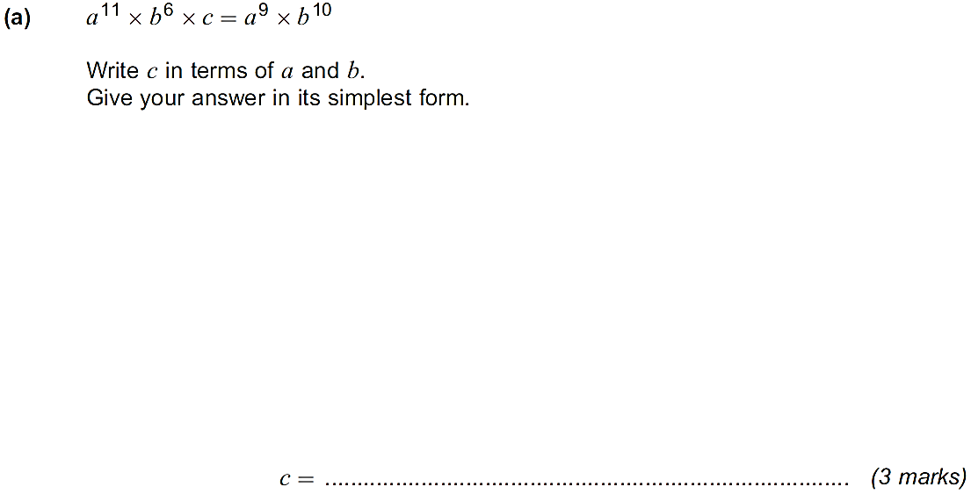  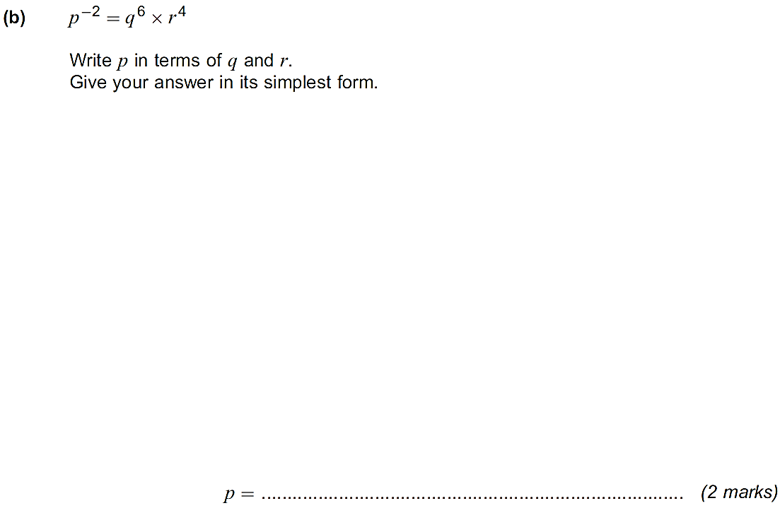
7 | 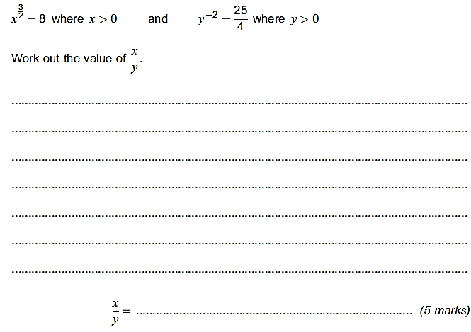

Section 3 – Surds – DO NOT USE A CALCULATOR - YOU ARE EXPECTED TO SHOW YOUR WORKING CLEARLY
1 | 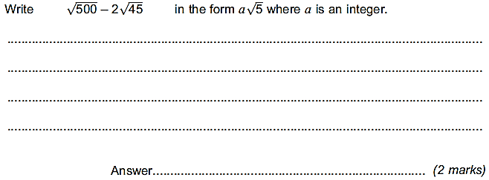
2 | 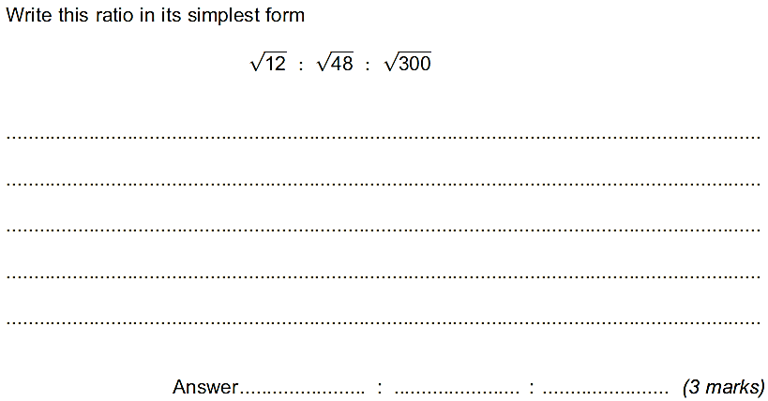
3 | 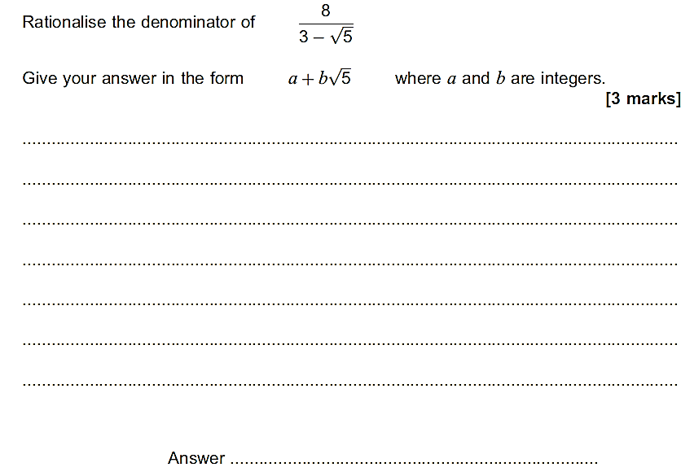
4 | 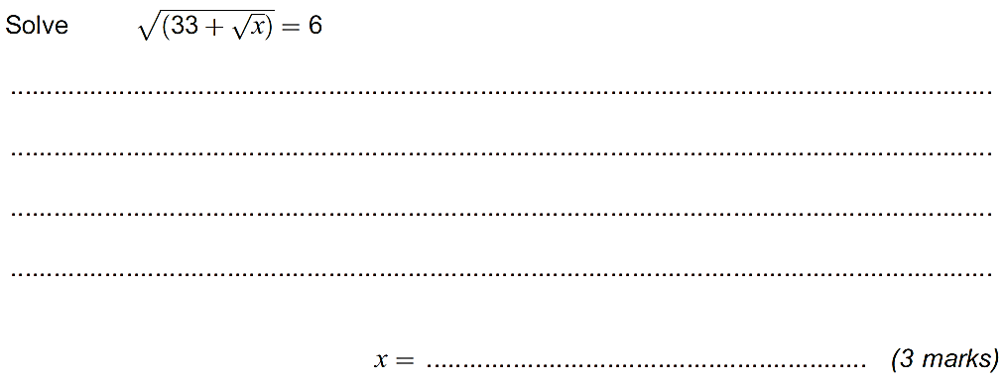
5 | 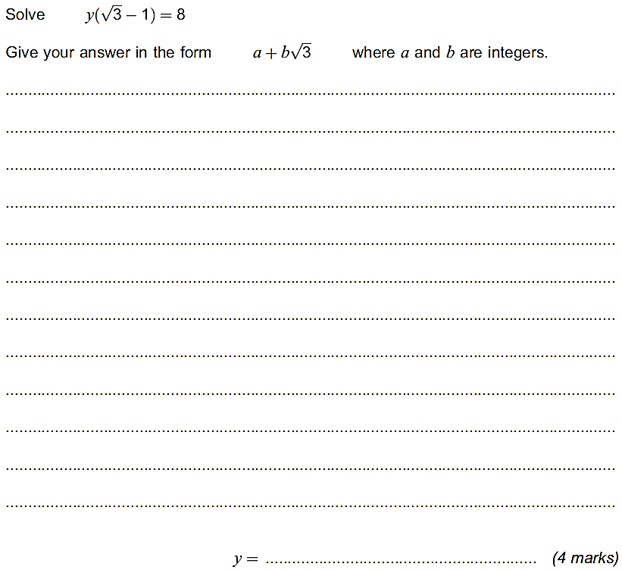

Section 4 – Proof
1 | 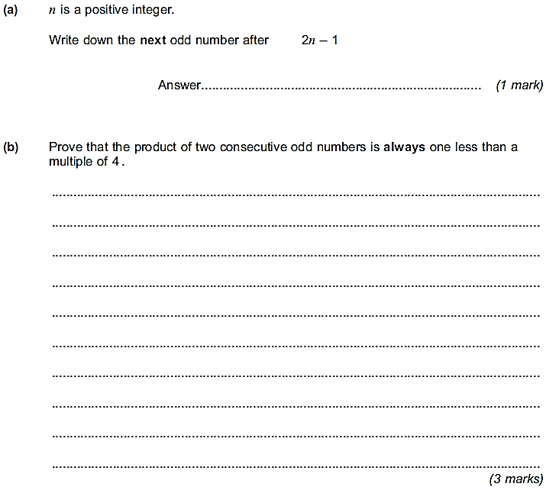
2 | 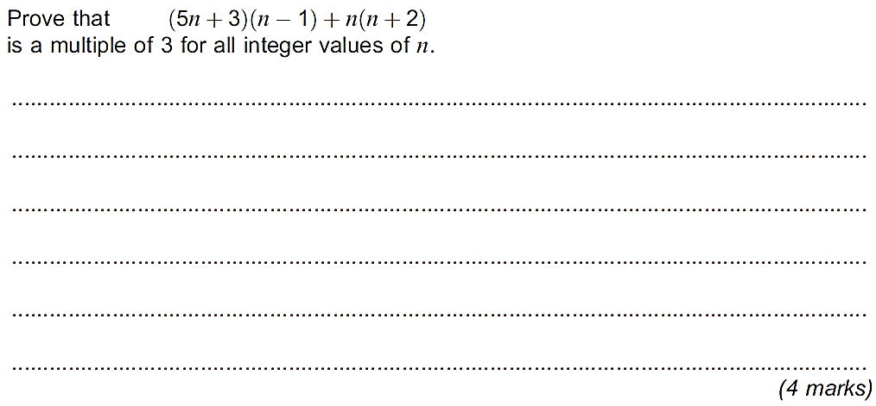
3 | 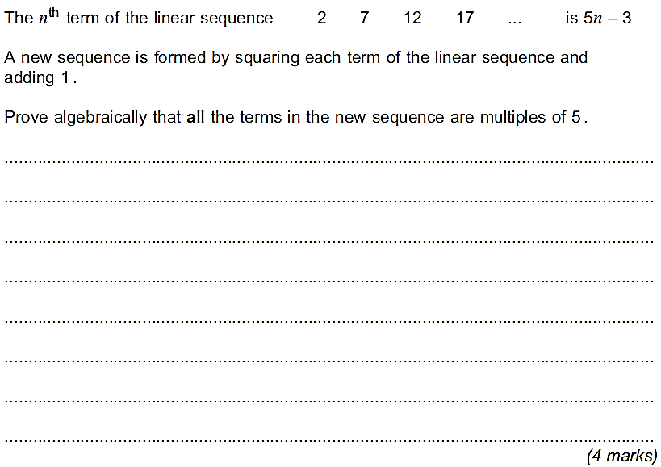
4 | 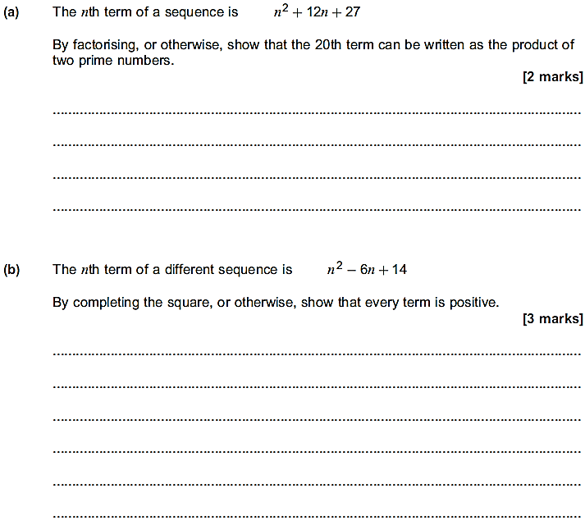

Section 5 – Coordinate Geometry
1 | 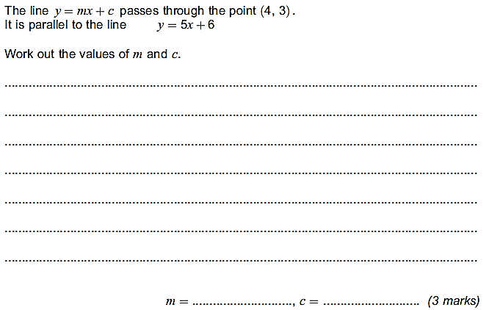
2 | 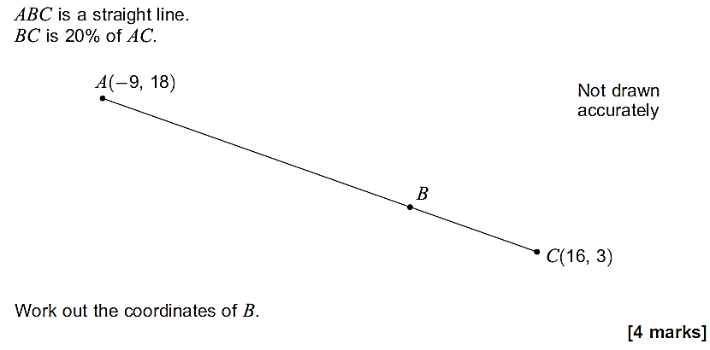
3 | 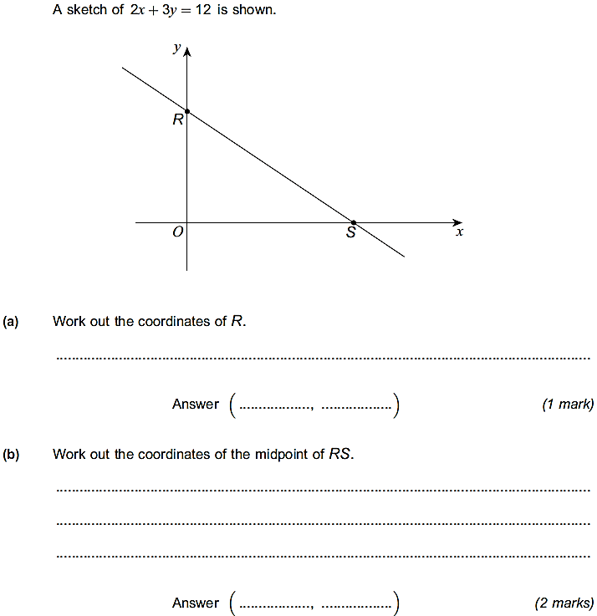
4 | 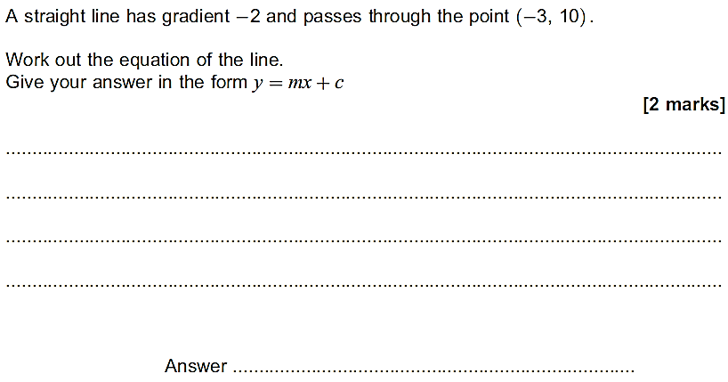
5 | 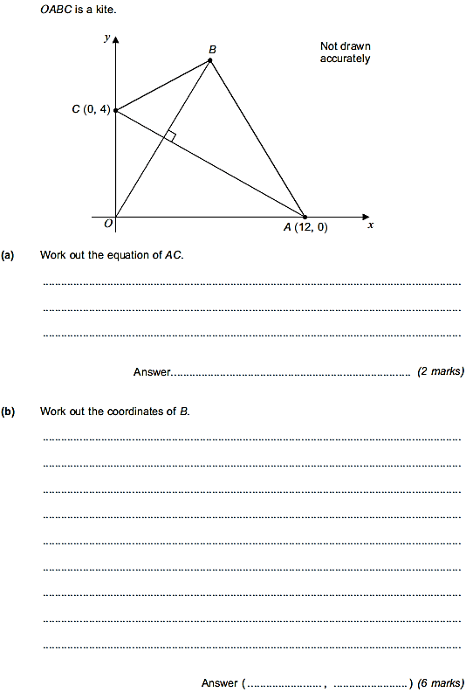

Y12 Maths and Further Maths written solutions
Use these written solutions to check that you have answered the questions correctly, or to offer some hints when you are stuck with a question. Do not just copy these solutions into the booklet. You must have a strong grasp of this content before you start the course in September. Please also ensure you revise any of the topics that you may have become less familiar with if necessary.
Section 1 – Algebra
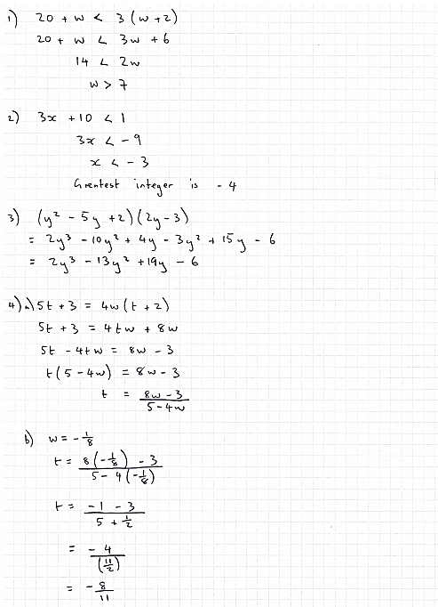
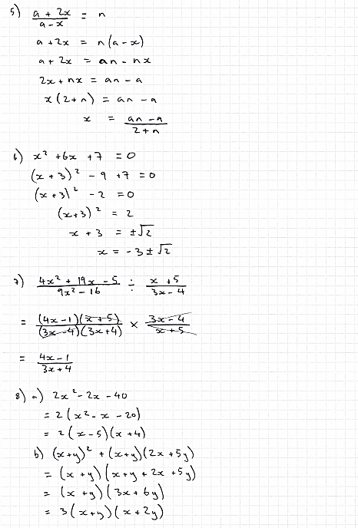
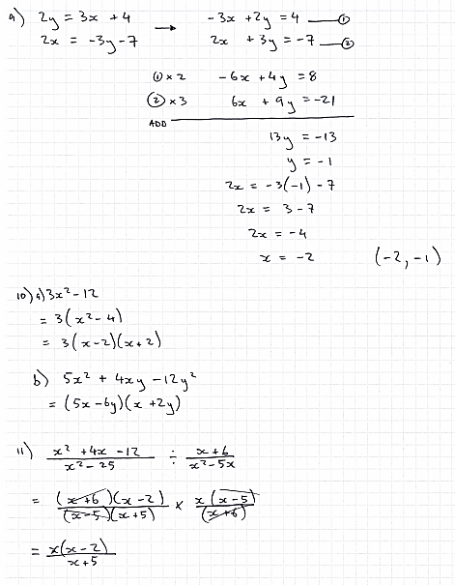
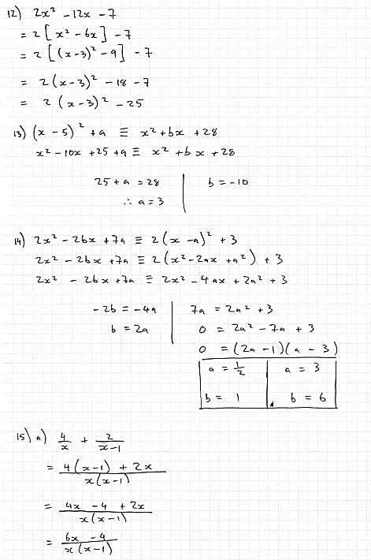
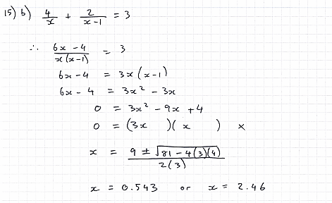

Section 2 – Indices
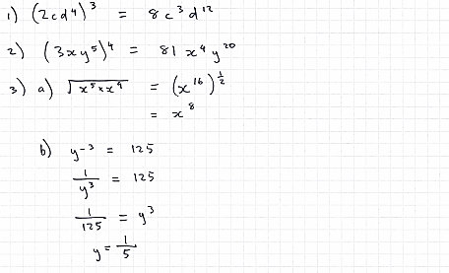
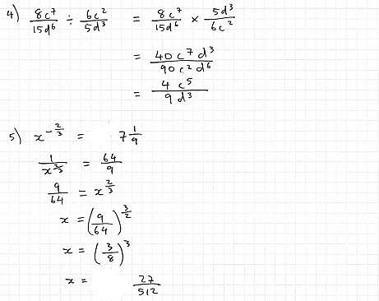
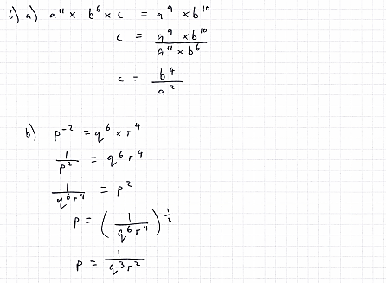
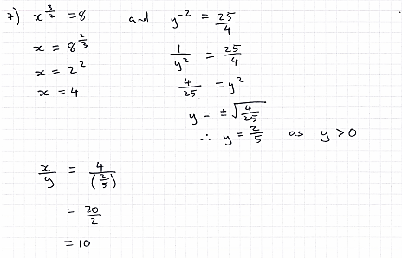

Section 3 – Surds
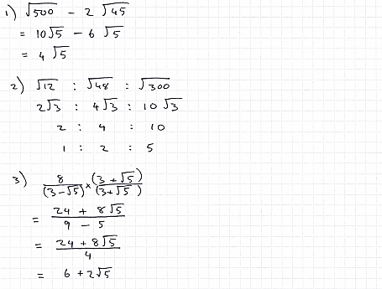
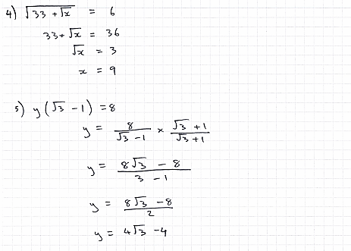

Section 4 – Proof
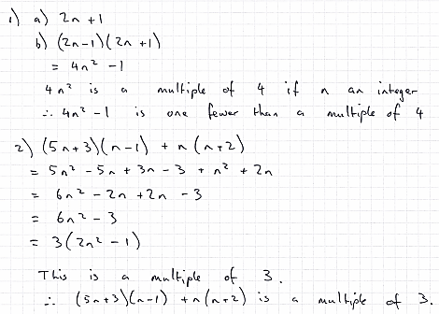
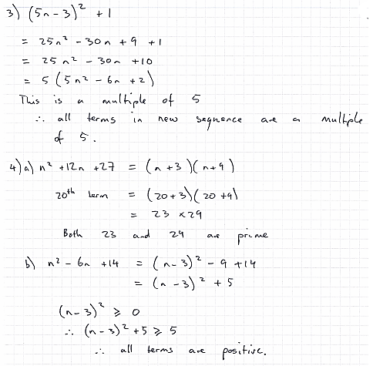

Section 5 – Coordinate Geometry
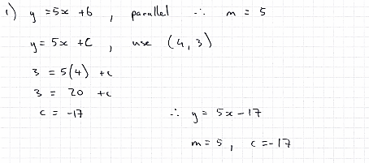
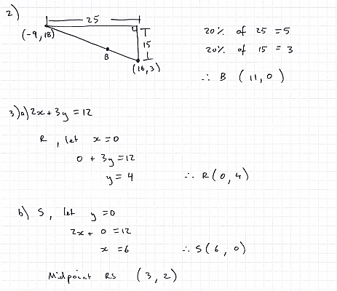
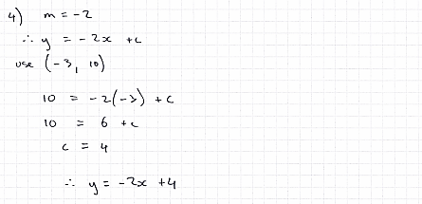
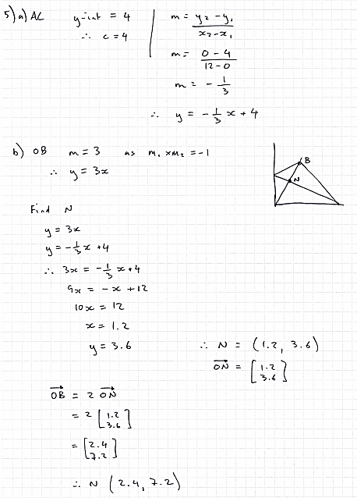

Y12 Maths and Further Maths practice test
Please prepare full written answers to the following on lined paper, stapled, with your name at the top.
This must be submitted to your teacher in your first A level Maths lesson.
1
2 | 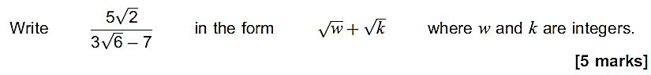
3
4 | 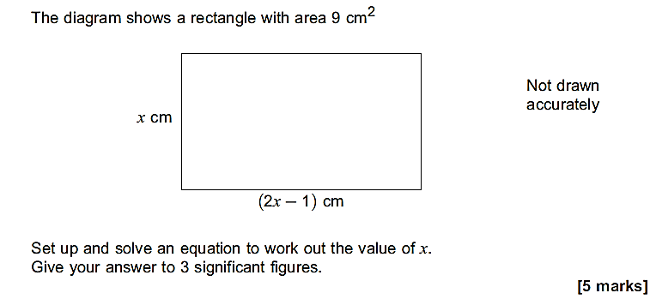
5 | 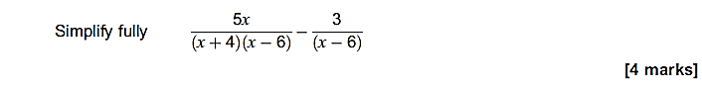
6 | 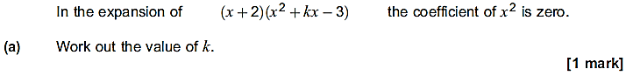
7 | 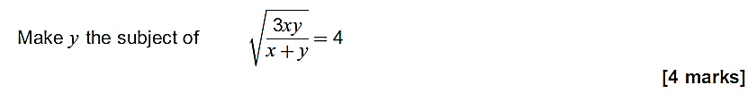
8
9 | 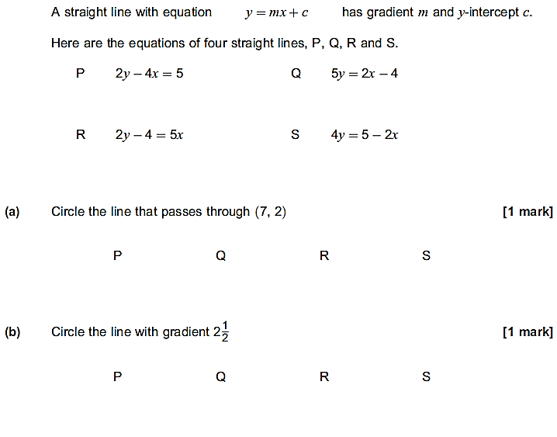  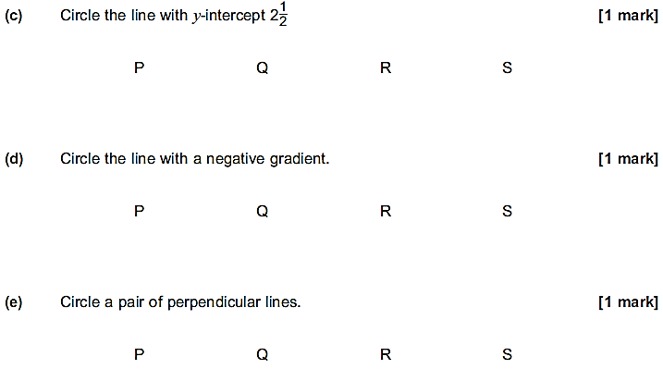
10 | 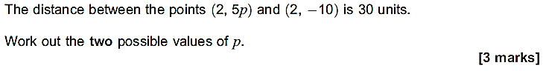
11 | 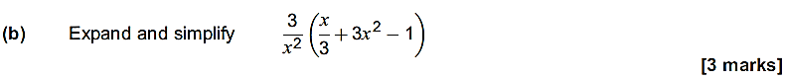
12 | 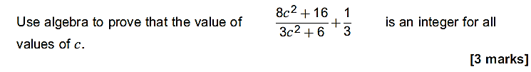
13 | 