Stick Songs

Sing these songs together and use two sticks (one in each hand). You can watch us singing these on the ‘Stanley’s Stick’ section of the school website to learn the tune and join in! Both songs are to the tune of ‘Here We Go Round the Mulberry Bush’
This Is The Way We Tap Our Sticks
(This song helps children practice keeping a steady rhythm)
This is the way we tap our sticks, tap our sticks, tap our sticks,
This is the way we tap our sticks, early in the morning.
This is the way we rub our sticks, rub our sticks, rub our sticks,
This is the way we rub our sticks, early in the morning.

This is the way we hammer our sticks, hammer our sticks, hammer our sticks,
This is the way we hammer our sticks, early in the morning.

This is the way we drum our sticks, drum our sticks, drum our sticks,
This is the way we drum our sticks, early in the morning.

Lets All Tap Our Sticks Today
(This song helps children to follow instructions – leave a pause before you sing the body part to encourage your child to listen)
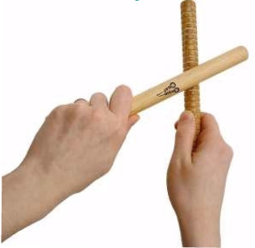
Let’s all tap - our sticks today,
Sticks today, sticks today.
Let’s all tap - our sticks today.
Let’s tap them - on our hand.
Tap, tap - tap, tap, tap,
Tap, tap - tap, tap, tap,
Tap, tap – tap, tap, tap,
Tapping on our hand.
Repeat with other places to tap the sticks.
Such as; head, arm, foot, elbow, etc.

