Aberford Church of England Primary School
School Lane, Aberford, Leeds, LS25 3BU
Tel: 0113 281 3302
Website: www.aberfordprimaryschool.co.uk
Headteacher – Nicola Crossley

Monday 8th June

Dear parents or carers of XXX,

Welcome to Aberford CE Primary School! We are Mrs Shaw and Mrs Jennings – the class teachers of Class 1. We can’t wait to meet you and have your child join our school community. As you can imagine, we’re not able to provide our normal transition experience for your child this year – we really wish we could. It is really important that we get to know you and your family, and you get to know us and the wider school community. However, hopefully over the next few weeks we can get to know each other better, and answer any questions you have. At this stage, we also don’t know what September will look like but we will of course be in touch as soon as we get guidance from the government.

For our records and so we can be in touch, please complete the form attached to this letter. One side is for you, and the other side for your child.

Once we have the letters, and if you choose to, we will knock on your door and then remain 2m away – just to introduce ourselves and ‘meet’ in person. We can then give you more information and forms for you to complete. If you’re happy for us to, we will take a picture of you and your child in front of their house - we can put it up in the classroom so they have something recognisable when they first start. Perhaps your child could choose their favourite toy to show us too? We will also give your child an empty book – we would love it if they could fill it with pictures and photos of what they get up to over the summer (you could always annotate to share news). Children love sharing these books and talking about their summer when we’re all together. If you don’t want us to pop round, or you’re not available that day, we will just send the documents out to you.

In the meantime, take a look at our website where we have created a New Starters section: www.aberfordprimaryschool.co.uk/children. We will update it regularly.

If you have any questions or concerns at any point, please don’t hesitate to get in touch. Having your child start school can be a daunting experience at any time, so we understand that you might be finding it especially worrying now.

There are some pictures of staff overleaf for your child to start familiarising themselves with us!

All the best,

Lucy Jennings and Lynda Shaw
Class 1 Teachers
l.jennings@aberfordceprimary.org.uk

Here are a few faces for you to get to know to begin with:

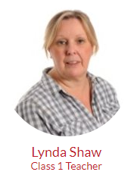

You are lucky enough to have not one but two teachers (we won’t always be there at the same time) – Mrs Shaw and Mrs Jennings.

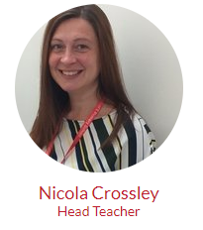
Mrs Goddard looks after the school office and is most likely to be the person who answers the phone and can answer questions you have.
Our Head Teacher, Mrs Crossley, is really new too, so you can share your new school butterfly feelings with her.
Please complete and return to school in the stamped addressed envelope:

Child’s Name:
What your child likes to be called:
Date of Birth:
Main adult contact:
Phone number:
Email address:
Name and address of Nursery/Childcare your child attended:
Name of Keyworker:

Have they returned to their nursery/childminder/childcare when the government guidance changed?
Would you like a door step meeting on Thursday 25th June? | 󠄀 Yes please  󠄀 No thanks | If yes,  󠄀 Morning is better  󠄀 Afternoon is better
Any other information you think would be useful for us to know at this point:

All about me!

Your child could draw or make a mark of their own – and perhaps you could have a chat with them and write down what they say.

My family: | I like playing:
I am really good at: | I don’t like it when:

