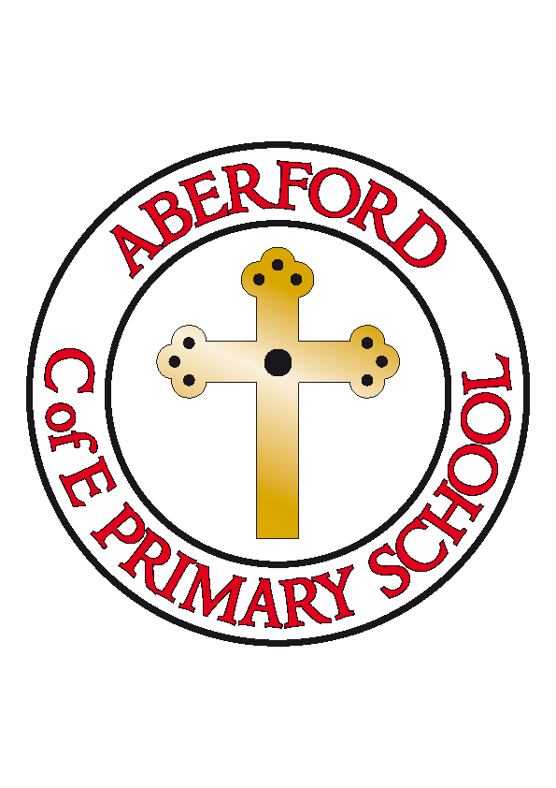
Aberford Church of England Primary School
School Lane, Aberford, Leeds, LS25 3BU
Tel: 0113 281 3302
Website: www.aberfordprimaryschool.co.uk
Headteacher – Nicola Crossley

Message from Mrs Crossley
I would like to say a huge thank you to our school community for making me feel so welcome during my first week at Aberford. It’s been lovely to start to meet some parents outside school (from 2 metres away, of course!) and to get to know some of you. I also need to say a big thank you to all the families who have followed our dropping off and picking up procedures so well and for keeping socially distanced from each other whilst following the pathway round. Mornings and evenings have been smooth and efficient and this has been greatly appreciated.
I have been so proud of our children this week. Returning to some sort of normality after ten weeks of lockdown is a big ask for everyone, but our children have handled this with great maturity and resilience. They have returned to school with positive attitudes and have got on with everything that the adults in school have asked them. It’s been a lovely week and I can’t wait to welcome even more children back into school, as soon as we are able.

Schools are not allowing visitors into the premises at present so Castleford Tigers will not be resuming any after school clubs at present. Please keep watching our website for information regarding this as we move forward.

Aberford Achievements

Our staff have nominated children who have been superstars this week. As we can’t send certificates home at the moment, here they are!
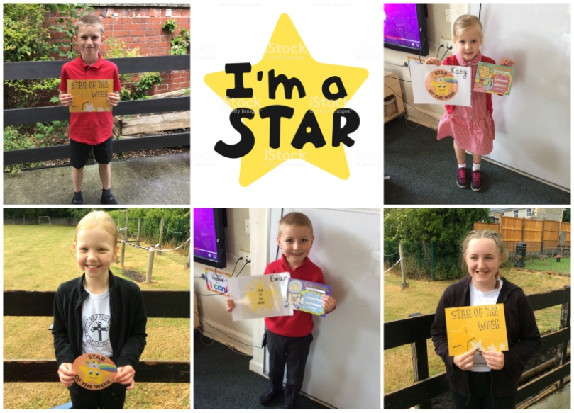 | Evie D  Evie has returned to school with a fantastic attitude, has produced some super work and has been really focused.
Kai W
This is for being really sensible and mature and keeping us all smiling this week.
Katy
Katy has returned to school with a fantastic attitude to learning and is trying really hard to follow the new rules that have been introduced to class one this week.
Ewan C
For being a super star in phonics and for blowing Miss Jones away with his reading!
Chloe
Chloe has had a wonderful first week back. She has been very enthusiastic about our new topics, in particular, Titanic and produced some fantastic work! Well done Chloe!

What our children have to say about our first week back....

I think everyone has enjoyed being here because we haven’t seen each other for quite a long time and it has been really enjoyable, especially being able to get out of the house and speak to friends and teachers.
- Olivia (Y6 bubble)
I have enjoyed pulling out all the weeds ready to plant in our flower beds.
- Kai (KW bubble)
I have enjoyed seeing my friends and learning about the Titanic. Being back and having fun at school again is lovely. I have liked meeting Mrs Crossley and leaving the house.
- Chloe
This week has been fun! Much more fun than being at home.
- Renita (KW bubble)
I have had lots of fun playing football and painting in art.
- Ruby (KW bubble)
I have loved learning about the Titanic and have liked having my own desk but I still wish I could bring my animals to school. I love being outdoors with my class.
- Beth (Y6 bubble)
I have had lots of fun seeing all the people in our new class on the first day.
- Kayla (KW bubble)
Some of the things we take for granted all leave our hearts lost, broken and gone without them and one of those is school. School to most is boring, and work, but it isn’t that. The socialising, the fun with the teachers – so I want to thank my friends, my headteacher and all my teachers for an amazing first week.
- Hayden (Y6 bubble)
Being back feels amazing seeing everyone after ten whole weeks: the terrific topic of Titanic has been an amazing topic to learn about so far. I can’t wait to see what comes next!
- Ella (Y6 bubble)

