Aberford C of E Primary School
Collective Worship Policy 2026-2027
Aberford C of E Primary School is a Church of England School, with Christian Values at the heart of everything we do.
Our School Vision
We are a family.
- We respect, support and celebrate each other.
- We work together and rise to every challenge.
- We live and learn, guided by our values.
Our vision at Aberford CE Primary is rooted in the Bible verse 1 Corinthians 13:
Rationale
Our collective worship policy strengthens and supports the distinctiveness of our school, reaffirms our school vision and celebrates the central role that each child has to play in their community. Our worship reflects the variety of traditions found in the Church of England and will recognise and follow the Christian liturgical year. The daily Christian act of worship is central to our ethos and is supported by all staff and governors.
Therefore Collective Worship at Aberford C of E Primary School is planned to:
- be inspirational and inclusive. It should engage all learners and they should be able to talk about the impact it makes on their relationships and on life in the school.
- regularly include Biblical material and Christian teaching and this should explore and relate to Christian values.
- have a strong focus on God as Father, Son and Holy Spirit enabling all learners to embark on an understanding of the Trinity.
- help all learners to understand Anglican and other Christian traditions found in the UK and worldwide.
- challenge all learners of all backgrounds to understand and embark on their own spiritual journey. They should understand the value of Prayer, Reflection, Stillness.
- be an opportunity to celebrate and give thanks for achievements within the school, local and international community and occasions of significance, including festivals.
- be invitational and an experience that does not offend the integrity of the non-religious or those of different faith.
Three things will last forever - faith, hope and love - and the greatest of these is love.

Legal Requirements
The law requires the Headteacher and Governing Body of every school to provide a daily act of Collective Worship which is in line with the schools Trust Deed and foundation.
Withdrawal from Collective Worship
We acknowledge the right of parents/guardians to withdraw their children from Collective Worship. The school must comply with any request from a parent to withdraw their child and parents are not required to give their reasons for wanting to do so. Should a parent/guardian wish to withdraw their child from Collective Worship we ask that they inform the school via Dojo or the office email address. We will endeavour to communicate clearly the place of inclusive and invitational Collective Worship to ensure that parents are in possession of all the necessary information. However, should a parent/guardian request that their child be withdrawn we will not attempt to persuade them to alter their decision. If a pupil is withdrawn from Collective Worship the school is required to provide supervision but should not incur any additional cost in doing so.

Our pattern of Collective Worship
Whole School Worship is held 4 times a week. These are taken by all staff on a rota basis. Class / Key Stage worship is held once a week. These are taken by class teachers. Acts of worship generally follow themes that are linked to the schools vision and values and include the pattern of the church’s year.

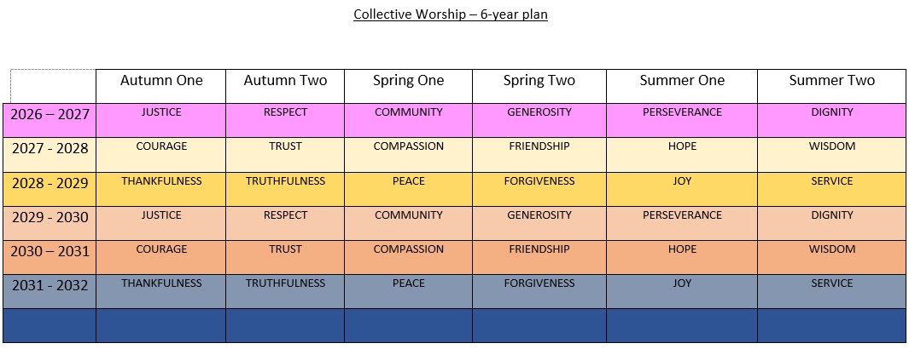

Planning Collective Worship
- Each person leading worship is expected to plan his or her act of worship with the same degree of thoroughness as any other aspect of their teaching. We use a 4 stage structure of planning including
- ‘Welcome’ ‘Learning’ ‘Reflecting’ ‘Responding’.
- and staff should refer to these parts specifically during their delivery.
Welcome | We mark out this special time by lighting the three candles as we say our Welcome Words together.  We are gathered in the name of God the Father,  Son and Holy Spirit to worship together  and think about our value…..
Learning | I Wonder  Staff should use the language of I wonder during collective worship sessions to help children to think about the ‘big questions’ and reflect on how the teachings of the Bible help them to develop as people.
Reflecting | Moments of quiet  Staff should incorporate moments of quiet and stillness for reflection into collective worship, so that children have an opportunity to reflect properly.  Class reflection  Class reflection activities build upon messages given within the worship theme.  Values booklets to be completed at the end of each half term.  Child led prayers to be completed in class at the first opportunity each half term.
Responding | Living it out  The children may respond in talking partners or individually to vocalise their thoughts on living out the value into their lives.  Prayers should be shared from children – based on the value – see appendix.  Child led prayers:  Should be written in class in the first available reflection time during the cycle. Teachers leading worship should then pick children to share the child led prayer in their planned worship.
Resources | - Roots and Fruits 1 and 2 (www.imaginor.co.uk)  - Oscar out of the Box (www.imaginor.co.uk)  - Journey through the Bible (https://dioceseofyork.org.uk/support/for-schools/journey-through-the-bible/)

Visitors
Visitors should understand the educational aims of Collective Worship at the school and the need to avoid any proselytising. Attempts to persuade pupils to adopt a particular religious or non-religious belief are not appropriate. In general, the Headteacher is consulted before a visiting speaker is confirmed. Visitors should not speak about raising money for any particular cause without the prior permission of the Headteacher.

Regular visitors to our school include:
- Anne and Mike: Church Leaders from Dayspring Church, Garforth
- Father Peter Townsley

Monitoring and Evaluation
Monitoring and evaluation of collective acts of worship, is undertaken by pupils, staff and governors on a regular basis. All who deliver worship will be observed on a regular basis. This process supports the school’s self-evaluation, is a specific responsibility of the foundation governors and is reported to the whole governing body. Pupils are also involved in evaluating collective worship through feedback in weekly class worship, questionnaires and ACE committee meetings. Our school regularly evaluates our acts of collective worship and the impact it has on the school and its wider community. This involves monitoring by school leaders, staff, pupils and governors in order to grow and develop, using the Collective Worship Observation Form. These are shared with our Ethos committee and play an integral part in developing the spiritual growth of the school. Worship is independently inspected by law under Section 48 of the Education Act 2005 in consultation with the Diocese of York (SIAMS).

Policy updated: July 2026
Review date: July 2027

My Prayer for

________________________________________________________________________________________________________________________________________________________________________________________________________________________________________________________________________________________
Monitoring and Evaluation
