**Dates:**

* PTA meeting in school – **Tuesday 26th April 3:15pm**
* Book Fair: **25th – 29th April**
* Y6 Sats week – **9th May**
* Y2 SATs week – **16th May**

**After School Clubs**

All After School Clubs will start again next week, all children who have requested a place for the clubs have been allocated a space. Please let the office know if your child would like to attend and has not already signed up. Thank you

**Book Fair: 25th – 29th April**

The Scholastic book fair is now in school. Call in to the hall next week to look at what’s available and buy a new book!

**Y6 Breakfasts - KS2 SATS Week: 9th – 12th May**

Suring SATs week, year 6 pupils can come to school at 8am, Monday to Thursday, to have breakfast together and prepare for their end of Key Stage tests.

**KS1 SATS – Year 2 – Weeks 16th & 23rd May**

Year 2 will complete their end of Key Stage tests in school during the week commencing 16th May, with the week after available to catch up any children who may have missed them. These will be done in class in a relaxed and low key manner and the scores from these will contribute towards our Teacher Assessment levels for the Year 2 children.

Class 1 – visit to Lotherton Hall

Today, class 1 have visited Lotherton Hall to look around the Wildlife World, explore the grounds and observe the Red Deer from the Deer Hide. They also worked together as a team to build dens. We had a super day and were delighted when a passing member of the public stopped to tell us how well behaved the children were.

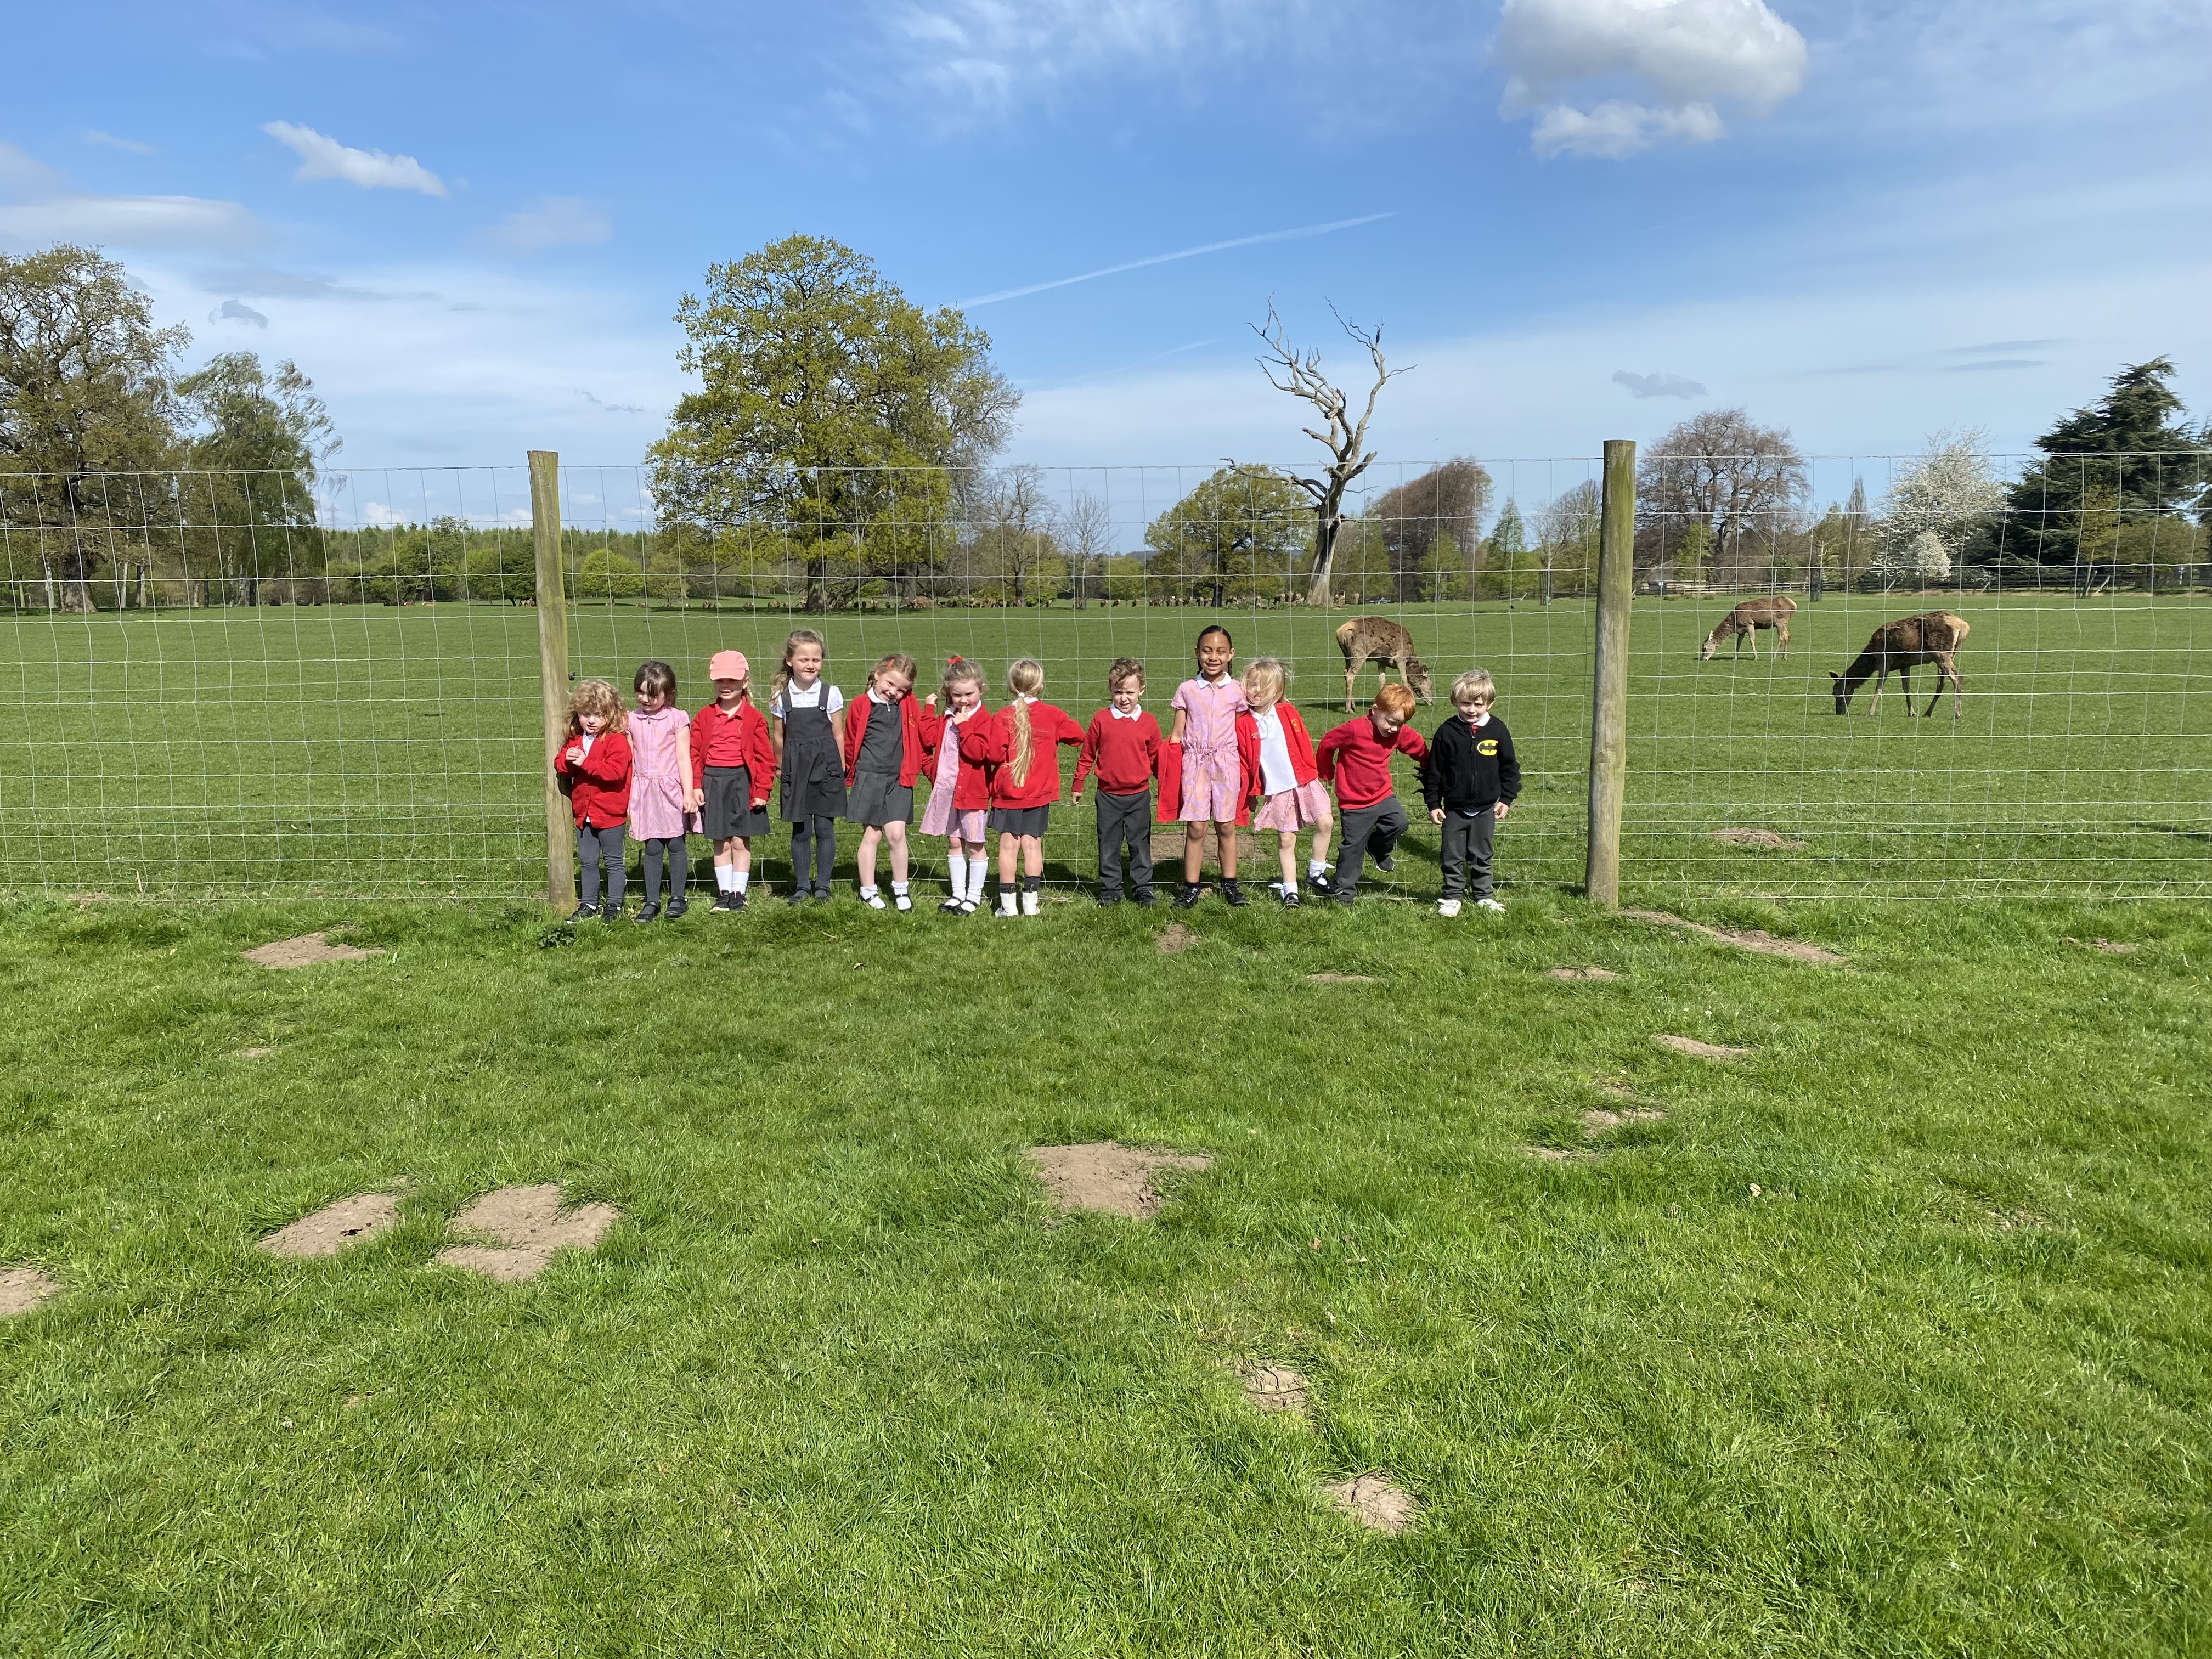

**Reading Prize Draw**

|  |
| --- |
| **Ruby W** |
| **Ben H** |

**Christian Values Award**



|  |  |
| --- | --- |
| **Kai** | **Tabitha** |
| **Lilly** | **Florence** |
| **Esme** |  |
| **Bethany** |  |

**Housepoints**

|  |  |  |
| --- | --- | --- |
|  | This week | Running total |
| **Becca** | **76** | **62** |
| **Lotherton** | **99** | **76** |
| **Parlington** | **67** | **56** |
| **Hazlewood** | **79** | **58** |

**Class attendance this week**

|  |  |
| --- | --- |
| **Class 1** | **88.5%** |
| **Class 2** | **97.2%** |
| **Class 3** | **95.7%** |
| **Class 4** | **90.3%** |

Well done to class 2 - our attendance winner this week!

**Individual Attendance Draw**

|  |
| --- |
| **Lizzy** |

**Message from the Office**

**Attendance letters will be sent out next week, please lookout for the letter in your child’s book bag. The letters will be coded Green for attendance above 95% Amber for 95%-90% and Red for Below 90%**

22nd April 2022

**Aberford CE Primary**

***Weekly Newsletter***