By Alexander
This morning, at 2:46am, the well-known Titanic sunk to its watery grave.
Yesterday (around midday) the famous Titanic set off on its voyage to America, [this was the Titanic’s first travel abroad]. The excitement around the Titanic was off the scale as people rapidly buying the hundreds of tickets, making it almost impossible to get on ‘The Queen of the Sea’. This day was known to mankind as the day that would go down in history. And so it did, but for very different reasons to those expected!
At precisely 11:40 am on the 14 April 1912, an ice berg in the Atlantic Ocean struck the Bow of the Titanic causing maximum damage. Luckily, with the help of modern technologies, the Titanic’s bottom was fit with multiple water tight spaces making it almost impossible to sink… but little did they know this unsinkable ship was not what they thought it was…
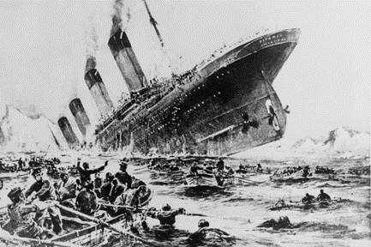

Carry on at page 6a

