Aberford C of E Primary School
Behaviour Policy

At Aberford, our vision is:
We are a family.
- We respect, support and celebrate each other.
- We work together and rise to every challenge.
- We live and learn, guided by our values.

Our vision at Aberford CE Primary is rooted in the Bible verse 1 Corinthians 13:

Three things will last forever - faith, hope and love - and the greatest of these is love.

Rationale
“So in everything, do to others what you have them do to you” (Matthew 7:12) firmly roots our approach and teaching at Aberford. It underpins all actions taken by children, staff, governors and families. Our school values are rooted in the teaching of Jesus Christ.
The Church of England’s Vision for Education references whole heartedly the aspiration to educate the whole child: “I came that they might have life, and have it abundantly and in all its fullness (John 10:10). The same Vision articulates the principle of education for dignity and respect, referencing:
“the basic principle of respect for the value of preciousness of each person, treating each person as a unique individual of inherent worth” (Church of England, Vision for Education).
The key principle and rationale of this policy is to outline, within the teaching of Jesus Christ, how positive behaviour is promoted and inappropriate behaviour challenged across Aberford C of E Primary School.
Aims
- To promote and live out our school’s distinctive Christian vision through positive behaviour and conduct of all members of the school community.
- To provide a secure and inclusive environment to learn and value respect for others, in line with Flourishing for All: Anti-bullying Guidance for Church of England Schools (2024)
- To provide a secure and caring culture where children feel safe and are taught about behaviour (including their own and that of others).
- To instil a culture of restorative practices to ensure that children are treated with dignity and respect when approaching behaviour management.
Principles

Our behaviour policy is built on the principles that every child is well behaved, enjoys learning and thrives on positive reinforcement in a safe, trusting and respectful learning environment. We actively seek to promote this culture across our whole school learning environment.
A key understanding for all staff, children, governors and families at Aberford in relation to behaviour is that it is all a form of communication. Careful consideration must be made to identify what a child is telling us by the way in which they are presenting. Our understanding is underpinned by the belief that, “to see a child differently is to see a different child”.
With this in mind, we view aspects of challenging behaviour as barriers for children. Our belief is that all children will behave well if they know how to and have no barriers blocking them. We strongly believe that no child will not behave well and instead understand that they may not be able to yet. It is the role of those around them, therefore, to identify barriers and remove them.
Behaviour Mantras for adults

Calm Responses
Don’t raise your voice – keep it low and steady
Give time to calm down
Appreciate their point of view but also explain why the consequence is appropriate
Consistent Approach
All adults give the same answer
Support other adults by sticking to agreed procedures
‘It’s not fair’ replaced by, ‘It’s what we expected’
Reinforce routines each day or things slip

Authentic Praise
Don’t overdo it
Don’t overuse amazing adjectives
Be specific with what you are praising for
Praise effort not attainment
Let them overhear you praise them to others - don’t let them hear criticism
Strong Relationships
Build relationships in every interaction
Get to know each child
Be interested
Demonstrate positive listening

Authentic Praise

We believe that recognising and praising positive behaviour is the most effective behaviour management strategy. As a school, we will recognise and praise positive behaviour in a number of ways including:
- Praise the effort, not the ability.
“I liked the strategies you used to solve that problem. You stuck with it and kept going.”
- Praise in specifics, not generalities.
“Well done - you used conjunctions such as because and although.”
- Praise authentically and not too much.
“I liked your story. It had an interesting ending.” rather than, “Wow, that was absolutely amazing!”
- Praise behaviour, not the child.
“Great walking in the corridor. Thank you.”
- Praise risk taking.
“I’m really proud that you tried to use the new method.”
- Praise responsiveness to feedback.
“You went back and improved your sentence. Well done.”

Praise around school:
All staff are encouraged to praise children around school for demonstrating the behaviours that we want to see in our pupils. This is one of our behaviour mantras for adults.

Calm Responses

- Ensure all conversations about behaviour are stripped of emotion.
- Privately and calmly, speak to the child at eye level (crouch where appropriate when a child is sitting).
- All adults should display calm tone and body language.
- Use language such as ‘I’ve noticed that’ rather than asking ‘Why are you…?’. Children often cannot or will not articulate an answer to this and pushing for it may lead to further conflict.
- Give the child a chance to make it right (take up time is needed).
- Secondary behaviours such as huffing, mumbling, eye-rolling, answering back, etc. must be ignored.
- Keep dialogue to a minimum.
- Look for an opportunity to praise the desired behaviour as soon as possible, no matter how small a step towards it (it may just be picking up a pen) and say thank you and smile.
- Consequences must not be a negotiation or discussion. Children will be able to have a discussion at reflection time / break time.

Behaviour Mantras

To make our behaviour expectations simple, we broke them down into 4 key behaviour mantras which staff are expected to reinforce to children daily:
Behaviour Mantras

Silent Starts
Walk in school
Move around school quietly
Line up well
Sit quietly in Collective Worship
Enter your classroom quietly and ready
Always Kind
Live our values
Be a good friend
Be kind to everyone
Don’t hurt each other
Work together
Be polite to everyone
Be Proud
Keep going until you are proud
Be determined
Learn from mistakes

Ready to Learn
Eyes on the speaker
Hands still and safe
Body is calm
Ears listening
Brain is thinking
Two feet on the floor
Class Behaviour Charts
- Within each class, a class behaviour chart is displayed with 5 different coloured steps.  - At the beginning of each day, each child will have their peg on ‘Ready to Learn’.  - Children will be asked to move their peg up or down depending on their behaviours for learning.  - Any child who has been moved down the ladder to thinking or below will be reset each lunch time, to give them opportunity to make a fresh start.  - Adults in class notice good learning behaviours and ask children to move their names up on to Super Student and then Wow! Children who get moved onto Wow! get a sticker saying Wow!  - Wows are also recorded in the class book and these are celebrated in Celebrations Collective Worships at the end of each week.  - When adults see inappropriate behaviours in class, they remind children of their behaviours verbally and this is not recorded.  - If a behaviour is repeated, adults will move their name onto warning, and then again onto consequence.  - If children move onto consequence, they will be expected to miss some time and complete a reflection sheet. There is a younger version and older version and class 1 should do this verbally only.  - Any behaviour ladder use must be logged in the class notepad, to be monitored for patterns of behaviour. | Wow!
 | Super Student
 | Ready to Learn
 | Warning
 | Consequence

Early Years

In Early Years, positive language around behaviour choices will be modelled by staff at all times. This will constantly reinforce good behaviour choices and will also be very clear about which behaviour is inappropriate if a child displays them. E.g. “We don’t hit”. Time outs will be given as consequences when the adults in the room deems the child ready to understand the consequence.

Playground Behaviour

In the playground, behaviour needs managing in the instant, rather than afterwards, back in class. This is so that children can fully understand which behaviours may not have been appropriate and also to ensure lesson time is not wasted, mopping up incidents which have spilled over into class.
Behaviours must be logged in the book and time outs given as

Playground Rules

Look after each other
No rough games
No Play fighting
No fighting
Respect adults
Include everyone
Be kind

Playground & equipment
Use equipment properly
Share equipment fairly
Tidy up
Hang up the ropes
No running on green area
No football on playground

Routines
Freeze on first bell
Line up on second bell
Line up nicely - no
pushing or chatting
Ask an adult to go to the
toilet
Bring water bottles out

Consequences
Friendly reminder first
Say sorry and make friends
5 minute time out
Ban from equipment
Reflection sheet
Sent in to the office
Phone call home
Logged in lunchtime book

Our Rewards at Aberford

Wow!:

- If a child gets onto Wow!, they get a Wow! Sticker, which allows other adults in school and at home to recognise the good behaviour.
- Their name is then put in the Wow! Book at the end of the week, which is on display in the hall.
Housepoints:
- House points will only be given for good work in class or for homework tasks, Arithmagicians, etc.
- They will not be given to reward behaviour.
- Housepoint certificates will be given out in Collective Worship each week -Bronze, Silver, Gold, etc
Christian Values Awards:
- These are given by class teachers to a child from each year group in the Friday Celebrations Collective Worship
Reading awards:
- Regular competitions and initiatives are set to encourage and reward children for reading at least 3 times a week at home. The reward system is updated every year but the focus is always to encourage and reward reading.
Lunchtime awards:
- Lunchtime certificates may be given by supervisors to reward good behaviour.
- Other lunchtime initiatives are launched regularly to keep children engaged and motivated.

In Class Rewards:

- Verbal or written feedback in relation to specific learning objectives from lessons
- Table points may be set up in classes when needed to motivate children to work as a team.
- A smile, gesture of verbal praise
- Being sent to other members of staff, including SLT, for praise
- Dojo messages home

Use of Force

All members of staff are aware of the regulations regarding Restrictive interventions including use of reasonable force in schools. Staff will only intervene when necessary. Procedures on the use of reasonable force are detailed in the Child Protection Policy and can be found online:
https://assets.publishing.service.gov.uk/media/6943dad6501cdd438f4cf5aa/Restrictive_interventions_including_use_of_reasonable_force_in_schools.pdf
Fixed term and permanent exclusions
We aim to avoid excluding any pupil, but in rare cases it may be necessary. When considering exclusion, the Headteacher will refer to the national statutory guidance Suspension and Permanent Exclusion from Maintained Schools, Academies and Pupil Referral Units in England (July 2026). https://assets.publishing.service.gov.uk/media/6a2c1d4aa3674dfd3eb50816/suspension-and-permanent-exclusion-from-maintained-schools-academies-and-pupil-referral-units-in-England-including-pupil-movement-comes-into-force-from-26-July-2026.pdf
Only the Headteacher can exclude a pupil. A pupil may be suspended for one or more periods, up to a total of 45 school days in an academic year or permanently excluded in exceptional circumstances.
When a pupil is excluded, the Headteacher will inform parents/carers immediately, explaining:
- the reason for the exclusion
- the length of the suspension or that it is permanent
- how parents/carers can make representations to the Governing Body
The Headteacher will also notify the Local Authority and the Governing Body of:
- all permanent exclusions
- any suspensions totalling more than five days in a term

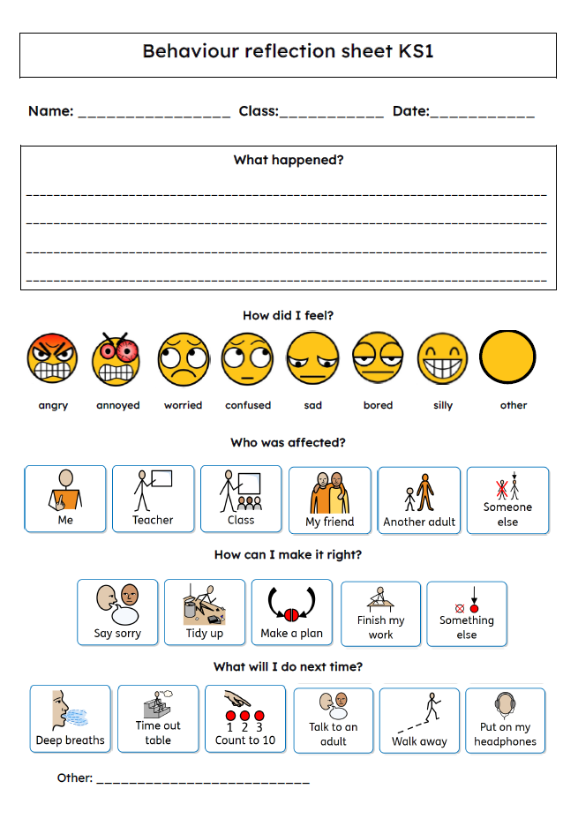

Aberford C of E Primary School
Reflection Time

Name: ________________________________ Date: ______________________

Which Behaviour Mantra have you broken?

Always Kind
Silent Starts
Ready to Learn
Be Proud

What were my actions?

________________________________________________________________________________________________________________________________________________________________________
Who did my actions affect?
________________________________________________________________________________________________________________
How can I solve it?
________________________________________________________________________________________________________________
How did it make me feel?
________________________________________________________________________________________________________________

