Class 2 – English 1 Click on the images for website links

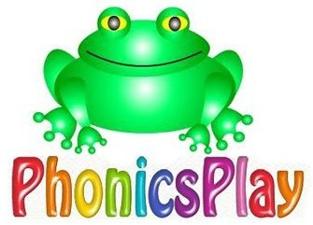  Phonics Play  Use the ‘Phonics Play’ website to practice your phonics every day. They have a free log on when  you click on the website.  -If you are in Phonics lessons, play the phase 3, phase 4 and phase 5 games.  -If you are in SPAG lessons, play these games and phase 6 games. | Handwriting  Practise your handwriting using trunks and tails | Animals  Create a fact file for the different animals that we have learnt about.  We have looked at mammals, amphibians, birds, fish and reptiles.  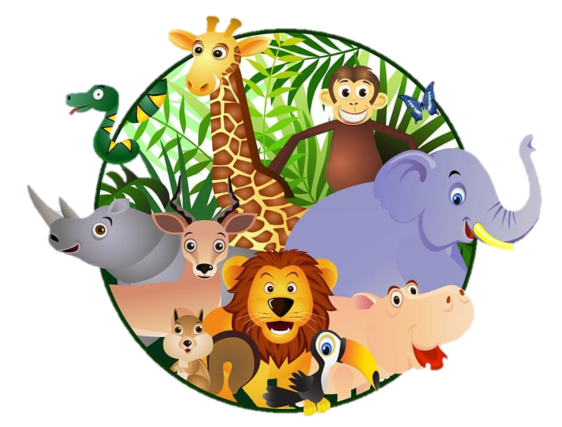
Instructions

Write some instructions for how to do something. It could be for how to brush your teeth, how to play a game or how to make a cake. Don’t forget to use openers like first, next, then, later etc.

Poetry  Write a senses poem for Spring.  I can see…..  I can smell….  I can hear…  I can taste…  I can feel…. |  | We’re going on a lion hunt  Write a story based on ‘we’re going on a lion hunt’ like we did in class. Change the animal, the setting and the obstacles that the family had to go through to get to the animal.
Poetry

Write a nonsense rhyming poem like ‘Ning, Nang, Nong’ by Spike Milligan.

