Class 2 – English Click on the images for website links
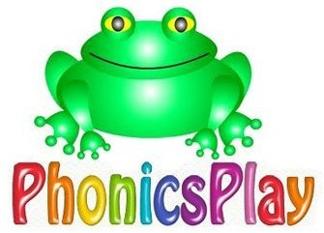  Phonics Play  Use the ‘Phonics Play’ website to practice your phonics every day. They have a free log on when you click on the website.  -If you are in Phonics lessons, play the phase 3, phase 4 and phase 5 games.  -If you are in SPAG lessons, play these games and phase 6 games. | 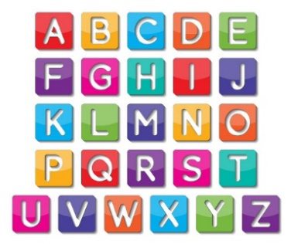  Alphabet  Practise the alphabet, saying the letter sound and the letter name.  This video is a letter name and sound song.  -Can you then write each lower case letter with its matching capital letter? Say the letter names and sounds as you go! | 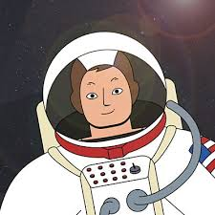  Research  Research Neil Armstrong and Christopher Columbus. These websites might help you:  CLICK ON THE PICTURES  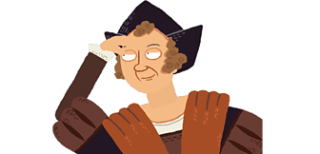  -Write a fact file for them both.  -Pretend to be one of them and write a diary about their adventures.  -Write some questions that you would like to ask them. EG: Why did you decide to become an astronaut? Why did you want to travel? Don’t forget to use a ? and not a .  -Can you pretend to be one and answer the questions that you have written?
The Tiger Who Came To Tea  Remind yourself of the story of ‘The Tiger Who Came To Tea’.  Change the story so that another animal comes for tea. What do they eat? What do they do to your house? Don’t forget to use punctuation! | Audio Books  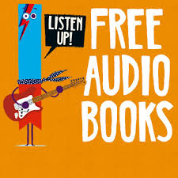  Listen to some different audio books and write some book reviews. Here are some free audio books:  -What was your favourite part?  -Who was your favourite character?  -Where was it set?
Different Sentence Types

Write some sentences using the different punctuation we have learnt about this year.
Write a…
-Statement using a capital letter and a full stop.
-Question using a question mark.
-Exclamation sentence using ‘what’ or ‘how’.
-List using commas to separate. EG: I have a skipping rope, a hula hoop and a ball.
Handwriting  Practise your handwriting for 15 minutes every day. Practise joined up handwriting or practise using trunks and tails. | Daily lessons  Hamilton Trust home learning site has some fantastic home lessons to complete

