Class 2 – Maths Click on the images for website links
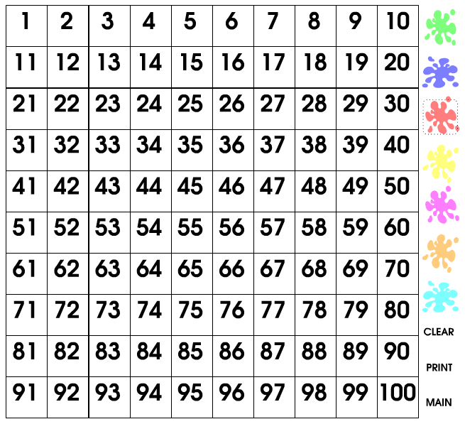  Splat Grid  Practise writing numbers to 100 (and beyond!) as numbers and words. In class, we use the 100 splat grid to help us. Find a given  number, splat it and then write the number as a word. Or write a given number as a number and a word and then splat it on the splat grid. | Shape Hunt  Go on a shape hunt around your house/garden. How many 2D and 3D shapes can you spot? Make a tally chart for which shapes you see.  Cylinders lll Tin Plant pot  Spheres ll Football Tennis ball  Prism l Bird house | Measuring  Using a tape measure or ruler, measure different items in cm. Create a table to show their length/height. Then order different items by height/length, starting with the smallest first.  Reading book 24cm height  TV remote 12cm height  Flower in the garden 40cm height  Smallest Tallest  TV Remote Book Flower
Splat Grid  We also use this splat grid to find odd and even numbers, doubles and halves, times tables and number problems. EG: I am thinking of a number. It is an odd number. It has 3 tens and 5 ones. Splat my number. | Hamilton Trust  Log on daily to Hamilton Trust Home Learning to support your daily maths learning. | Number Bonds  Practise saying and writing number bonds to 10, 20 and 100. How many different ways can you make these numbers?  EG: 7+3 = 10  16+4 = 20  80+20 = 100
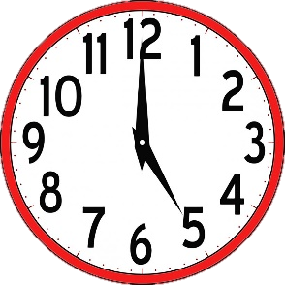  Time  Practise telling the time to the hour, half past, quarter to/past and then to the nearest 5 minutes. | TTRS  Spend 15 minutes a day on Times Table Rockstars! | 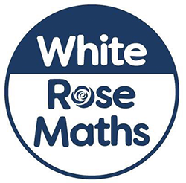  Maths  Log on daily to the White Rose Maths Home Learning packs to carry out your daily maths lessons. Watch the video, complete the activity and check your answers.

