English Policy
Aberford C of E Primary School
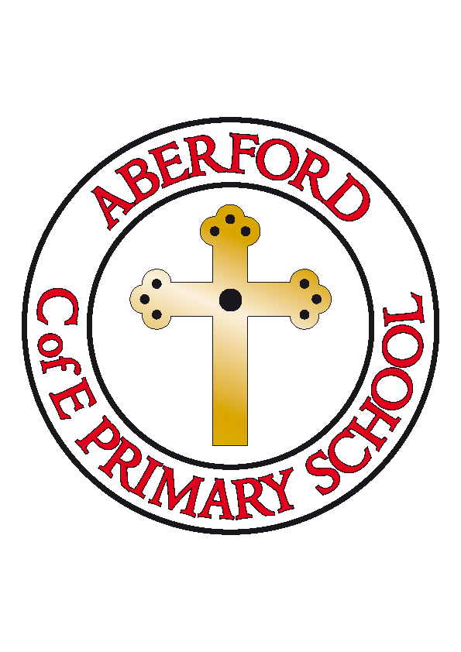

Approved by: | Nicola Crossley | Date: 7/03/2022
Reviewed by Governors on:
Next review due by: | March 2023

Contents
1. Our Vision
2.National Curriculum Aims
3. Aberford C of E Primary School Aims for our policy:
4. Delivery of the Engish Curriculum
5. Speaking and Listening
6. Phonics
7. Reading
8. Library
9. Writing
10. Handwriting
11. Spelling
12. Planning
13. Assessment and record keeping
14. Inclusion

Our Vision:

The study of English develops children’s abilities to listen, speak, read and write for a wide range of purposes and thus use language both to learn and communicate ideas, views and feelings. It enables children to express themselves creatively and imaginatively as they become enthusiastic and critical readers of stories, poetry and plays, as well as non-fiction and media texts. Children gain an understanding of how language and vocabulary works by looking at its patterns, structures and origins. They use their knowledge, skills and understanding in speaking, listening, reading and writing across a range of different situations and topics across the curriculum.

At Aberford C of E Primary School, we want our teaching of English to capture the imagination of our pupils. We aim to empower them by giving them the opportunities and guidance to develop their skills to be confident at speaking, listening, reading and writing. We wish to celebrate English in all its diversity and be enthusiastic and creative in our delivery of its content. We seek to continually improve our own standards of teaching and the standards achieved in English by all our pupils. We aim to deliver the English curriculum to all pupils through our broad and balanced curriculum, in a way that is accessible, relevant and challenging. Above all we will strive to embed a love of English that will enrich the lives of the children we teach.

National Curriculum Aims:
The overarching aim for English in the national curriculum is to promote high standards of language and literacy by equipping pupils with a strong command of the spoken and
written word, and to develop their love of literature through widespread reading for
enjoyment. The national curriculum for English aims to ensure that all pupils:
*read easily, fluently and with good understanding
*develop the habit of reading widely and often, for both pleasure and information
*acquire a wide vocabulary, an understanding of grammar and knowledge of linguistic
conventions for reading, writing and spoken language
*appreciate our rich and varied literary heritage
*write clearly, accurately and coherently, adapting their language and style in and for a
range of contexts, purposes and audiences
*use discussion in order to learn; they should be able to elaborate and explain clearly
their understanding and ideas
*are competent in the arts of speaking and listening, making formal presentations,
demonstrating to others and participating in debate

This policy describes our aims and our practice in the teaching of English: reading, writing, spelling, grammar and spoken language. It is defined by current national guidance on best practice, staff discussion and professional judgement.

Aberford C of E Primary School Aims for our policy:

*To provide a language rich environment that promotes a culture of reading and writing
*To develop in pupils a love of books and high-quality literature that will not only support their learning across the curriculum, but also extend beyond the classroom environment and enrich their lives
*To explicitly teach reading skills throughout the school that continually develop children’s understanding and enjoyment of texts
* To teach children the craft of writing in order to develop the confidence and skills to write well for a range of purposes and audiences
*To teach the basics – spelling, grammar, handwriting and punctuation – well so children have all the necessary tools
*To foster in pupils the confidence, desire and ability to express their views and opinions both orally and in writing
*To value and celebrate diversity in culture and language.

In their delivery of the English curriculum teachers will:

Have a clear understanding of the objectives being taught, sharing both objectives and success criteria with the pupils in an age-appropriate manner.
Plan for well-paced lessons using the National Curriculum to support the coverage of the knowledge and skills required for each year group. Teacher’s will be knowledgeable of what has been previously taught and build upon this to ensure that progress is progressive across school. Mapping across school enables this.
Use a range of teaching strategies as appropriate, including:

*Direction *Immersion *Demonstration *Imitation *Modelling *Innovation *Invention
*Independent group, individual and whole class tasks *Scaffolding *Explanation *Questioning
*Discussing and challenging ideas generated by the children *Whole class reading and writing
*Drama and role-play
The differing abilities and preferred learning styles of the children are considered, providing a culture where the children progress, develop and thrive within the classroom environment.

Speaking and Listening:

At Aberford we believe that the ability to speak and listen is fundamental to pupil’s language and social development. It is an essential tool for all the areas of the curriculum because talk underpins learning and thinking. It is vital that its significance is recognised by pupils, parents, and teaching staff. Pupils are given many and varied contexts to talk where this is modelled by staff in school by demonstrating clear diction, reasoned argument, use of imaginative and challenging language and use of standard English.

Phonics:

The teaching of phonics at Aberford, starts in Reception and continues through to Year Two. Phonics will continue into Key Stage Two, where necessary, to support those children who do not yet have the phonetical knowledge and skills that they need. As a school, we have developed our own phonics programme based upon the ‘Letters and Sounds (2007)’ documentation.
Please see separate Phonics Policy for more information.

Reading:

As children begin to read, we focus on decoding, primarily through phonics in addition to other strategies e.g. whole word recognition, rhyme and context. As children build fluency, comprehension skills become our main area of focus and questioning looks at skills such as re-telling, inference and prediction. We believe that high-quality literature is key to motivating children to read and here at Aberford, instilling in children a love of literature is very important.

Children in Reception, Year One, and Year Two have high-quality, daily, discrete phonics lessons, where they are taught the sounds from the English language and the different ways of reading and writing these sounds. The correct enunciation of sounds and the modelling of blending are extremely important at Aberford. We ensure that all staff are accurate and effective in their teaching of phonics.
The children have access to a range of reading books and we have ensured that our reading scheme is closely matched to our phonics scheme. Children in Reception and Year One will take a sound book home each week, that includes sounds that they have learnt that week in phonics. They will also take home a fully phonetically decodable book, matched to their stage of phonics. This book will be chosen by the child each week and will support their progression of reading skills and comprehension development. The children will keep these reading books for a week to become familiar with them and to build up their fluency. This is extremely important in a child's reading development and doing this at home gives them a chance to consolidate their reading in a relaxed environment.
Children in Year Two will also take home a reading book each week. This will help to develop their fluency and will include previously learnt phonic sounds and newly learnt phonics knowledge to embed their learning. By Year Two, children will be onto Phase 6 phonics and they will be reading with much more fluency. They will start to read words in three different ways; reading automatically, decoding in their head, and decoding unfamiliar words out loud. They will be building up their list of known words and high-frequency/tricky words and will have a bank of strategies for sounding out unfamiliar words. Our reading scheme supports this development and allows children to read longer fiction and non-fiction texts.
For any children still working on phases 2-6 in Year Three or beyond, we provide individualised interventions to diminish gaps and accelerate progress for these children.

In KS1 pupils are emergent and developing readers and pupils will focus on decoding using phonic strategies as required by the 2014 curriculum, but also understanding what the words they are decoding mean and how they contribute to the meaning of the whole text. Grouping pupils according to their stage of reading development is essential here so that pupils can access the chosen text, apply phonic knowledge, pay attention to sentence structures without loss of meaning. The curriculum requires us to ensure that all pupils read willingly and for pleasure, developing positive attitudes to reading and guided reading sessions must allow pupils to understand, respond to and enjoy the text.

In KS2 pupils are becoming more fluent and independent readers. Decoding has become a more automatic process and, in addition, they use knowledge of spelling patterns and grammatical knowledge to read unfamiliar words and with accuracy. They will read different texts for different purposes and need to experience and develop higher order reading skills in order to engage fully and respond effectively. Inferential thinking, stating preferences and opinions and justifying them, understanding the different viewpoints, including their own, in a text and considering the writer’s craft are among the required skills.

What does this look like at Aberford?
Whole class reading has recently been introduced at Aberford and aims to improve the reading skills of all pupils. It builds stamina and fluency for reading and develops understanding through the VIPERS skills taught by teachers. Text choice is paramount in the success of this strand of the English curriculum and all texts used are age related.

Reading is primarily taught as a whole class based on a class text or text extracts. The class text or extract is chosen to reflect the topic or theme where possible but also needs to respond to the children’s interests and be age related. Each reading lesson focuses on the VIPERS skills.
VIPERS is an acronym to aid the recall of the 6 reading domains as part of the reading curriculum. They are the key areas which children need to know and understand in order to improve their comprehension of texts.

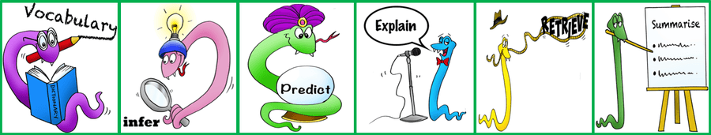

In Reception, guided reading begins in the Spring term where children work in smaller groups to focus on an age-related text. It is through these sessions that key reading and comprehension skills can be taught. In KS1 and KS2, reading is taught explicitly in a weekly lesson

Independent reading: children are expected to read at home for 15 minutes per day (in KS1) and 20 minutes per day (in KS2). Children are expected to have their reading records signed by a parent or carer at least three times per week. Staff ensure that children also have lots of opportunity to practise at school if home reading is ever an issue. This is done with teaching assistants and reading volunteers who come into school on a weekly basis. We keep a weekly record of those children who are reading at least 3x per week and those who fail to do so on a regular basis are recognised quickly, conversations are had between the class teacher and parents and support is provided where needed. Children who require additional support with their reading have access to this throughout the week reading with a TA.

Library:

Our Library is a lending library, keeping a good catalogue of quality fiction and non-fiction books for children throughout school to access. The cataloguing system is electronic, allowing the books to be stored on a database and the reading habits of pupils to be recorded. Children throughout school have weekly opportunities to visit the school library and to borrow a book.

Writing:

At Aberford, we strive to create an environment that will promote writing. We aspire to develop passionate readers and authors who develop a love of language and vocabulary and are inspired to write. Core texts will form the basis of our English lesson stimuli. This will enable children to read and write for a variety of audiences and purposes within different subjects. Our approach will support pupils to move from dependence to independence, with the teacher using shared and guided teaching to develop the ability in children to write creatively and powerfully.

Early Writing
The process of our writing begins in Early Years, where we focus a great deal on children’s gross and fine motor skills to ensure that they develop physically and are able to hold a pencil and form letters. There are many skills that are needed before a child can write and we ensure that all of the building blocks are in place for early writing. This process helps to empower our children to have the confidence and skills to be able to write for both pleasure and for a purpose.
KS1 and KS2
Lessons are delivered across a 2 (or sometimes 3) week cycle per genre of writing. This will enable children to become immersed and inspired by high quality texts, be exposed to and guided to write through teacher’s high quality modelling (imitate) and to then build confidence to apply these taught skills to become independent writers and readers (innovate and invent).

Key Skills
Each year group begins the teaching of writing by focusing on the key skills which we expect children to master. These are rigorously taught and practised so that children develop their fluency with these skills. Writing is a creative process which can set the children’s imaginations alight. Teachers model how to capture these ideas using the key skills, in addition to always striving to use more ambitious vocabulary and sentences. Grammar and punctuation are taught both explicitly and implicitly within English lessons using the Non Nonsense Grammar scheme across school. We also ensure that grammar skills are effectively embedded into the children’s everyday work. This leads to very high-quality outcomes of which both teachers and children are deservedly very proud.

Editing
Encouraging children to read their writing aloud also helps to develop their ability to edit and check with the aid of our editing system, “ARMS and COGS”. Children are taught to edit and improve their finished pieces effectively in KS1 and use a green pen to demonstrate their editing. Class teachers embed such lessons in to their planning to ensure children identify the importance of this as part of the writing process.

Handwriting:

We expect children to have very high standards of presentation in their writing and teach a cursive style of handwriting. We have recently introduced the Nelson Handwriting Scheme. Nelson Handwriting is a whole-school programme designed to help all children develop a confident, legible and personal handwriting style and meet higher curriculum expectations. The programme includes resources for pattern practice and motor skills work as well as fun activities to bring handwriting to life.

Spelling:

We teach spelling to build on children’s knowledge and understanding of phonics. At Aberford we use the No Nonsense spelling scheme from Year 3 where children learn the spelling patterns and rules which they must apply to increasingly ambitious vocabulary. Each week, children memorise up to ten words from the statutory vocabulary and spelling rules which they are expected to spell correctly, and have weekly practice of applying rules and recalling these spellings

Planning:

Teachers are responsible for the planning of the overall English programme for their year group, ensuring balance and progression across the Key Stages.

Long-term Planning is guided by the National Curriculum Programmes of Study for English (2014) and identifies the coverage and skills required at each stage.

Medium-term Planning is based on a core age related text. Teachers will plan to teach a variety of genres through novel based learning following the Aberford writing process and including the grammar and skills-based learning set out in the National Curriculum. Basic skills are a vital component of the teaching of English and this is a high priority at Aberford C of E Primary School.

Short-term Planning is undertaken by individual teachers on a weekly basis, setting out specific learning objectives for each lesson and considering the children’s previous learning. Short-term plans are uploaded onto the staff share and monitored by the SLT and the English curriculum leader.

Assessment and Record Keeping:

The assessment of English is continuous and informs the planning process. Teachers use marking and feedback to inform their teaching and planning. To ensure that pupils meet the required standard, gaps are identified and addressed through the editing, marking and feedback process.
Assessments made during lessons and the marking and evaluation of children’s work, help teachers to adjust their daily plans. Half termly assessments for writing and on-going assessment for reading measure the progress against our internal assessment system and the exemplification materials in Years 2 and 6.
Summative assessments are made three times a year and are used to track progress against school benchmarks and local and national targets. These are then discussed at pupil progress meetings with the SLT. These assessments enable teachers to set targets for the next school year and to summarise the progress of each pupil before discussion with parents or end of year reports.
Please refer to Assessment policy for summative assessment timetable.
At the relevant point in the year, Years 1, 2 and 6 also complete the statutory assessments.
Curriculum leaders will monitor in a variety of ways including learning walks, lesson observations, talking to children, looking at planning, discussions with staff at pupil progress meetings, gathering evidence/samples of work and book scrutiny.
Teachers keep records of progress in reading, writing, spelling, reading at home, book bands and phonics on the in-house tracking system. Records are used to inform planning and help to track children and highlight any issues that need to be addressed.

Inclusion:

The teaching of English is in accordance with Aberford C of E Primary School’s policy for equal opportunities. We enable all children to access the English curriculum. Appropriate resources are used to support individual needs, including children with specific needs, by providing suitable support and enrichment.

Written by Joanna Warner and Jessica Jones
Revised March 2022

