Daily Phonics Lessons
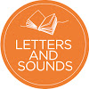
Letters and Sounds
We are excited to say that the Letters and Sounds team are planning to deliver a daily phonics lesson from Monday 27th April.
The lessons will be on the Letters and Sounds YouTube page at the following times:

CLICK HERE to go through to their YouTube page.

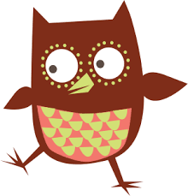
Oxford Reading Tree
After watching each lesson, we encourage you to read aloud to your child or listen to them read. You can use the Oxford Reading Tree website to access the reading scheme that we follow at school. All the e-books on there are free and easily accessible.
CLICK HERE to go through to Oxford Owl Reading Tree website.

If you need any help on deciding which lesson to watch then please feel free to contact us for any help or advice.

Thanks,

Mrs Jones and Mrs Shaw

