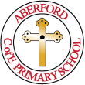
Aberford C of E Primary School

7th January 2022
Class 1 Newsletter – Spring 1

This letter is to let you know about some of the lovely things that we have planned for Spring term 1.

The Arctic

For the first half of this half term, we will be learning all about the season of Winter and the Arctic. We will start by exploring the weather around us and think about how we can keep ourselves warm. We will then move on and learn about the Arctic and ice. We will compare our life to life in the Arctic and will learn about the people who live there, the animals and the weather. We will also look at climate change and how this has changed life in the Arctic.

Maths

At Aberford, we use and follow the White Rose Maths resources to plan and deliver our maths lessons. The activities are both engaging and practical for the children. Alongside White Rose Maths, we also use the numberblocks resources in Reception.

During this half term, we will be learning about day and night, the days of the week, the numbers 0 and 5, the composition of numbers to 5, mass and capacity.

Phonics
The children have daily phonics lessons in school that last for around 20 minutes. We follow the structure of revisit/review, teach, practise and then apply in each phonics lesson. New phonics sounds are introduced each week and corresponding reading books are sent home the following Monday. We are currently working through our Phase 3 sounds and tricky words.

If you have any questions about our phonics lessons or would like any further information, please do not hesitate to speak to Mrs Jones.

Superheroes

During the second half of the half term, we will be learning all about Superheroes. We will be thinking about what superhero qualities we have and will design ourselves as a superhero. We will also look at and design our own superhero vehicle. Finally, we will be reading the story of ‘Supertato’ in our English sessions. We will be retelling the story together and solving the mystery of the evil peas!

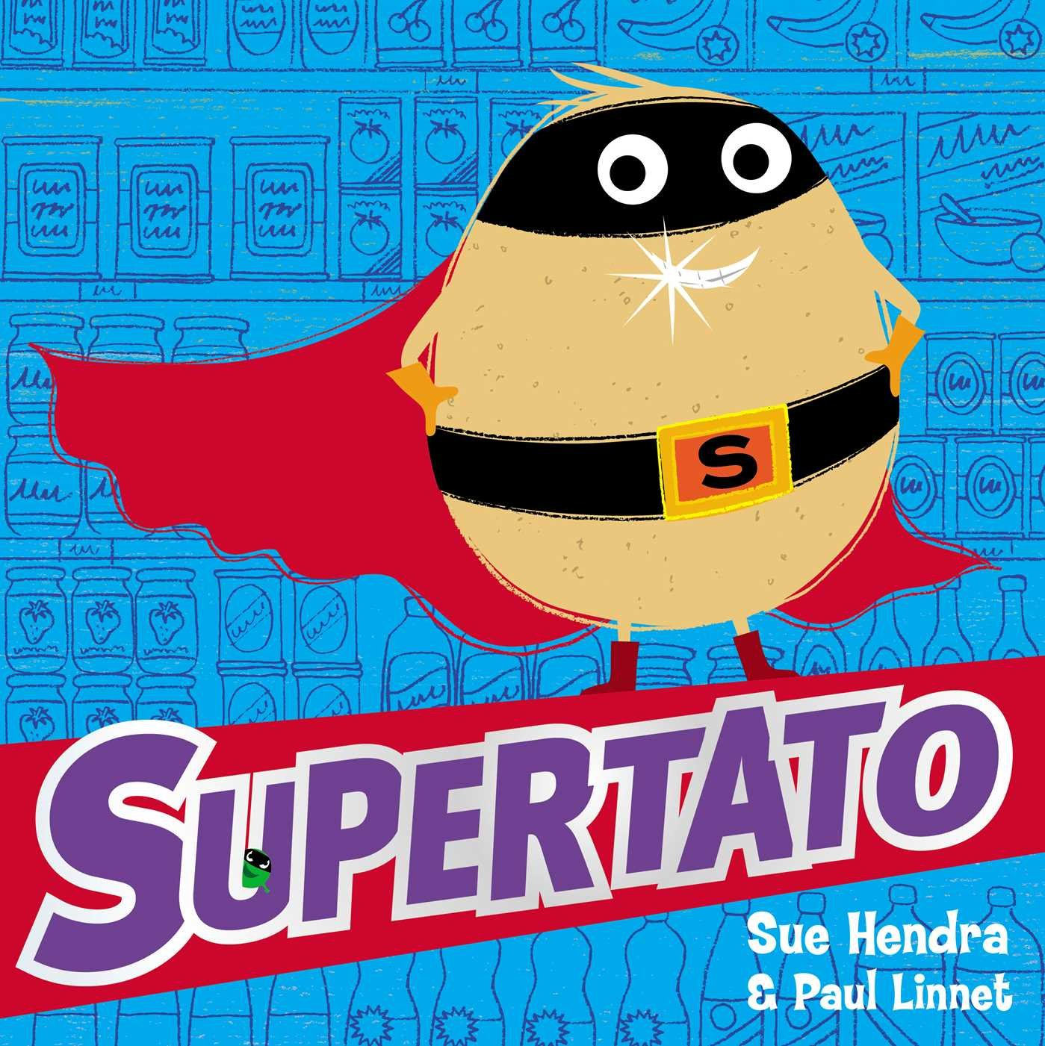

Did you know?

In Reception we also learn Spanish just like the rest of school. Last term, we learnt the colours in Spanish and this term we are moving on to learn the numbers in Spanish.

We also have weekly PSHE (personal, social, health, economic education) lessons and music lessons. This half term our PSHE topic is called ‘Dreams and Goals’ and we will be thinking all about our dreams and goals for this year and the future.

Religious Education is a big part of our curriculum at Aberford and our Christian Values are at the heart of our school. We have regular RE lessons and follow the Leeds syllabus and Understanding Christianity. This half term our RE topic is all about special places. We will be thinking about what places are special to us and what buildings or places are special for different religions.

What you can do to help at home…
*Practise the sounds/words that are sent home in the red sound books.
*Read the weekly sound books and reading books that are sent home.
*Send pictures and videos to school on Tapestry or Class Dojo for the children to talk about with the class.
*Practise forming numbers and letters correctly and the right way around.
*Encourage the children to be more independent on a morning when coming to school.

