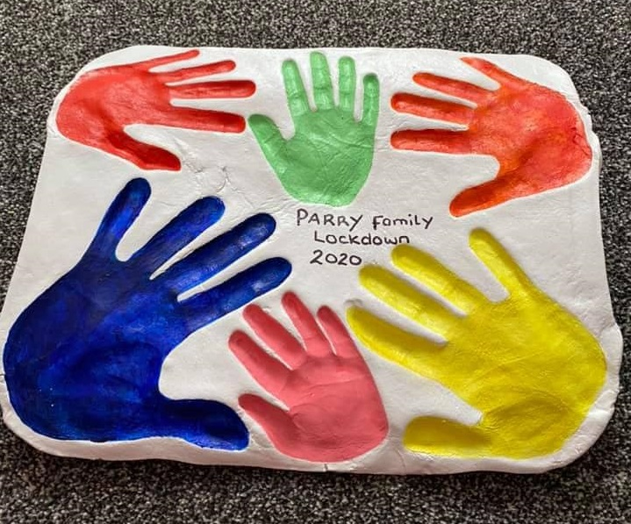
Challenge: Make a family salt dough piece
Ingredients
- 500grams of plain flour
- 250grams salt
- 250 millilitres of water (add slightly more water if necessary)
Bake in oven on lowest heat for 3 hours or until rock hard (took about 4 hours for ours)
Method

- Mix the flour and salt then add the water
- Mix into a dough
- Roll out onto flat surface into desired shape about 1-1.5cm thick (remember to sprinkle some flour down to prevent sticking)
- Place on a baking tray
- Make hand imprints (as deep/clear as possible)
- Place in the oven on the -lowest heat possible- and leave for 3-4 hours or until completely solid top and bottom. (Alternatively you can leave to air dry for a couple of days in a cool dry place- this is the best option if you only have self-raising flour)
- Paint with your choice of paints/colours (I used acrylic paints)
- Seal with any kind of varnish or sealer to preserve it. Varnish, modpodge, PVA and water mix
Make sure the bottom is rock hard before taking it out the oven

