Home Learning Tasks – EYFS Click on the images for website links
Phonics  Please spend some time completing the phonic booklets | High frequency words/  tricky words  Practise reading and writing the HFW/Tricky words. | Story  Listen and enjoy a story together. Maybe think of a different ending or change the characters. | Numbers  Please spend some time completing the number booklet.
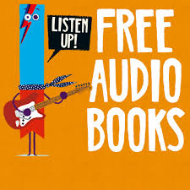  Reading  Make sure that you spend some time reading every day.  Can you create a book review for some of these books?  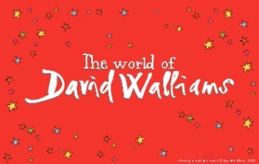  You may enjoy listening to some audio books to! | 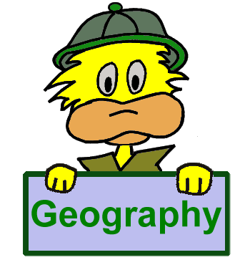  Geography  Select a country to research. You could find out about climate, physical landscape, traditions, culture, food, religion, stories, animals or language.  Display your learning in a creative way to share with your class. | Science  Spend some time watching the interesting videos on BBC Bitesize. Discuss your learning with the people at home. What can you find out? | 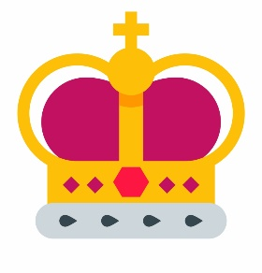  Kings and Queens of Britain  Choose a King or Queen throughout British history to research and choose an interesting way to display your findings. You may wish to choose more than one King or Queen.
Garden Art Attack  Bring out your inner artist and use materials from around the house or garden to create a large scale piece of artwork. | Christian Values  Select one of our Christian values, for example love, truthfulness or peace and create a piece of work to reflect this value. You may wish to compose an acrostic poem, design a poster to encourage this value or write a story featuring this theme. Be creative! | Spring Artwork  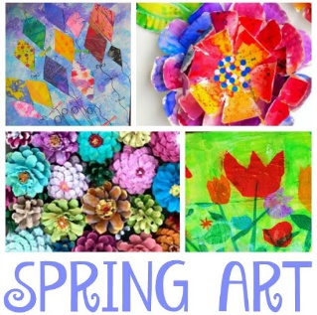  Create a piece of spring artwork for a whole school display (similar to the butterflies that we created). This may be a collage, a 3D design, a model from recycled materials or a painting to depict this season. | 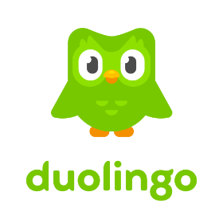  Spanish  Challenge yourself to learn something new in Spanish. How could you share this with a friend? EG: a fact file, a booklet, a drama or a video.

