Aberford Church of England Primary School
School Lane, Aberford, Leeds, LS25 3BU
Tel: 0113 281 3302
Website: www.aberfordprimaryschool.co.uk
Headteacher – Nicola Crossley

Dear Parents and Carers,
We are writing to let you know about our homework policy for this year. Once again, in response to parental questionnaires and from the school report feedback forms, we are slightly adapting the homework tasks set in Key Stage 1 and Key Stage 2.
Each week, your child will have 4 tasks to complete at home. Each of the tasks focus on the key skills for Maths and English and have been considered in response to our priorities in school.
Task 1: Reading
Children need to learn to read as quickly as reasonably possible, so they can move from learning to read, to reading to learn, giving them access to the treasure house of reading, as well as allowing them to access the rest of the curriculum. Reading is a skill that most of us take for granted yet is one that is essential for being able to get on in life. The ability to read not only enables us to discover new facts and to learn at school, but also opens a world of new ideas, stories and opportunities.
Your child will be expected to read each day for at least:
Key Stage 1 = 15 minutes Key Stage 2 = 20 minutes
Please ensure you sign their reading records at least three times a week and send these back in to school every Monday for us to keep our records up to date as we are required to keep track of those children not reading at home and offer additional support where needed. An example of how to complete the reading record is pictured below.
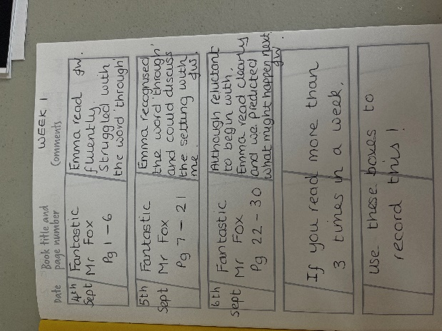
Start a new page at the beginning of each week and if your child reads more than 3 times, use the bottom 2 boxes to record this.

Please note, the children will keep the same reading book for the week to help them to become familiar with it and to build up fluency and more in-depth comprehension. Reading fluency supports reading comprehension and is a vital skill for children to develop.

In Year 1 and 2, the children will bring their Little Wandle reading book home every Wednesday. These decodable books have been carefully matched to your child’s current reading level. When listening to them read the book please remember to give them lots of praise – celebrate their success and where necessary their perseverance!
Tips:
-If they can’t read a word, allow them time to use their sounds to build it up, where necessary help them to build the word or read it to them.
-Re-read sentences with the children to develop rhythm and intonation.
-After they have finished, talk about the book together.
These books MUST be returned every Monday for our Reading Practise sessions to continue each week in school.
In Year 3 - Year 6, the children will be bringing a reading book home every Monday. Please see the VIPERS bookmarks which have been sent home with your child for ways in which you can support the comprehension of their reading. VIPERS are reading skills we use in school and stand for: Vocabulary, Inference, Prediction, Explanation, Retrieval and Summarise. Completing these recommended tasks will support your child with a more in-depth understanding of the texts they read.

Reading Challenge:
We are excited to launch our new reading challenge for this term which has caused much excitement in school! In the back of their homework books, the children have a 100 square which is the key to unlocking different prizes. Each day your child reads (for at least 15 minutes) they can ask an adult to write their initials and the date in the square and shade this in. When 25 ‘reads’ are complete, they will receive a prize. When 50 ‘reads’ are complete, they will receive an even better prize, then the next milestone is 75 and then on to the all important 100 reads where they will be able to choose their very own new book

Task 2: Times table Rockstars
Children will be asked to complete 10 sessions (which equates to 10 minutes) to learn and revise their times tables and associated division facts. This is a key area in Maths and it is important for children to become fluent and confident with these.
Task 3: Arithmetic
In KS2, children will be set 10 arithmetic questions each week for them to complete in order to consolidate their maths learning.
Task 4: Spellings
Children will be having regular phonics and spelling lessons in school each week. They will then be given new spellings to learn which consolidate their learning. It is important that children spend time at home learning and retaining their spelling words to enable them to use these in their future work.
In Class 3 and 4, new spellings will be given on a Friday in homework books for the children to learn and there will be a weekly spelling test in school each Thursday to monitor progress in this area.
In Class 2, new spellings will be given on a Monday in homework books for the children to learn and there will be a weekly spelling test in school each Monday to monitor progress in this area.
Deadlines:
 | Class 2 | Class 3 | Class 4
Reading Books | Due Monday | Due Monday | Due Monday
TT Rockstars | Due Monday | Due Thursday | Due Thursday
Handwriting Task | Due Monday | Due Thursday | Due Thursday
Spellings | Due Monday | Due Thursday | Due Thursday

KS2 Homework Club:
We are excited to inform you that we will be holding a Homework lunchtime club for Key Stage 2 children. This will be run on a ‘drop in’ basis and aims to support children in the completion of their homework tasks. Members of staff will be there to support children who may need additional help or will enable those children to access the online homework tasks such as TT rockstars using the school ipads/laptops. Some children may opt to use the session to learn their spellings for the week or to have some quiet time to read their book. The sessions will take place on:
Monday with Mrs Warner and Miss Brown
Friday with Mrs O’Neill and Mrs Sanpher
Mrs Shaw will support Class 2 children as and when they should require any additional support.
Whilst we understand that there are times when it is difficult to complete homework, if pupils repeatedly fail to complete their homework tasks then they will be expected to attend the homework club sessions to enable them time and support to do this in school time.
Many thanks for your continued support. If you have any questions, please don’t hesitate to contact us.

Yours sincerely
The Aberford Staff Team

