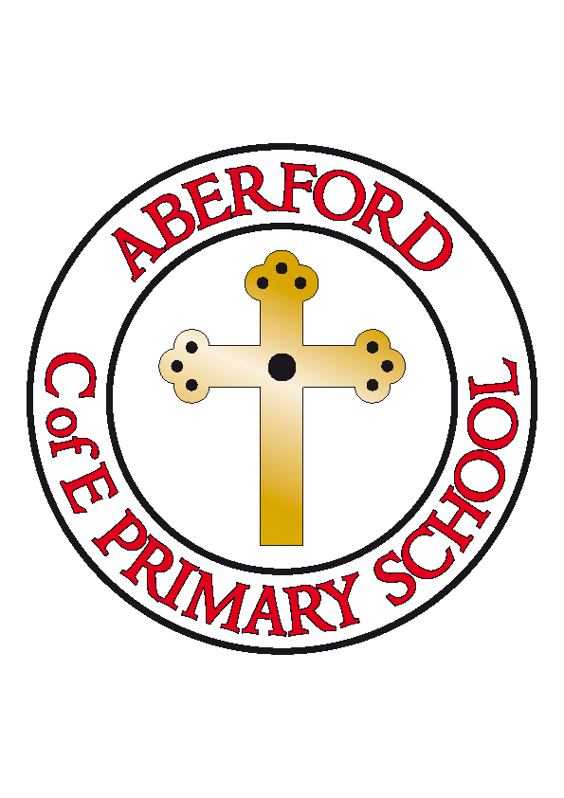
Aberford Church of England Primary School
School Lane, Aberford, Leeds, LS25 3BU
Tel: 0113 281 3302
Website: www.aberfordprimaryschool.co.uk
Headteacher – Nicola Crossley

Dear Parents and children in Year 3, 4, 5 and 6,
We are very aware that this is the half term where we would usually be busily preparing for our end of year, Key Stage 2 production. Sadly, as you are aware, this year we are unable to prepare and stage our usual performance in the village hall in our usual ‘Aberford’ way.
However, we cannot let our children down – particularly our Year 6’s who are missing out on all of our usual ‘end of primary school’ celebrations. And so… THE SHOW MUST GO ON… and so it will, whilst adhering to social distancing measures and ensuring safety of all.
We are planning on a performance with a difference this year, but we still want everyone to be involved if they would like. Our production this year is:
Tuishi Pamoja – A friendship under African Skies
Our Year 6 children have all been given their character/s and we have started to learn some of the songs. We plan on staging this in the classroom and producing a ‘movie’ version of the performance that we can share with you all. Whilst Year 6 children will take the main acting parts, we would like to invite you all to join in at home. Please see how in the instructions below:
- Create an African animal mask. Be as creative as you can
- Unleash your inner artist and produce a piece of amazing African artwork
- Learn some of the songs from the production using our online music scheme (usernames and passwords can be obtained by making a phone call to school and these will be shared for your child)
- You may wish to choose one or all of the activities above. All we need you to do is to complete the task and then ask an adult to take a photograph/video of you either wearing your mask, displaying your art work and/or singing along to one of the songs (a white background would be preferable). Then, send it in to school via the office email. The deadline for all photographs and videos is Friday 3rd July 2020 to provide us with enough time to put the ‘movie’ together. Any work sent in after this date will unfortunately not make the final version.
We will provide details of how you can access our final version later in the term once it is complete. We are very excited to be able to put on such a unique and memorable end of year production and we can’t wait to see the finished product.
If you have any questions or queries, please do get in touch with school.
Many thanks for your continued support,
Mrs Warner, Miss Brown and Mrs Darley

