**Newsletter Class Two**

**WELCOME FROM MRS SHAW…** A very warm welcome back to the new academic year and to all our Year 1 and Year 2 children. Firstly, may I thank you for the lovely gifts and cards that I received at the end of term. The first few days back have been fantastic. I am very proud of how all the children have returned to school particularly the Year One’s as it is a big change for them, but they are rising to their new learning expectations. All the children are settling well into their new routines and learning. I am very much looking forward to the year ahead and I know the children are too. It is going to be a busy half term but very exciting and I know the children are very much looking forward to our first school trip to Abbey House Museum in the next few weeks as this will support our English and history learning. If you have any questions please message me on Class DOJO and I will replay as soon as possible.

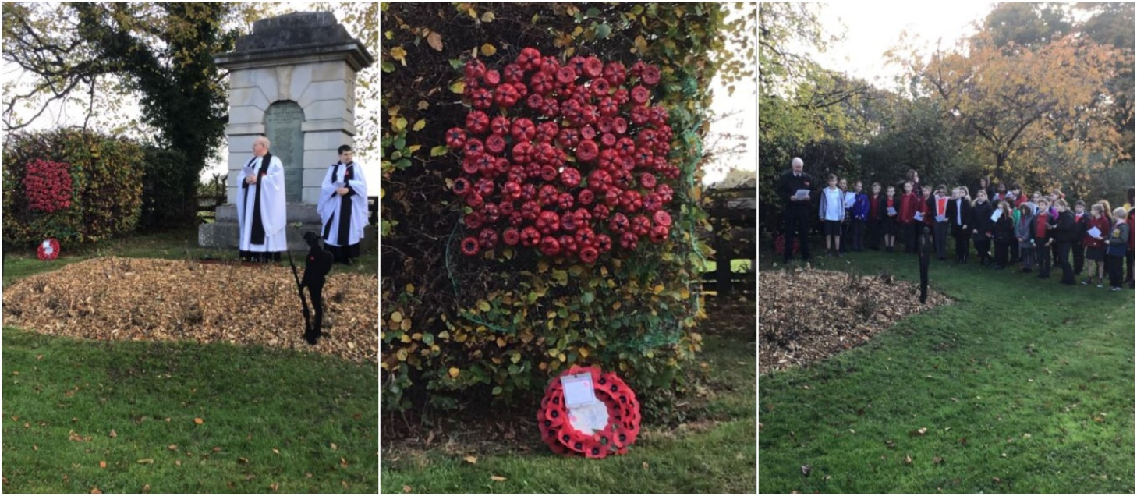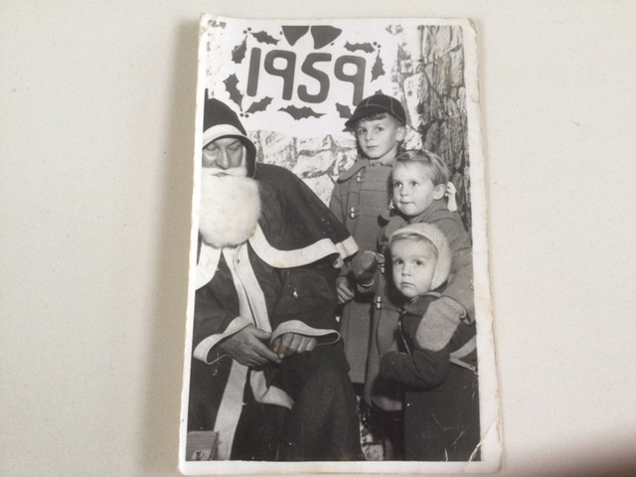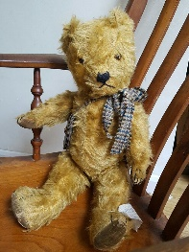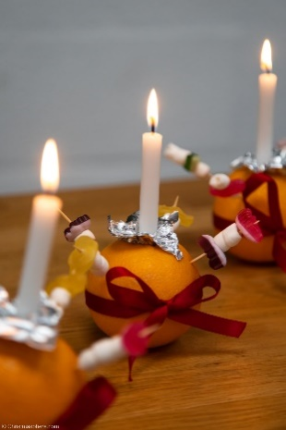

**What will your child need?**

**Reading books** in book bags every day- changed weekly on a Monday.

**Named water bottle –** please only water.

**Homework book-** to be handed in on a Monday. ( See separate homework letter).

Please encourage your child **NOT** to bring in toys from home as this can cause issues with sharing and breakages.

**School uniform –** please follow the school uniform policy.

Name **ALL** school uniform, this allows us to find lost uniform and return it to the child quickly.

**Our class reading book**.

**Dates**

PE -Tuesday/Thursday – please come to school in the correct PE Kit. Hair needs to be tied up, no jewellery apart from a watch.

Wednesday 20th September – KS1 visit to Abbey House Museum.

Friday 29th September – Book Fair

Class Two love reading and if any parent, grandparent would like to volunteer to hear our children read please let me know, thank you.

**Science**

This half term we will learn how to distinguish between an object and the material from which it is made. They also learn how to identify and name a variety of everyday materials, including wood, plastic, glass, metal, water, and rock. They describe the simple physical properties of a variety of everyday materials. And finally, they learn how to compare and group together a variety of everyday materials based on their simple physical properties. A group of images of various materials

**History** Childhood then and now

**Art**

The children will learn different drawing techniques. We will use our local area for inspiration. We will experiment with colour, oil pastels, pencils and blending chalks. What a creative half term we have to look forward too.

Who will be helping us this term?

Mrs Teale

Mrs Darley

Mrs Sadler

Miss Coates

Miss Sharpe will be teaching ICT on a Tuesday.

Michaela/Laura from Castleford Tigers will teach PE on a Tuesday and Thursday.

**RE**

How & why do people pray?

An introduction to how Christians and Muslim prays. As class we will develop an understanding of the importance of prayer to those who belong to that religion.

**English:**

Narrative

Recount through letter writing (from museum visit)

Report writing – history of teddy bears.

Descriptive writing – toy descriptions

Instructional writing linked with DT-making toys.

Poetry focus:

Repeating Pattern Poetry.

Poetry focus:

Repeating Pattern Poetry

Yr 2 Poetry Shed

**Geography:**

This half term we will use simple fieldwork and observational skills to study the geography of our school and its grounds and the key human and physical features of its surrounding environment.

**Maths:**

Lessons will be taught in two different sets.

Year 2 led by Mrs Shaw

Year 1 by Mrs Teale & Mrs Crossley.

Autumn 1 - Place value

- Addition and subtraction

**Music, Computing, PE, Spanish, PHSE:**

Music - Hands Feet Heart

PE – Ball Skills

Computing - Creating Pictures

Spanish – Animals

PSHE -Being in my World.