Yesterday, a report came in that the largest ship had collided with an iceberg. In the early hours of this morning, the humongous Titanic sank and now rests at the bottom of the ocean. Around 1200 people died as they either sank along with the ship or froze to death in the icy waters. The captain, Edward Smith, is said to have gone down with his ship!

by Olivia
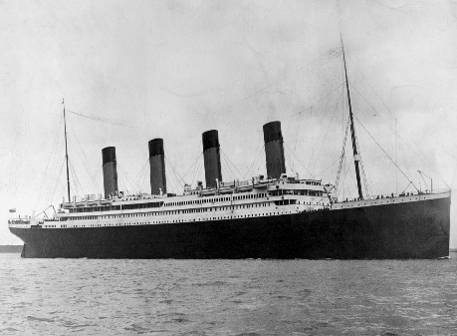
The iceberg smashed a hole into the starboard side (front right) of the ship and six water compartments were rapidly filled, pushing the ship down by the front, slowly pushing the back out of the water. Gradually, the Titanic was stood upright in the water, making the ship sink.

The Titanic lost it’s battle, leaving many survivors freezing on the lifeboats. It is reported that there were not enough lifeboats to fit everyone in. White star line, those who built the Titanic reported that: “This was an ultimate mistake, we heard they were going ‘full speed’ and turned too slowly”. Tragically, many loved ones were lost in the sinking.

