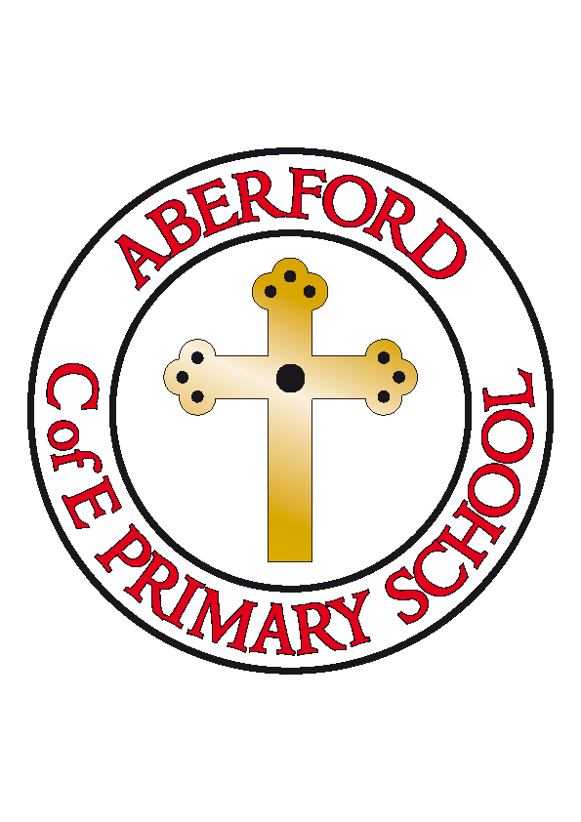Aberford C of E Primary School
PE Grant Expenditure

In 2019-20, the PE Grant is targeted to:
Total number of pupils on roll | 96
Total amount of PE Grant received | £17,000
Nature of support 2019-20
Spent on |  | cost | Projected Impact
Coaching from Castleford Tigers |  | £9,880 | Teaching from professional coaches in a variety of different sports.  After school coaching to allow for children to be selected to take part in competitions with local schools.  Staff expertise developed within school.
Go Tri Event Garforth |  | £250 | Opportunities for children to tryout participating in a Triathlon
Schools’ Yorkshire Tour + Tour De Garforth Cycling Days |  | £250 | Opportunities for children to participate in cycle events with other schools and develop a love of cycling
Healthy Schools programme |  | £699 | Explicit links with Active Schools to promote healthy lifestyles and choices alongside regular activity
Planned opportunities to participate in a wider variety of sporting opportunities – whole school |  | £1500 | Opportunities to trial different sporting activities and develop skills in alternative sports
Big Dance Off competition |  | £405 | Competition opportunity across schools in the wider Yorkshire region
Active Learning Sports Leader |  | £4200 | To target active learning across the curriculum and lead sports during lunchtimes to increase physical activity and improve learning

