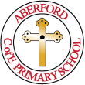
Phonics Policy
Aberford C of E Primary School
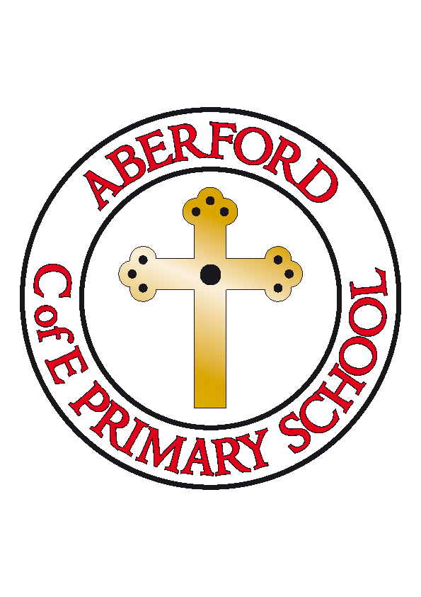

Approved by: | Nicola Crossley | Date: 09.03.2022
Last reviewed on: | March 2022
Next review due by: | March 2023

Contents
1. Intent 2
2. Implementation 2
3. Impact 4
4. The Teaching and Learning of Phonics 5
5. Planning 6
6. Assessment of Pupil Learning and Progression 6
7. Non-negotiables 7

---------------------------------------------------------------------------------------------------------------------------------------------------------------------------

- Intent

At Aberford C of E Primary School, we are committed to the delivery of excellence in the teaching of phonics. We love reading and we strive to ensure that all children become successful and fluent readers by the end of Key Stage One. Being able to read is the most important skill that children will learn during their early schooling and we believe that this is achievable through a combination of strong, high-quality, discrete phonics teaching. We aim for all children to leave school at the end of Key Stage Two with a genuine passion for reading and a ‘reading for pleasure’ culture.

We aim to teach high-quality, synthetic, daily phonics lessons to ensure that children have the best possible start in reading and writing. The learning of phonics is the beginning part of a child’s reading journey and is essential for them to be able to read and understand texts. High-quality phonics teaching allows children to be secure in the skills of word recognition and decoding, allowing them to learn to read fluently. Therefore, resulting in children being able to read for pleasure and developing a passion for reading.

This policy will outline how we teach phonics at Aberford and will give information on our phonics implementation and the impact that our phonics teaching has.

- Implementation

The teaching of phonics at Aberford, starts in Reception and continues through to Year Two. Phonics will continue into Key Stage Two, where necessary, to support those children who do not yet have the phonetical knowledge and skills that they need.

As a school, we have developed our own phonics programme based upon the ‘Letters and Sounds (2007)’ documentation. We have used the ‘Letters and Sounds’ phonics document that was published by the DFE and adapted it to fit into our English curriculum. We also use the Read Write Inc (RWI) mnemonics to support our teaching.

Children in Reception, Year One, and Year Two have high-quality, daily, discrete phonics lessons, where they are taught the sounds from the English language and the different ways of reading and writing these sounds. The correct enunciation of sounds and the modelling of blending are extremely important at Aberford. We ensure that all staff are accurate and effective in their teaching of phonics.

The children have access to a range of reading books and we have ensured that our reading scheme is closely matched to our phonics scheme. Children in Reception and Year One will take a sound book home each week, that includes sounds that they have learnt that week in phonics. They will also take home a fully phonetically decodable book, matched to their stage of phonics. This book will be chosen by the child each week and will support their progression of reading skills and comprehension development. The children will keep these reading books for a week to become familiar with them and to build up their fluency. This is extremely important in a child's reading development and doing this at home gives them a chance to consolidate their reading in a relaxed environment. We recommend that children and parents/carers use this timetable at home when reading their decodable books:

- Monday - Discuss the front cover, the title, and the blurb. Make predictions about what might happen and then read the book with help (if needed).

- Tuesday - Recap what the book was about. Re-read the book independently. Were your predictions correct? Discuss your favourite characters and parts of the story.

- Wednesday - Re-read the book independently and then answer some of the VIPERS questions provided.

- Thursday - Read the book using a 'storyteller' voice. Try to use expression and different voices for each character.

- Friday - Re-read the book confidently for a final time. Try hard to use expression, different voices, tone, and pitch.

Children in Year Two will also take home a reading book each week. This will help to develop their fluency and will include previously learnt phonic sounds and newly learnt phonics knowledge to embed their learning. By Year Two, children will be onto Phase 6 phonics and they will be reading with much more fluency. They will start to read words in three different ways; reading automatically, decoding in their head, and decoding unfamiliar words out loud. They will be building up their list of known words and high-frequency/tricky words and will have a bank of strategies for sounding out unfamiliar words. Our reading scheme supports this development and allows children to read longer fiction and non-fiction texts.

For any children still working on phases 2-6 in Year Three or beyond, we provide individualised interventions to diminish gaps and accelerate progress for these children.

- Impact

We ensure a progression of skills in Phonics throughout Reception and Key Stage One.

Age-Related Expectations for the end of the school year:

By the end of Reception, children should:
- Say a sound for each letter in the alphabet and at least 10 digraphs.
- Read words consistent with their phonic knowledge by sound-blending.
- Read aloud simple sentences and books that are consistent with their phonic knowledge, including some common exception words.
- Write recognisable letters, most of which are correctly formed.
- Spell words by identifying sounds in them and representing the sounds with a letter or letters.
- Write simple phrases and sentences that can be read by others.

By the end of Year One, children should:
- Apply their phonic knowledge and skills as the route to decode words.
- Respond speedily with the correct sound to graphemes (letters or groups of letters) for all 40+ phonemes, including, where applicable, alternative sounds for graphemes.
- Read accurately by blending sounds in unfamiliar words containing GPCs that have been taught.
- Read common exception words, noting unusual correspondences between spelling and sound and where these occur in the word.
- Read words containing taught GPCs and –s, –es, –ing, –ed, –er, and –est endings.
- Read other words of more than one syllable that contain taught GPCs.
- Read words with contractions [for example, I’m, I’ll, we’ll], and understand that the apostrophe represents the omitted letter(s).
- Read aloud accurately books that are consistent with their developing phonic knowledge and that do not require them to use other strategies to work out words.
- Re-read these books to build up their fluency and confidence in word reading.

By the end of Year Two, children should:

- Continue to apply phonic knowledge and skills as the route to decode words until automatic decoding has become embedded and reading is fluent.
- Read accurately by blending the sounds in words that contain the graphemes taught so far, especially recognising alternative sounds for graphemes.
- Read accurately words of two or more syllables that contain the same graphemes as above.
- Read words containing common suffixes.
- Read further common exception words, noting unusual correspondences between spelling and sound and where these occur in the word.
- Read most words quickly and accurately, without overt sounding and blending, when they have been frequently encountered.
- Read aloud books closely matched to their improving phonic knowledge, sounding out unfamiliar words accurately, automatically, and without undue hesitation.
- Re-read these books to build up their fluency and confidence in word reading.

- The Teaching & Learning of Phonics

The teaching of phonics starts in Reception with Phase 1 and Phase 2. It then continues into Year One, Year Two and where necessary, Key Stage Two. The phonics phases are taught in the following way:

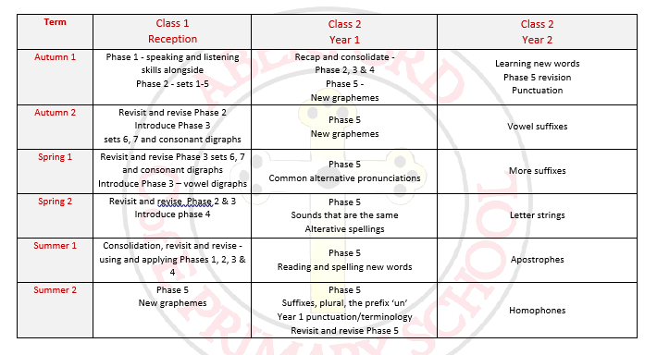
However, we are aware that within each year group, there may be children who are not working at the phases that are outlined above. This may be because they are working above or below their age-related expectations and we ensure that we cater to every child’s individual needs.

In Reception, phase 1 phonics is embedded throughout the day during the first half term. This runs alongside phase 2, as we have found that most children start Aberford with a good awareness of phase 1 phonics from their previous settings.

In Reception and Key Stage One, we teach daily phonics lessons. These lessons are short and fast-paced and the children are mostly taught in their year groups. This allows us to ensure that all children are being exposed to all sounds regardless of their ability, background, or learning needs. Some children will then have additional phonics sessions or interventions to support them in their learning. The sounds are introduced using the Read Write Inc. mnemonics and flashcards, which have engaging pictures, rhymes, and actions. We find that these are highly effective in helping children to remember each new grapheme-phoneme correspondence. These sounds are displayed in the classrooms and are referred to throughout the day.

By the end of Year Two, the majority of children will have completed all of the six phases of our phonics programme. For those children who are not secure with phases 1 to 6, they will continue to receive targeted phonics teaching and interventions into Key Stage Two.

- Planning

At Aberford, we have developed our own long-term, medium-term and weekly phonics planning to ensure progression and high-quality phonics teaching. All long-term and medium-term planning can be found on our school website. All of our phonics planning follows the National Curriculum, Development Matters, and The Early Years Foundation Stage Profile, to ensure skill progression and maximum impact.
Teachers and the phonics curriculum leader alike, plan for and deliver short, fast-paced, and high-quality daily synthetic phonics sessions. All sessions follow the ‘Letters and Sounds’ format of:
- Revisit/Review – where previously learnt letters and sound are revisited through flashcards. Oral blending/word reading may also be recapped.
- Teach – a new sound is taught using the Read Write Inc. flash cards.
- Practise – practise reading and writing the new sound and words with the new sound in.
- Apply – read or write a caption, words or sentence with the new sound in. Could include previously learnt tricky words.
- Tricky words – learn a new tricky word and play a tricky word game/complete a tricky word activity from the weekly planning.

- Assessment

Assessment is regarded as an integral part of teaching and learning and is a continuous process. We strive to make our assessment purposeful, allowing us to inform our planning and therefore benefit the pupils and ensuring progress. Each child from Reception, Year One, Year Two, and any child still on the phonics programme in Key Stage Two, has their own phonics tracker. These trackers are updated every half term and continue to be updated as the children move through school. The phonics trackers that we use are both discrete and assess reading and writing knowledge from phonics sessions.
At the end of Year One, children participate in the phonics screening check which assesses their knowledge of grapheme-phoneme correspondence and their skills in blending. This information is submitted to the Local Authority and is used to inform planning for their next half term and academic year. Those children who do not succeed in the phonics screening check, are given further interventions and receive targeted support before completing the phonics screening check again at the end of Year Two. For children who do not succeed a second time, provision is made for them to receive intervention and targeted support in Key Stage Two.

Teachers provide feedback to pupils during each lesson. They also provide feedback to parents regularly about their child’s progress and achievements. This happens at parents evenings and through the end of year report. Assessment information and data is also passed onto the next teacher as part of end of year transition meetings.

- Non-negotiables

At Aberford, we have a non-negotiables phonics document for all staff to use.

Key Language
This language is used in every lesson and is discussed with the children regularly.

Language to use | Meaning
Phoneme | Smallest unit of a sound in a word.
Grapheme | A way of writing down a phoneme. Can be 1 letter, 2 letters, 3 letters or 4 letters.
Digraph | Two letters that make one sound.
Consonant digraph | Digraph made up of 2 consonants. EG: sh.
Vowel digraph | Digraph made up of 2 vowels. EG: ea.
Split digraph | A digraph that is split between a consonant. EG: cake.
Trigraph | Three letters that make one sound.
CVC word | Consonant, vowel, consonant. EG: dog, cat, mop, fin.

Modelling
We model using the phrase ‘my turn, your turn’. As we say the phrase, our hands model it, ‘my turn’ – hand to chest. ‘Your turn’ – hand to the children on the carpet.

Rhymes and Mnemonics
These are the rhymes that we use for each sound that is introduced:

Sound | Rhyme
a | Round the apple and down the leaf (apple)
b | Down the laces to the heel, round the toe (Boot)
c | Curl around the caterpillar ( caterpillar)
d | Round his bottom, up his tall neck and down to his feet (dinosaur)
e | Lift off the top and scoop out the egg (egg)
f | Down the stem and draw the leaves (flower)
g | Round her face, down her hair and give her a curl (girl)
h | Down the head to the hooves and over his back (horse)
i | Down his body, and a dot for his head (insect)
j | Down his body, curl and dot (Jack in the box)
k | Down the kangaroo’s body, tail and leg (kangaroo)
l | Down the long leg (leg)
m | Down Maisie, over the mountain, over the mountain (Maisie and mountains)
n | Down Nobby, over his net (football net)
o | All around the orange (orange)
p | Down his plait and around his head (pirate)
q | Round her head, up past her earrings and down her hair (queen)
r | Down his back, then curl over his arm (robot)
s | Slither sown the snake (snake)
t | Down the tower across the tower (castle tower)
u | Down and under, up to the top and draw the puddle (umbrella)
v | Down a wing, up a wing (vulture)
w | Down up, down up (worm)
x | Down the arem and leg and repeat the other side (exercise)
y | Down a horn, up a horn and under his head (yak)
z | Zig – zag- zig (zip)
Bouncy vowels |  | Bouncy consonants | Stretchy consonants

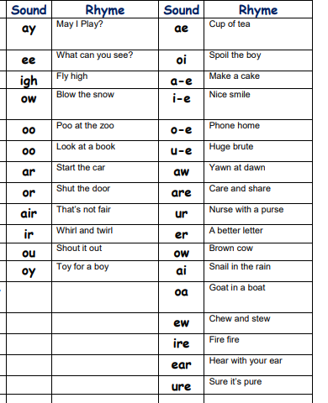

This phonics policy will be reviewed regularly by the phonics curriculum leader and Head Teacher.

