Aberford C of E Primary School
Poetry throughout school 2022-2023

EYFS
Poems to Share | Rhymes, Poems and Songs to Perform
Poems Out Loud - L Stansfield  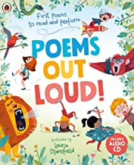  Zim Zam Zoom - J Carter & N Colton  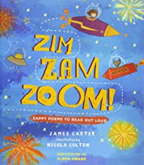 | Clap, clap hands, 1, 2, 3.  Head, shoulders, knees, toes.  If you’re happy and you know it.  The magic porridge pot.  Polly put the kettle on.  In and out the dusty bluebells.  5 little men in a flying saucer.  5 currant buns.  5 little monkeys.  One elephant went out to play. 5 little ducks went swimming.  Row, row, row your boat.  Twinkle, twinkle little star.  The wheels on the bus.  Wind the bobbin up.  The bear went over the mountain.  Old McDonald had a farm.  10 fat sausages sizzling.  10 green bottles.  10 in a bed.  Wiggly woo.  The animal fair.  The animals went in 2 by 2.  Down in the jungle.  Hey diddle, diddle.  Dinosaurs.  A sailor went to sea.  Rub, a, dub, dub.  There’s a hole in the bottom of the sea.  When I was one. Incy Wincy Spider Dingle Dangle Scarecrow Grand Old Duke Humpty Dumpty Oat and Beans and Barley Grow

Year 1
Poems to Share | Poems to Perform | Poems to Read | Poems to Write
Perfectly Peculiar Pets -  E Woollard & A Boretzki  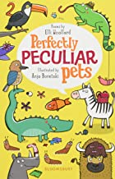  A First Book of the Sea -  N Davies & E Sutton  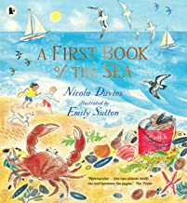 | Water  - Shirley Hughes  Rickety Train Ride  - Tony Mitton  ‘Emus’  Roger McGough  ‘What a Fandango’  Michael Rosen  ‘No Breathing’  Michael Rosen  Wildlife Rules  (Poetry Shed) | Spaghetti! Spaghetti!  Jack Prelutsky  Feasts  Shirley Hughes  Chocolate Cake  Michael Rosen  Nook of Nonsense  Michael Rosen | Acrostic  An acrostic is a poem in which the first letters of each line spell out a word or phrase. Usually, the first letter of each line is capitalised. Acrostics do not have to rhyme and there is not set length or rhythm for each line.  Free Verse  Free verse poems have no rhyming structure and often don't have a particular rhythm or syllable patterns. Poets use line breaks, punctuation and the use of shorter and longer lines to convey meaning.  List poems  A list poem collects content in a list form. It can be purely a list without any transitional phrases. List poems don't have any fixed rhyme or rhythmic pattern – this is the poet’s choice.  Riddles  The poem describes a noun without giving the reader the name of the object. Clues are given throughout the poem and the last line will address the reader with a question. E.g. ‘What am I?’. The first clues should be more difficult and general, and the final clues will become easier and allow the  reader to guess what the topic of the poem is. It is usually written in the first person. Each line starts with a capital letter. Lines end with a full stop, except for the last line, which will end with a question mark. The mood of the poem is often light-hearted

Year 2
Poems to Share | Poems to Perform | Poems to Read | Poems to Write
Tiger Tiger Burning Bright  - Fiona Waters  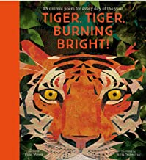  Midnight Feasts: Tasty poems chosen by A.F. Harrold  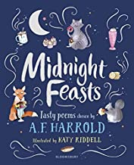 | Daddy Fell into The Pond –  Alfred Noyes  Cats Sleep Anywhere –  Eleanor Farjeon  ‘Conquer’  Joseph Coelho  What a poem’s not’  John Hegley  Tails  Poetry Shed  Heroic Tiny Creatures  Poetry Shed  Dispose of your waste responsibly  Poetry Shed  If I were…  Poetry Shed | Footprints in the Sand – B Williams  A Tiny Burning Flame - Unknown  Owl and the Pussy Cat – E Lear  My Lonely Garden from Take off Your Brave  – Nadim (aged 4)  Cobwebs – Unknown  Please Mrs Butler  Allan Ahlberg | Diamante  A diamante is an unrhymed seven-line poem. The first and seventh line of the poem have one word and this word is a noun. The second and sixth lines have two words and these are adjectives connected to the first noun. The third and fifth lines have three words and these are verbs. The fourth line has four words and these are nouns.  Free Verse  Free verse poems have no rhyming structure and often don't have a particular rhythm or syllable patterns. Poets use line breaks, punctuation and the use of shorter and longer lines to convey meaning.  Shape poems  The poem is written in the shape of the object it is describing. The shape adds to the meaning of the  poem and can be presented with the words written inside a shape or the outline of the shape is created  using the words from the poem. A shape poem does not need to rhyme and does not follow a set  structure. Each line starts with a capital letter. Lines often end with a comma or full stop  Repeating patterns  Poems with repeated patterns or rhyme are effective in making the main idea of the poem more memorable. These poems use a figurative language feature known as repetition and this helps to draw the reader’s attention to a thought, feeling or idea within the poem. Each line starts with a capital  letter. Typically, each line ends with a comma or full stop. The children will most often see this poem type in nursery rhymes.

Year 3
Poems to Share | Poems to Perform | Poems to Read | Poems to Write
I Am the Seed That Grew the Tree -  F Waters & F Preston-Gannon  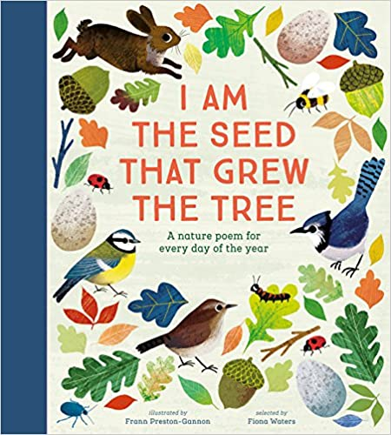  Stars with Flaming Tails -  Valerie Bloom  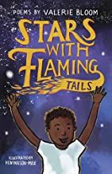 | The Sound Collector -  Roger McGough  The Adventures of Isabel -  Ogden Nash  ‘You’re Called What?’  Kes Gray  Poetry Pie  Roger McGough  Asp  Poetry Shed  A Dodo’s message  Poetry Shed  Sharks  Poetry Shed  Ocean Rhyming  Poetry Shed  ‘My Heart is a Volcano’  Valerie Bloom | The Dragon of Andor –  Reading Explorers  Mr Moore –  David Harmer  Ghost in the Garden -  Berlie Doherty  The Small Dragon -  Brian Patten  If Anger was an Animal -  The Emotional Menagerie  The Witch of Axon -  Reading Explorers  My Brother Might be Bigfoot-  Kenn Nesbitt  The Listeners  Walter de la Mer | Limerick  The poem is five lines in length and follows the rhyme scheme AABBA.  The first line usually begins with ‘There was a...’ and ends with the name of a person or place. The last line  should be rather unusual or far-fetched. The last line often ends with the same word as the first.  Each line starts with a capital letter. Lines often end with a comma. The mood of this type of poem is comic,  and it can even be nonsense.  Kennings  A kenning is a two-word phrase which describes an object. The two words are joined using a hyphen. Kenning poems are a type of riddle, and they are commonly used in poetry to describe something without stating what it is. Kennings use metaphors to describe the object. Each line within the poem will consist of one kenning and the kennings should be ordered based on the impact they have on the  reader. There is no set number of lines in each verse. Each line starts with a capital letter and no punctuation is required at the end of each line  Quatrains  The poem is four lines in length and is a rhyming poem. The rhyming pattern of this poem can differ, with the most common pattern being the AABB or ABAB rhyming pattern. Each  line starts with a capital letter. Lines often end with a comma or full stop. Several quatrains can be used together to create a longer poem  Question and answer poetry  The poem uses repeated questions to create a dramatic effect. The poet then answers each of the questions using rich vocabulary. Figurative language features, such as alliteration, similes and metaphors may also be used in the poem. There is no set structure or rhyming pattern. Each line starts  with a capital letter; questions end with a question mark and the answers end with a full stop  Free Verse  Free verse poems have no rhyming structure and often don't have a particular rhythm or syllable patterns. Poets use line breaks, punctuation and the use of shorter and longer lines to convey meaning.  Clerihew  A clerihew is usually a humorous poem written about a specific person. It is a four-line comic verse with two rhyming pairs of lines with the rhyme scheme AABB. The First line of the poem will include the name of the person about whom the verse is written.
1

Year 4
Poems to Share | Poems to Perform | Poems to Read | Poems to Write
Where Zebras Go – S Hardy-Dawson  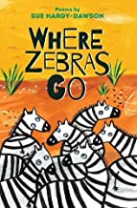  This Rock, That Rock - D Conlon  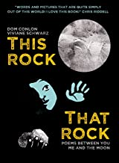 | Granny’s Sugarcake – John Lyons  From a Railway Carriage – R L Stevenson  Koala  Poetry Shed  Ocean Theft  Poetry Shed  Jungle Rain  Poetry Shed  ‘To the Last Dinosaur Standing’  Kate Wakeling  ‘The Land of Blue’  Laura Mucha  ‘Little bit of food’  Joseph Coelho | It Couldn’t Be Done - Edgar A Guest  Hey Diddle Diddle  The Jaberwocky – Lewis Carroll  The Magic Box  Kit Wright | Nonsense poetry  Nonsense poems are poems that intentionally do not make a lot of sense. They can include made-up  words, nonsensical ideas or can be contradictory. There is no set structure or rhyming pattern, but often  nonsense poems do rhyme. Each line starts with a capital letter and lines typically end with a comma or  full stop.  Tanka  The poem is five lines in length and follows a strict syllable pattern. The entire poem consists of 31 syllables  Each line starts with a capital letter but there is no ending punctuation. The poem does not follow a rhyming  pattern. The poem typically presents a whole story.  Haiku  Haikus originate from Japan, are three lines in length and follow a strict syllable pattern. Each line starts with a capital letter. Lines can end with a comma, full stop or no punctuation mark. The mood of this type of poem is generally serious and they can relate to a range of themes, including nature or love.  Cinquain  The poem consists of five unrhymed lines and follows a strict syllable pattern. Each line starts with a capital letter but typically, there is no ending punctuation. The poem tells a story,  includes an action and feeling and has a conclusion  Simile/metaphor  A simile and metaphor poem is a poem which includes these two figurative language features to create  an image in the reader’s mind. Similes compare something to something else using the words ‘like’ or  ‘as’, whilst metaphors use a direct comparison by saying that it is the thing it is being compared to.  There is no set structure or rhyming pattern to simile and metaphor poems. Each line starts with a  capital letter. Lines often end with a comma  Free verse  Free verse poems have no rhyming structure and often don't have a particular rhythm or syllable patterns. Poets use line breaks, punctuation and the use of shorter and longer lines to convey meaning.

Year 5
Poems to Share | Poems to Perform | Poems to Read | Poems to Write
Welcome to My Crazy Life – J Seigal  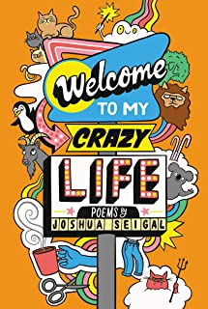  Bright Bursts of Colour – M Goodfellow  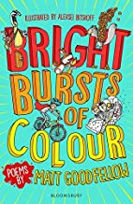 | Leisure –  W H Davies  Walking with My Iguana –  Brian Moses  Plural Nonsense  Poetry Shed  Built in adolescence  Poetry Shed  Warm Up  Poetry Shed  Conversation with a tree  Poetry Shed  ‘Pockets’  Ruth Awolola  ‘Thought Machine’  Laura Mucha  ‘Put the Kettle On’  John Agard  ‘You Look Like A Rainbow’  Joseph Coelho  Didgeridoo  Roger McGough  59  Harry Baker  ‘We can be more’  Solli Raphael | Storm in a Rainforest –  Sally Garland  Autumn leaves –  James Mcinerney  The Sky Artist –  Grace Nichols  The British –  Ben Zephaniah  Whispering Waves –  National Poetry Library  Twas the night before Christmas - Clement Clarke Moore  A Poem to be Spoken Silently –  Pie Corbett  The Highwayman  Alfred Noyes  Jabberwocky  Lewis Carroll  The Sick Rose  William Blake | Narrative poetry  Narrative poems are poems which tell a story and are often longer than traditional poems. They include key  story elements such as: a setting; characters; dialogue and a clear plot line, consisting of a conflict and  resolution. The aim of a narrative poem is to entertain the reader and to leave them with a story to remember.  Each line starts with a capital letter. Lines often end with a comma or full stop. The mood of this type of poem is  more serious. Narrative poems consist of a range of poetic and figurative language  Figurative Poetry  A figurative language poem is a poem which includes a range of figurative language techniques for effect.  Figurative language often compares something to something else to create a vivid or emotive image in the  reader’s mind. These poems do not follow a set structure or rhyming pattern. Each line usually starts with a  capital letter. Lines often end with a comma or full stop  Monologue  Monologues are used in plays, books and films and are a long piece of speech, which will be spoken by one  actor/character. They can be comical or can be more serious, where a character is complaining, talking or being dramatic. Other characters may be included in this piece of writing, but there will only be one character speaking aloud. Monologues are effective in showing a character’s thoughts and feelings in more detail, allowing the audience to see the scene through the eyes of that specific character. There are two types of monologues –  • Internal monologue – This happens inside a character’s head and gives the reader an idea of what the  character is thinking and feeling.  • Dramatic monologue – This is usually performed to an audience and involves the character’s opinion on  what is happening.

Year 6
Poems to Share | Poems to Perform | Poems to Read | Poems to Write
The Lost Words –  R Macfarlane & J Morris  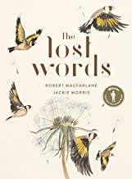  Belonging Street – M Coe  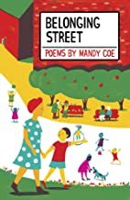 | The River – Valerie Bloom  In Flanders’ Fields – John McCrea  24 Hours of Reality  Amanda Gorman  Proximity  Darius Simpson  Plastic Bag  Poetry Shed  The Last Rhino  Poetry Shed | The Book –  Michael Rosen  My Grandma's Bonsai Tree –  Ben Mayoh  The Highwayman –  Alfred Noyes  The Listeners –  Walter de la Mare  The Hill We Climb –  Amanda Gorman  Raven –  R Macfarlane  Cloud Busting –  Malorie Blackman  The Tyger  by William Blake  The Owl and the Pussycat  Edward Lear  Shakespeare | Classics  Classic poems are poems which have appealed to and have been read by readers over a long period of time. These poems will have been written many generations ago and are still loved and read today. A range of emotions are included in a classic poem. Classic language will be used in this style of poetry. Each line starts with a capital letter.  Lines often end with a comma or full stop, but there are no set punctuation rules to this type of poem. Classic  poems consist of a range of poetic and figurative language  Sonnets  The poem is fourteen lines in length and each line is made up of 10 syllables (iambic pentameter). The themes of this poem are usually love, beauty, hate, separation, jealousy and the passing of time. There are two types of sonnets –  • Shakespearean sonnets are split into three quatrains, following the ABAB, CDCD, EFEF rhyming pattern. The  last two lines of the poem form a rhyming couplet.  • Petrarchan Sonnets begin with eight lines, known as an octave, where a problem or question is presented.  The ninth line is a volta, where the tone of the poem changes. The final lines respond to the problem or  question. The rhyming pattern can vary in this type of sonnet.  Each line starts with a capital letter and ends with varied punctuation marks (commas, question marks, colons, semi-colons and full stops  Free Verse  Free verse poems have no rhyming structure and often don't have a particular rhythm or syllable patterns. Poets use line breaks, punctuation and the use of shorter and longer lines to convey meaning.  Narrative  Narrative poems tell a story, usually about a very specific moment in time. They can be written in rhyme and with strict rhythmic pattern but are most often in free verse.

