Reception Home Learning Tasks – Sheet 2
Ideas for Physical Development
Cut out a circle, square, rectangle and triangle and stick in in your book | 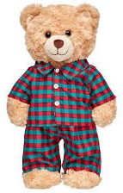  Button up a t-shirt that you have put on your teddy | Practice your name using pre-cursive writing
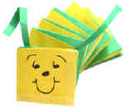  Make a concertina caterpillar by folding paper | Make a den in  your house | 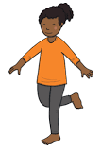  Hop on each leg for 10 seconds
Count how long it takes you to run around the garden. Can you beat it next time? | Wash your hands whilst singing happy birthday | Find me 3 “healthy foods” and 3 “treat” foods. Can you name each one
Make a ball and bucket – can you get the ball in the bucket 5 times in a row? | Write the day of the week, keeping your letters on the line | Paint me a picture of a caterpillar or a butterfly

Ideas for wider activities
With help, make a family tree back to your great grandparents | Find me something soft, hard, rough and fluffy and write a sentence about each object | Make a picture of a flower, labelling the parts of the flower
Watch Rabbit Foo Foo and watch Wonky Donkey | 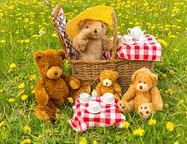  Host a teddy bears picnic | Record yourself performing a dance to your favourite song
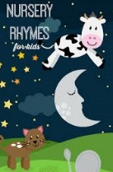  Sing a nursery rhyme | Write down facts about your favourite animals | 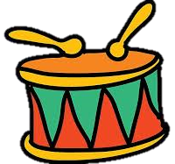  Make a musical instrument and play along to your favourite song
Draw a picture of Lotherton Hall or the National Railway Museum York | 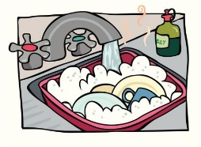  Help mum and dad wash the dishes | Clean your bedroom to help your grownups!

Ideas for English
Write a list of teddies names using phase 2 and 3 phonics” | 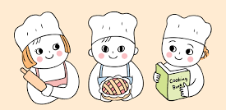  Read a recipe to help your grown-ups do some cooking | Write a shopping list for mum and dad
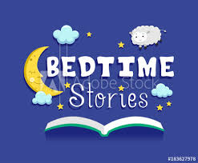  Help your grown up read you a bed time story | Make a set of digraph/trigraph words cards to practice reading them | Make a card for a friend you miss  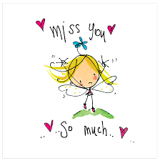
Play scrabble with a family member. (or a similar game) | 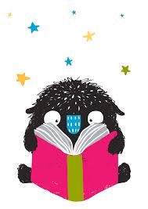  Record yourself reading your story book from your book bag | Read and spell 5 “tricky” words
Play I spy and write down what you can see. | Re-write your favourite story. Can you include story language? | Write a sentence about your family and pets.

Ideas for Maths
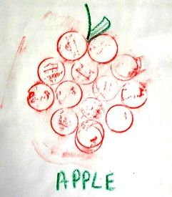  Count out 20 coins and make a  coin  rubbing picture | Show me the number bonds of 5 and 10 using teddies and toys | 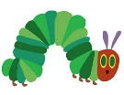  Make a new version of ‘The Very Hungry Caterpillar’ with a new number of fruits eaten. Draw the pictures
Show me one less than 10 | Make a rocket and launch it counting back from 20 | Fill up 3 cups showing me “empty, half full and full”
Count and write down how many spoons and forks you have in the house | Make a repeating pattern using 3  colours | 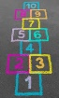  Play hopscotch and count your jumps forwards and backwards
Draw a circle and colour in half of it | Line up your shoes. How many pairs do you have? You will need to count in 2s | Keep a tally of how many days you are not in school  - Mrs Shaw

