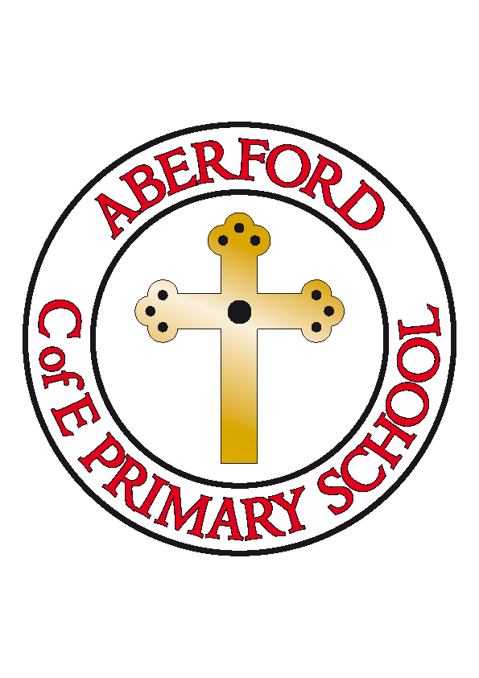
Aberford Church of England Primary School
School Lane, Aberford, Leeds, LS25 3BU
Tel: 0113 281 3302
Website: www.aberfordprimaryschool.co.uk
Acting Headteacher – Joanna Warner

26th May 2020
Dear Parents,
Firstly, we would just like to thank you for your continued support, understanding and patience during this time of uncertainty. We understand that this is a difficult time for us all and that some of our families have been faced with very hard decisions. As always we want to do the very best for our Aberford family and have been planning our potential re-opening in the safest, most manageable way, always with the children at the forefront of everything we do.
As you can imagine, we have been inundated over the last few weeks with guidance from the government, the Department For Education, Leeds City Council and Health and Safety teams, all of which has been updated and somewhat changed on a daily basis. You will have read the letter from Leeds City Council (dated 20/05/20) which clearly states that they... “have asked head teachers to look at the situation in their own school and decide what is safe for your child.” They… “do not expect that all schools in Leeds will be in a position to welcome back all children in the eligible year groups due to each school’s unique set of circumstances.”
Here at Aberford, we are in a position to be able to open our doors from Tuesday 2nd June (Mon 1st June remains an inset day for essential staff training) to the key year groups - reception, year 1 and year 6 - if and when the government advises us to do so. Every staff member is presently in a position to return to work and we are eager to welcome some our children back when we are told it is safe to do so.
Although we are yet to be given official permission to re-open, following our telephone conversations with parents of the key year groups, we wish to give you a further understanding of our planning so far. We understand that school will seem very different with the measures we have put in place and will certainly not be the same as before we were asked to close, but as always, our staff team will endeavour to make this as much of an ‘exciting adventure’ as we possibly can.
The following pages set out some of the main plans we have had to put in place to ensure we are re-opening in the safest possible way for both our children and staff. We would ask you to read these carefully and if you have any further questions, please don’t hesitate to get in touch.
Please note that this is of course subject to change should any further guidance or advice be released and of course if our situation within school changes. We will review our plans on a regular basis. As always, we must continue to remain flexible and be adaptable, particularly in such unprecedented times. School staff have the right to make changes as they deem appropriate.

After reading the following, we would ask families for each key year group (reception, year 1 and year 6) to confirm if your child/ren will be returning to school on Tuesday 2nd June, should this be our opening date. Please do this in writing via email to: office@aberfordceprimary.org.uk as well as providing an indication as to whether you wish your child to receive a school meal (grab bag) or whether they will be bringing in their own packed lunch. We ask for this to be sent before Friday 29th May 2020 to enable us to keep up-to-date records.
Once again, we would like to thank you for your understanding and support as we enter this very new and different way of working. If there are any changes in the meantime, we will inform you immediately. We wish you all a lovely half term.
Best wishes and stay safe,
Mrs Warner and Mrs Crossley
(Acting Headteacher) (Headteacher from 1st June)
Our current plans, based on the most up-to-date guidance, are as follows:
Organisation of Groups:
- Children returning to school will be placed into a ‘bubble’. This will be a group with a maximum of 15 children.
Due to the number of children due to return the week commencing 2nd June, and recommendations from the Health and Safety team, children at Aberford will be split into 3 bubbles.

Bubble 1: Year 6 children Staff = Mrs Warner, Miss Brown, Mrs Darley

Bubble 2: Reception and Year 1 children Staff = Mrs Shaw, Mrs Jones, Mr Thomas,
Mrs Mcnally

Bubble 3: Key worker children Staff = Mrs O’Neill, Mrs Teale
(From Year 2, 3, 4, 5)

-Children and staff will remain in their own bubble throughout the school day. They will not mix with anyone from a different bubble
-Outside areas will be divided into sections for each bubble in order for as much outdoor learning as possible, as well as to allow for break times
-Resources and equipment will be minimised – to allow for thorough cleaning at the beginning and end of each day – and will be kept within each specific group. Older children will be given an individual pack of resources (pens/pencils etc) which will be used by only them throughout the half term
-Staff from each bubble will not mix with each other and separate staffrooms and toilet access have been arranged accordingly
-If numbers change, we may be required to change the organisation of these bubbles

-Although we will endeavour to socially distance as much as possible, guidance recognises that this cannot be guaranteed within a primary school setting

Drop off and Collection:
- We will be operating a staggered start and finish time each day to enable the safest possible drop off and collection of the children. This is as follows:

Year 6 and Arrive 8.40am – 8.50am Depart 3.00pm – 3.10pm
Key Worker children

Reception and Arrive 8.50am – 9.00am Depart 3.10pm – 3.20pm
Year 1 children

-It is important that you do not arrive any earlier than your allocated slot
-If you are running a little late, please let Mrs Goddard know as soon as possible and she will arrange a separate safe drop off time for you
-Class teachers will greet the children one by one at the gate and welcome them into school at the beginning of the day. At the end of the day, they will deliver your child back to you in the same way. We request that you wait on the school drive – at a two metre distance – and we will send the children out to you on the basis of the ‘queue’
-We would like to suggest that we operate a one-way system outside school grounds. As much as possible, please ensure that you enter school via the school driveway, wait against the right hand side wall (at a 2 metre distance) and once your child has been dropped off/collected, exit via the ginnel onto main street (opposite the village hall). If this is not possible, we politely request that you acknowledge the social distancing rules, for the safety of both our staff and other parents
-Guidance requests that only one parent drops off and collects their child/ren. We do understand if siblings need to be brought along due to no other childcare but this should be minimised where possible
-Parents will not be allowed on school premises or inside the school building without a prior appointment
Lunchtime Arrangements:
- The children will not be allowed to bring any bags or other equipment into school, other than a packed lunch (if this is their meal choice) and a full named water bottle. Lunches in a disposable bag are preferable. Please note, there will be limited access to drinking water in school and the water fountain is clearly out of bounds! It is important that all children bring sufficient to drink throughout the school day.

-We have been working closely with Catering Leeds, and to begin with, they will be providing a ‘grab bag’ option for those children opting for a school meal. This is subject to change as the half term progresses and we will of course provide you with any further information as we receive this. We have been advised by Catering Leeds that children who receive a school meal will not be provided with a drink
-If you would rather send a packed lunch into school for your child, please could you inform us as soon as possible so we have accurate numbers for our catering staff.
-Children will eat their lunch in the classroom. They will be allocated an hour lunchbreak outside (weather permitting) within their specific group.
Health and Safety:
- Our precautionary measures will be similar to those followed before Lockdown:
-Promoting regular handwashing and the ‘catch it, bin it, kill it’ approach. Children will be expected to wash their hands when instructed to do so by a member of staff.
-Regular cleaning of settings and resources, including door handles, table tops, play equipment and toys etc.
-Minimising contact and mixing through smaller group sizes and through staggered break times, drop off and collection times
-Making sure that children do not attend if they or a member of their household has symptoms of coronavirus
-Arranging for any child who is showing symptoms to be immediately placed in isolation and to be collected immediately (in accordance with government guidance).
Guidance from the DFE states:
When a child, young person or staff member develops symptoms compatible with coronavirus, they should be sent home and advised to self-isolate for 7 days. Their fellow household members should self-isolate for 14 days. All staff and students who are attending an education setting will have access to a test if they display symptoms of coronavirus.
Where the child, young person or staff member tests positive, the rest of their class/group within their childcare or education setting should be sent home and advised to self-isolate for 14 days. The other household members of that wider class/group do not need to self-isolate unless the child, young person or staff member they live with in that group subsequently develops symptoms.
As part of the national test and trace programme, if other cases are detected within the child or young person’s cohort or in the wider education or childcare setting, Public Health England’s local Health Protection Teams will conduct a rapid investigation and will advise schools and other settings on the most appropriate action to take. In some cases, a larger number of other children and young people may be asked to self-isolate at home as a precautionary measure - perhaps the whole class, site or year group.
Please be aware that children under 5 are presently not eligible for testing.

Additional Information:
- We will not have Castleford Tigers for P.E. These sessions will be led by the adults in each bubble using ‘easy to clean’ equipment.
- All bubbles have at least one full time teacher who will be leading learning as usual. Some of these lessons may be taken from the resources we have been using on our Home Learning site. Teachers have been asked to focus on Phonics and reading ‘catch up’ with the reception and year 1 children and in year 6, supporting children where there are any gaps in learning and ensuring they are ready for their next stage of learning at high school. Timetables will support English and Maths teaching, as well as providing other fun learning opportunities
- The home learning page will be updated at the beginning of next half term. Where possible, teachers will update those pupils who are unable to return to school with the topics, lesson ideas and resources (mainly for English and Maths) on a weekly basis. These will be accessible via the school website ‘Home Learning’ page. Please note however that staff will be back in school and working within their ‘bubble’ throughout the day so we ask for your understanding with this
- It has been advised that both pupils and staff wear clean, washed clothing each day and that when they arrive home from school, they have a shower/bath and wash their hair (to reduce the risk of transmission)
- Children will be expected to attend school in their school uniform however, due to lots of outdoor learning, dark coloured shorts or tracksuit bottoms may be deemed more appropriate, with trainers
- Year 6 children will be required to bring 1 reading book in every day please
- Please ensure long hair is tied up
- We are advised to complete as much outdoor learning as possible. Please ensure your child comes to school in sun cream (we are not able to re-apply this for them throughout the day) and a sun hat. This is not something we can provide for the children in school.
Please note, over the course of the half term, if any parent makes the decision to accept their child’s place in the key year groups, this will not be with immediate effect. As a school, we will need to make the necessary arrangements for additional children to take their places and we will require enough time to put any other plans in place. Many thanks for your understanding.

