Activity Bingo Click on the words in blue for website links
Do some origami. You could decorate your own paper too! | 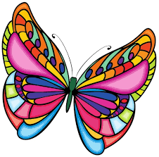  Draw or paint a butterfly with exotic colours | 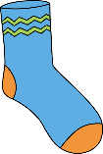  Make your own sock puppet | 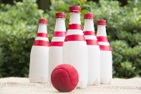  DIY bowling – create makeshift bowling pins out of your recycling. | 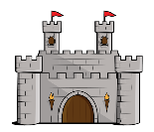  Make a castle using an empty box | Make some cornflake or rice crispy cakes
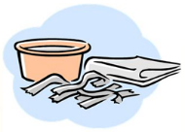  Make a papier-mâché sculpture | 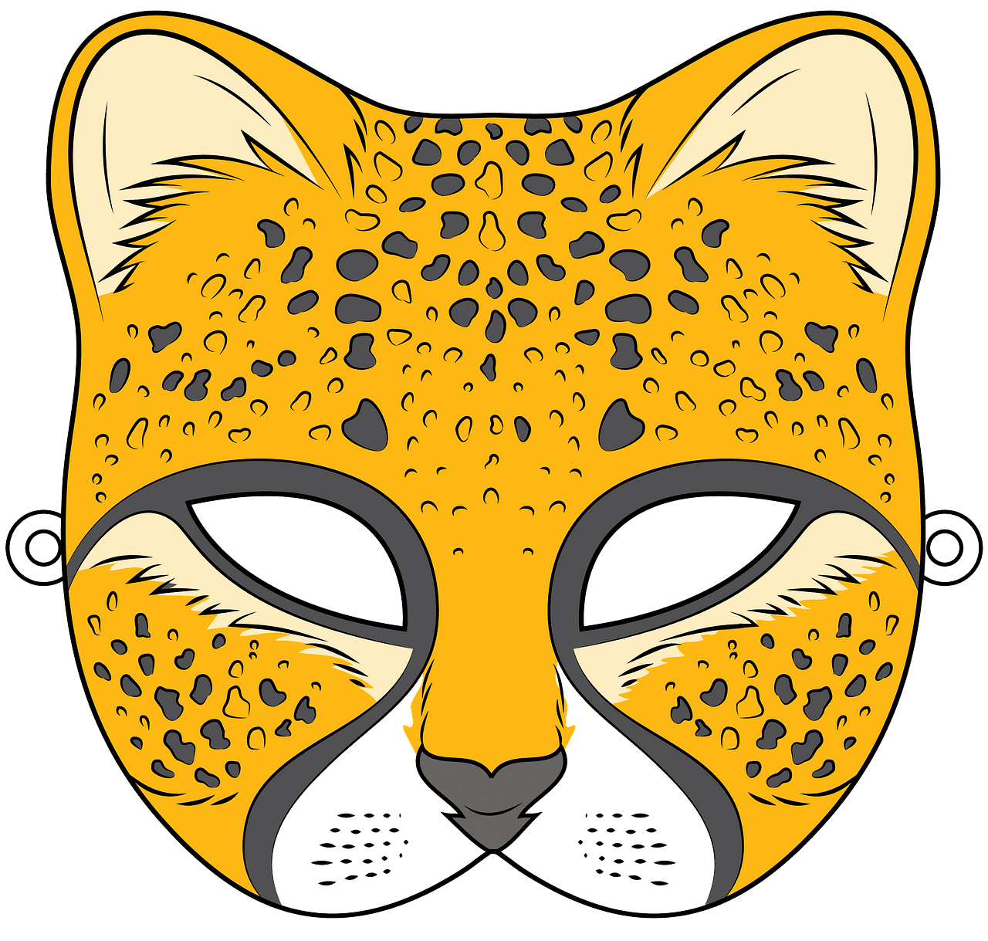  Design a mask for yourself – it could be an animal, warrior or something else! | 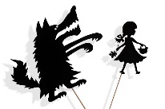  Make some shadow puppets and put on a show | Plan and host a movie night with family, choose snacks and a film– don’t forget to make tickets. | 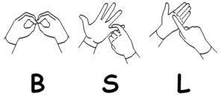  Learn the alphabet in sign language. | Go for a walk and take some photographs
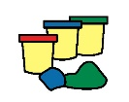  Make some playdough or clay and build an animal | 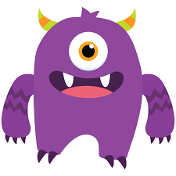  Make your own monster bookmark | Make a rocket using recycled card or plastics | 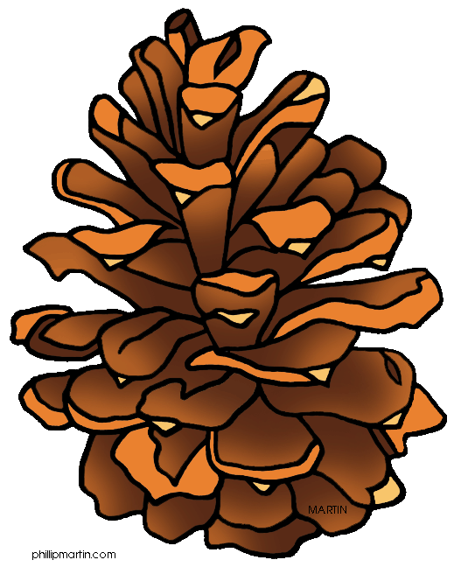  Collect some nature things make an Andy Goldsworthy picture or collage | 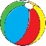  How many times can you throw and catch a ball with a family member without stopping? | 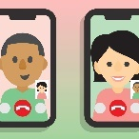  Video call a family member
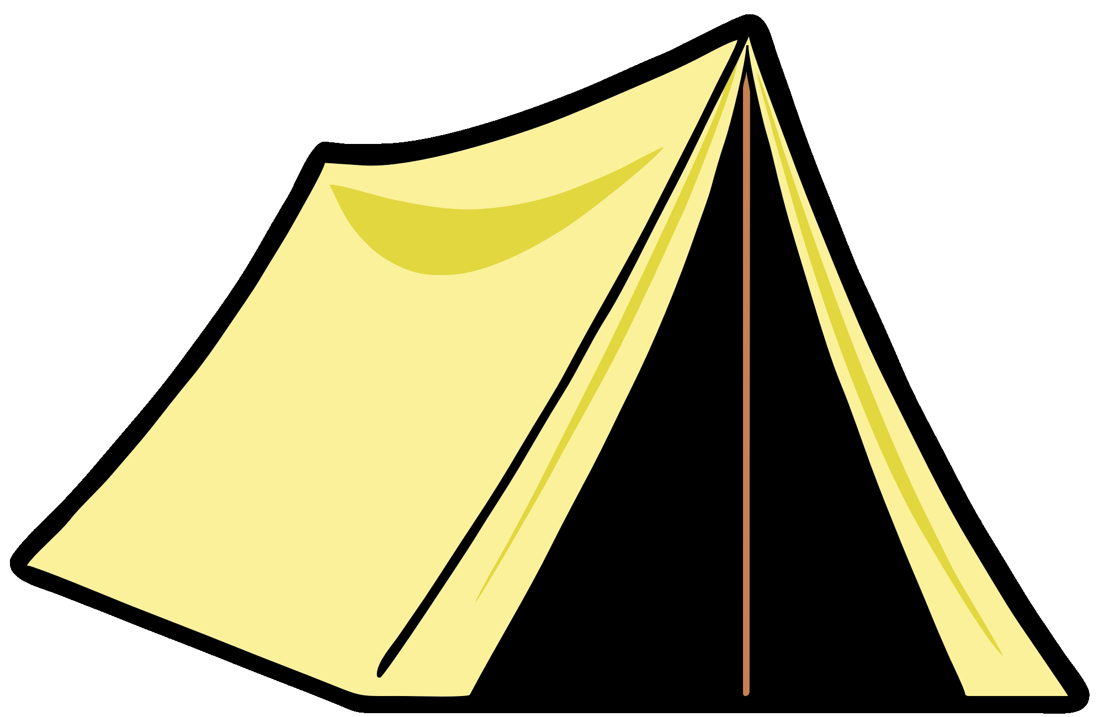  Make a den in your house or garden using fabric, cushions etc. | Read a joke or fact book on myOn | 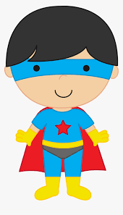  Design your own superhero with superpowers | 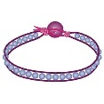  Make a friendship bracelet out of thread, beads or wool | Try a science experiment | 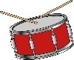  Make musical instruments out of things you find in your house
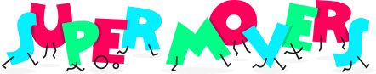  Join in with a BBC Supermovers video | 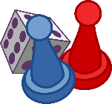  Make your own board game | 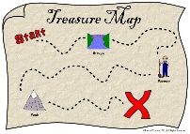  Design a treasure hunt around your house or garden | 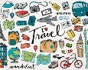  Make a collage of your favourite things using magazines or drawings | Do an Oti Mabuse dance class on YouTube | Walk or run a daily mile
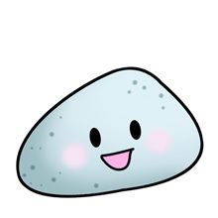  Paint rocks and turn them into rock pets | 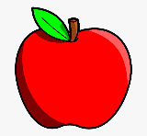  Create a poster showing healthy and unhealthy foods | 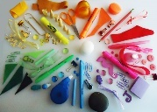  Make a colour wheel out of objects in your house | 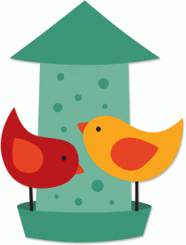  Create a bird house or bird feeder to hang in your garden | 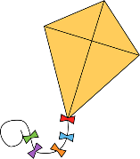  Make your own kite | Do a Joe Wicks workout on YouTube

