Design a poster to put in your window to make people smile when they are going for a walk | Play the ‘Yes/No’ game with someone in your house | 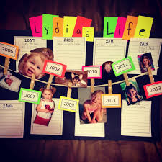  Create a timeline showing the main events in your life | 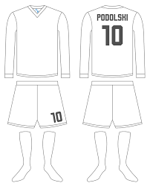  Design a new football kit for your favourite team or for Euro 2021 | Think about your favourite book and design a front cover for it
Teach someone in your house a new skill | 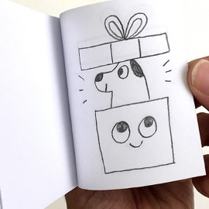  Learn how to make a flipbook | Make some  homemade soap | 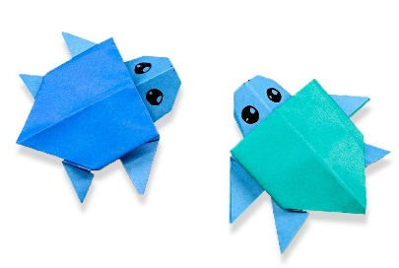  Learn some origami | Choose 5 countries you know nothing about and learn 2 key facts about each
Create a poster to encourage people to help protect the environment | Create a puppet with moving parts | Design a healthy menu for a café and a poster to promote it | Design a cover or a box for your favourite game | Play 20 questions with a friend or family member over the phone
If you could choose 4 people to have dinner with, who would they be and why? (They could be famous!) | Write an acrostic poem about the year so far using the words ‘ TWENTY TWENTY’ | 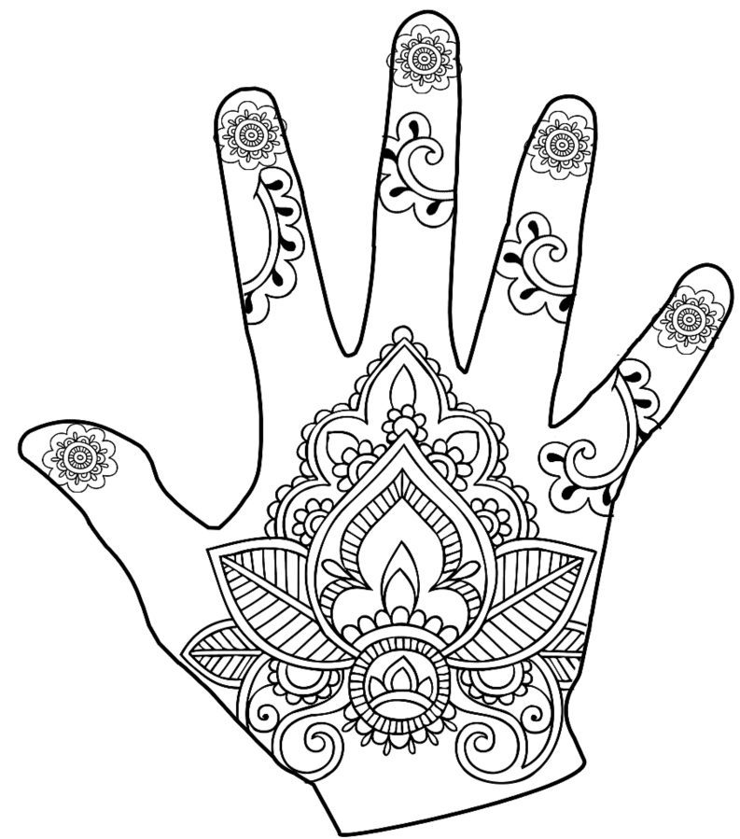  Research Mehndi patterns and make one of your own | 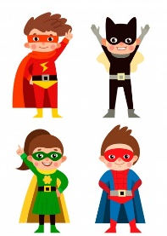  Design a superhero character and label it with it’s special features | 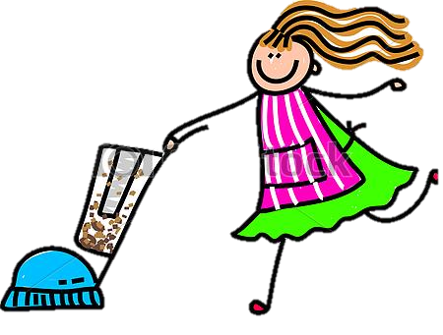  Do a job around the  house without being asked to do it
Create 10 rules that people should follow to be online safely | Interview a person in your house about their life | Try and think of 50 ways to use a tennis ball | Design a new chocolate bar | 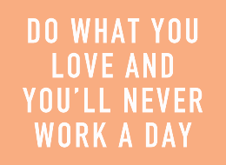  Research what skills and work experience you will need to have to apply for your dream job
Activity Bingo 2 Click on the words in blue for website link

