Home Learning Tasks – Sheet 2 Click on the images for website links
Science  Can you choose an animal and research as much as you possibly can? Think about: habitat, diet, appearance, movement, life cycle, offspring, enemies, behaviours, special features, interesting fact etc. - Be creative in the way to present this information.  If you finish, how about choosing a different animal? Could you select some from the main animal groups: Invertebrate Fish Reptile Birds Mammals Amphibians  D.T  You may also wish to make a 3d model of  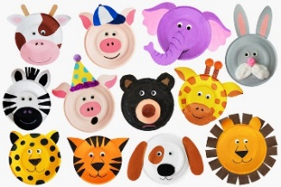  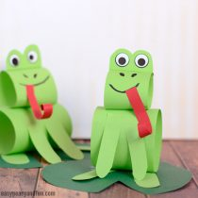  an animal. | Our local area  Imagine a visitor from another country is coming to stay with us for a week. Can you really impress them by showing them the most interesting places in our local area? (Aberford, Leeds or Yorkshire!) Where would you take them? Plan an itinerary for each day detailing the transport that will be taken to each location, how long will be spent there, what will be eaten and any activities that may take place. |  | P.E.  Have a look at a P.E. session with Joe Wicks  Can you design your own daily exercise routine? Keep a diary to show your chosen moves. Perhaps record between 5 and 10 moves for each routine, lasting 30 seconds each. Now get active and perform your routine. Can you add more moves each week?  (For example: Kangaroo Jumps, Star Jumps, Bunny Hops, Squats, Plank)  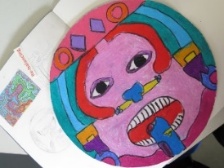  Art  Search for your inner artist.  Have a look at the website link below to find a range of different art activities. How many can you complete?  PSHE - Upcycling  Chose and item within the house that you don’t use anymore (e.g old clothing, accessory, household item) and upcycle it to make a new item that you will use. Evaluate your project and identify any areas that you could improve if you were to do it again. If you’d like, write a set of instructions so other people can upcycle the same item too!
 | R.E  Hopefully you have been inspired by our Easter garden challenge. Using the same idea., challenge yourself to plan, design and make:  - A mini spiritual trail garden  - A peace garden  - A prayer garden  Science/Geography  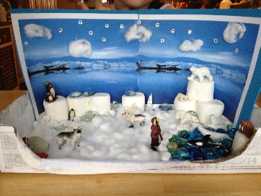  What about making a mini beast lodge or a mini scene for a particular environment. E.G Desert, Arctic, Rainforest, mountain environment, under the sea etc. | 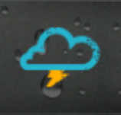  Geography  Select either an extreme weather condition (for example: hurricanes, tornadoes, floods) or a different natural disaster (for example: volcanic eruptions, earthquakes, tsunamis)  Research this and produce information in a fascinating way.  If you finish, how about choosing a different one? You could even record detailed information about all of the above.  English  Become a reporter!  Write a script as if you were reporting for a major news channel providing information about one of these disasters! Can you act this out?
History

Study a period of time/an event that interests you from throughout history. Think carefully about what kind of tasks/ activities you complete in your history lessons at school, can you set your own learning intention?

