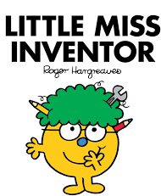  Science: Marvellous Inventions  Can you invent a product to present on Dragon’s Den? Share drawings and designs and write about what your product can be used for. Can you design a product that will make ‘life in lockdown’ more engaging?  100 inventions that changed the world in the last 100 years! – Would yours make the list?  World Environment Day  - 5th June 2020  This year’s theme is Biodiversity. On this day people from all over the world will do something positive to help our planet. What could you do? Lots of little things can make a big difference. What could you do to celebrate WED? Can you create a poster? | R.E.  A religion is a set of beliefs that is held by a group of people. Did you know it’s estimated there are 4200 different religions in the world?  Research a different faith or religion. Create an information poster to explain their key beliefs.  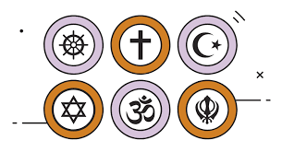  “Science is magic that works!”  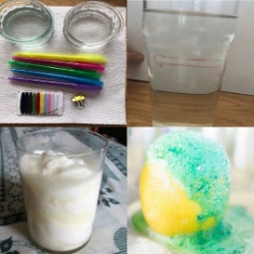  Click on the pictures for experiment instructions.  Dyson engineers have also designed challenges specifically for children. Ideal for home or in the classroom, they encourage inquisitive young minds to get excited about engineering.  How many can you complete?  Download the challenge cards from the link | Geography  Research famous viewpoints from around the world (e.g. The Eiffel Tower, Harbour Bridge, Grand Canyon etc). Draw what you think you would see from this viewpoint. After this, design and create a miniature scale of the landmarks that give these viewpoints. | History  Create a Lockdown Time Capsule – a great way to looks back on the COVID-19 pandemic in years to come. There are many things you could include, here are some ideas:  - A letter to whoever opens your capsule  - A newspaper clipping or print a news article from the Internet.  - Drawings or photos  - Evidence of games or activities you did as a family  - Some diary entries  - A record of any special memories (for example: Clap for Carers)  - Handprint tracing of everyone in the family  - A 2020 dated coin  - A couple of bits of clean toilet paper and a hand wipe (reminding you of how people were panic buying)  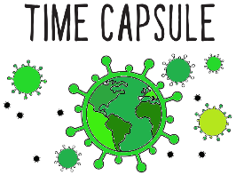  Maybe gather your things in an old shoe box - See ‘Additional Home Learning Tasks’ for extra ideas.
P.E

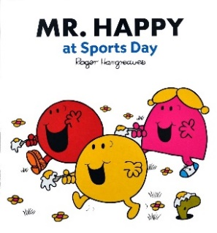
Create your own Sports Day at home. You could use the usual races, but could you think of some crazy/ unique/ different ones as well? You could also spend some time making medals and certificates too!
Music - Learn a new song, singing is incredibly powerful and can help support us in so many ways! The benefits are endless. Which genre will you choose?

- Silly stuff
- Relaxing/ Soothing
-Songs to get moving
- Empowering/ Uplifting

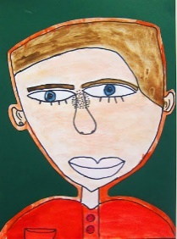
Art

Draw a self/family portrait. Watch artist, Emma Majury as she demonstrates techniques for drawing self-portraits.

Home Learning Tasks – Sheet 3 Click on the images for website links

