Year 5 - English Click on the images for website links
Setting Description  Write a detailed setting description of ‘the place between’. Think about the senses. What can you see, hear, touch, taste, smell? Think about using: vivid vocabulary, expanded noun phrases, adverbials, similes, personification etc. to bring your writing to life. What objects might there be? What colours are there? Is anything/anybody else trapped in ‘the place between’?  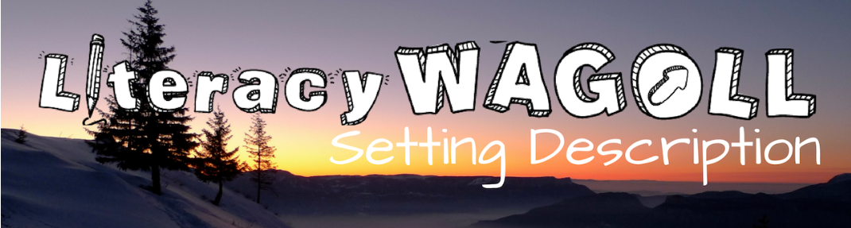  Click on image below for a setting description WAGOLL –  ‘What a good one looks like’ | 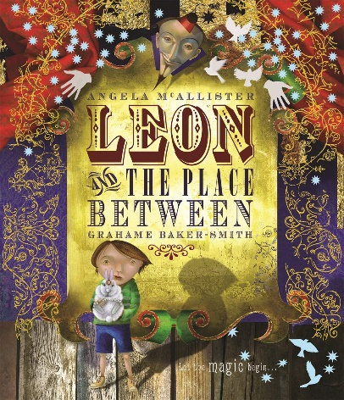  Newspaper article  Can you write a newspaper article to report the fact Leon is lost in ‘the place between’. Remember to come up with a catchy headline, write your opening to the article (which includes when, where, who, why and a brief description of what), then the main body of the article detailing what has actually happened. This may include direct quotes, reported speech, pictures and captions. Remember to  write in columns too.
Reading  Write an additional part to the story. Think of an adventure that Leon may have whilst he is trapped in ‘the place between’.  Who does he meet? What other setting may we be introduced to? Does he face a problem and if so, how does he resolve this? In your story, does Leon escape from ‘the place between’? Can you include a statement, a command, a question and an exclamation? Write an additional part to the story. Think of an adventure that Leon may have whilst he is trapped in ‘the place between’. Who does he meet? What other setting may we be introduced to? Does he face a problem and if so, how does he resolve this? In your story, does Leon escape from ‘the place between’? Can you include a statement, a command, a question and an exclamation? | Greek Mythology  Challenge yourself to write your own Greek Myth. Consider the layout of the ones we have studied in class and compose your own version based on this format. Use the techniques of writing we always endeavour to include in our writing.  