Aberford Church of England Primary School
School Lane, Aberford, Leeds, LS25 3BU
Tel: 0113 281 3302
Website: www.aberfordprimaryschool.co.uk
Headteacher – Nicola Crossley

Message from Mrs Crossley
It’s been a rainy week at school this week but the children haven’t let that dampen their spirits! Lots of excellent work has been produced by all our bubbles and the children who are back with us have really settled back into the routines of school life.
We would like to say a huge thank you for all the donations of plants we have had for our key worker bubble to plant in our beds and grounds. They are over the moon at everyone’s generosity. If anyone else would like to contribute, that would be amazing. You can leave the plants outside the front of school.
Watch out for Class Dojo being launched at Aberford over the next few weeks. This platform will enable us to be able to communicate letters and information to parents much more easily, including when the school is closed. This will mean that if we are still waiting for announcements from the government regarding further reopening during the summer break, we will be able to keep you up to date with all our plans as soon as possible.

Aberford Achievements

Our staff have nominated children who have been superstars this week. As we can’t send certificates home at the moment, here they are!
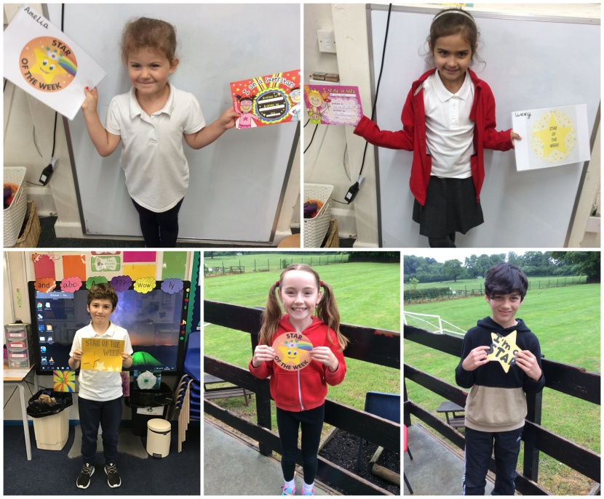 | Amelia  For working very hard this week with her reading and phonics.
Logan
For having an amazing first week back at Aberford, demonstrating a positive attitude and infectious smile.
Livvy M
For a super first week back at school. She has come to school every day with a huge smile on her face.
Beth P
For her enthusiasm for the KS2 production and for being determined to learn her lines so quickly.
Hayden
For his enthusiastic approach to all learning since coming back to school.

