By Evie D
In the early hours of April 15 1912, the ‘Queen of the Ocean’ disappeared in a disastrous tragedy. This incident occurred in spite of several warnings that they were going to hit something due to ice bergs being present in the sea. Yet, at present, this catastrophe cannot be blamed on anyone in particular and investigators are not sure if this is anyone’s fault. They don’t have enough information as of yet – was this just a natural disaster? More information will soon hopefully be realised to the public.
Around mid-day on April 14th, passengers filled the crowds around the beauty of the Titanic. Thousands of people ready to wave the ship off on her first long ride out into the Atlantic Ocean. At this point, nobody could have expected anything bad would happen. On her luxurious way she stopped at Cherbourg, France and Queenstown, Belfast to let more passenger’s board.
Approaching the Atlantic Ocean, 1st class passenger’s quoted that this was the most luxurious sea ride to America so far and that they hoped they would all arrive at their destination safe and sound. At this point, no one thought anything bad, just that they would be there before expected.
Around 9:20pm on April 14th, the captain decided to return to the cabin for a rest leaving 2 others in charge of the boat. However, they started to receive more and more warnings that they were going to hit an iceberg ahead. This meant that they decided to take an extra 10-mile diversion.
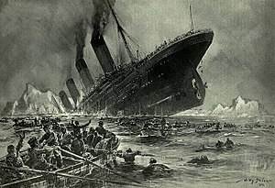
The Titanic sinking
Clearly, they were hoping that they wouldn’t hit anything. Passengers started to panic as the captain reported ‘he wished that he never retired to his cabin and he’d kept in charge of the ship’. Approximately 2am on the 15th of April the ship scraped against the icebergs, which meant 3rd class passenger’s rooms started to flood with cold ocean water. As this happened, life boats started to launch for children and women - no men were allowed to board them. This was a heart breaking moment for many children losing their fathers. Wives losing their husbands – this of course was devastating for them.
Desperately hoping and waiting for help, more started to jump for their lives or attempt to reach the life boats.
Shockingly, only 710 survived after finally being saved and brought back to land by the Carpathia.
More information will shortly be known and we will report this as soon as the information comes in.

