In the early hours of the 15th of April, the Titanic sank with thousands of people on board. As the ship didn’t have enough lifeboats to save everyone in the event of an emergency, this was surely going to end in disaster. About 1500 people died with only 710 survivors.
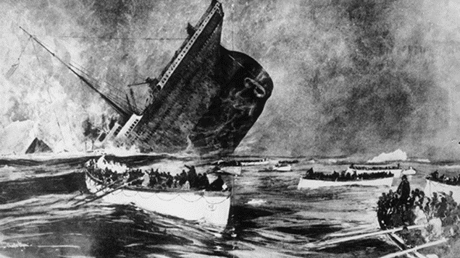
The iceberg was the predator in this case, the Titanic was the prey. After having been warned several times about icebergs, the captain, who went down with the ship, was reported to have said “Take a ten-mile detour, and go forth at full steam ahead”. The trouble only got worse from there, as it was dark night, making it hard to see anything in front of the ship’s stern.
At exactly 9:20 pm the captain retired to his cabin after a long day of work. Forty minutes later one of the surviving lookouts told us during an interview- that when he saw the iceberg they told every single one of the staff, alerting the crew who were steering the ship. They immediately shut down the furnaces, hoping that it would help them slow down. They turned as quickly as the crew could. But unfortunately… not quick enough. The Titanic hit the iceberg, making several holes on her starboard side at 11:40 pm 14th of April. As they didn’t have enough lifeboats for everyone, people were definitely going to die, resulting with 1512 people whose innocent lives were snatched away from them.
As the night went on, women and children were being ushered onto the lifeboats and said goodbye to their loving fathers. One child named Eva Hart said that she had been told to “Hold mummy’s hand and be a good girl,” by her father, Benjamin Hart. Later on that evening, the stern started to sink with still many on board [as lifeboats weren’t being filled to their full capacity] many had already started to plunge to their watery death. Soon enough, the ship snapped in half with the stern pulling the bow with it, sending the boat perpendicular. At 2:20 am the 15th of April. The titan Titanic sank. We all feel great pain as many of us had loved ones aboard this ship. We dearly hoped more of these lives had been saved.
The Titanic sinking By Ella

