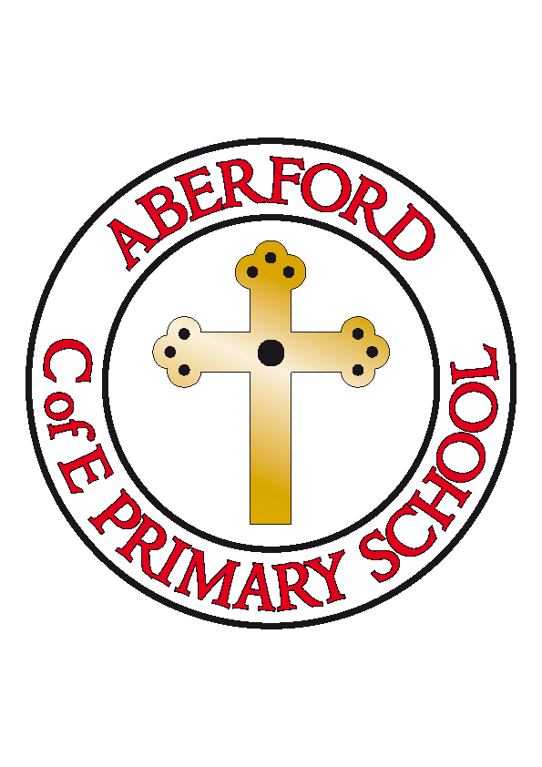
Aberford Church of England Primary School
School Lane, Aberford, Leeds, LS25 3BU
Tel: 0113 281 3302
Website: www.aberfordprimaryschool.co.uk
Headteacher – Nicola Crossley

Dear Parents and Carers,

School Dinners September 2020

I am writing to inform you that, after careful consideration, we are having to implement an increase in the price of school meals with effect from Tuesday 8th September 2020. The cost increase means that meals will rise from £2.10 to £2.20 per day, £11.00 per week. We have managed to keep school meal prices low at Aberford for many years whilst the cost to the school from the Local Authority has risen. We now need to increase our prices to start to bring them in line with the charge to the school of £2.40 per meal.

The Government have pledged continued support for the Universal Infant Free School meals project and this means that all of the children, from Foundation Stage to Year 2, continue to be entitled to free meals and, only from Year 3 onwards, do meals have to be paid for. Please remember to keep your schoolmoney account topped up as meals are payable in advance.

At Aberford, we are very proud of our healthy and delicious school meals. These are freshly cooked on site daily in our kitchen. All our meals are prepared from scratch using fresh ingredients. The children have a wide choice and the meals always include lots of salad and vegetables.

In September, school will reopen fully with some social distancing measures still in place. With this in mind, we have taken the decision to continue with grab bag lunches for the first two weeks of term. We will then review this and will aim to reinstate our normal hot meal menu as soon as possible. Please will you let the office know if your child will be bringing packed lunches or will require a school meal.

From September 2020, we will require all children to commit to a full week of either school meals or packed lunches and will require written notice of one week to change preferences. This is to ensure the kitchen staff can order the correct food in advance.

Many thanks,

Mrs Crossley

