By Chloe

In the early hours of April 15th 1912, the RMS Titanic sank into the Atlantic after hitting an iceberg on her maiden voyage from England. Captained by Mr Edward Smith, she was due to arrive at her destination early, but then disaster struck!

Many people were lost, including Captain Smith, but some escaped during the 2 hrs and 40 mins it took to sink completely. The ocean liner is rumoured by some survivors to have snapped in half between funnels 3 and 4 as they told the captain of the rescuer.

Some lifeboats were said to only be ½ full so more could have been saved (some did end up going back). But some were worried they would be all grasping at the boat to get inside and it could result in tipping.

We will now speak to those rescued aboard the Carpathia:
“We were all fooled into believing it was unsinkable as it was meant to be, and myself and everyone on board thought it was!” reported Mrs Ellen Dunworth from 2nd class.

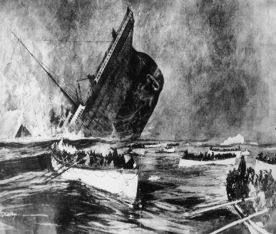
“It was the worst thing to happen in my entire life!” quoted Mr William Wood from 1st class.
“I was cuddling my mother the whole time.” said little Miss Elizabeth Stevensons.
The voyage was all successful until this tragic incident. Many important people died also, such as Sir John Jacob Astor (J.J. ) who was the richest person on board.
We all have great sympathy for those whose families and friends have been lost due to this disaster!

