January 2024

Dear Parent/guardian,
We are pleased to announce that parents will now be able to see homework assigned to pupils by their subject teachers using the School Connection app in Microsoft Teams for iOS and Android devices.

What is the School Connection app?
The School Connection app in Microsoft Teams empowers parents and guardians to engage, support, and monitor their student's learning at school. As a parent, you can now easily stay up to date with your child’s homework through Microsoft Teams.
If you would like to take advantage of this, please download the Teams app on your mobile device. Please note, School Connection is only available on Teams iOS app, and Teams Android app.
You will need to login to the Microsoft Teams mobile app with the same personal email address as the one shared with school. Please be aware that if your email address shared with the school is a workplace Office 365 account, it will not work with Teams. If this is the case, please provide us with an email address that is not a workplace Office 365 account to be take advantage of this. This webpage by Microsoft contains step by step instructions on how to get started with the School Connection in Microsoft Teams mobile app and includes answers to frequently asked questions. Instructions can also be found overleaf.
May I take this opportunity to thank you in advance for your continued support and should you have any questions or require any support with this, please do not hesitate to contact the school.

Yours sincerely,
Mr S Porter
Senior Assistant Headteacher

How to access School Connection
You will need to have the Microsoft Team app on your iOS or Android device. If it is not already loaded on your device, proceed to download the Microsoft Teams mobile app.
With the Teams app installed on your device, sign in with the email address that you have on file with your child’s school. For this app, a work-based email account (on file with the school) cannot be supported. If needed, you can easily create a personal Microsoft account for free on the Microsoft Teams mobile app or here.
Once all of that is setup, you can proceed with the following steps.
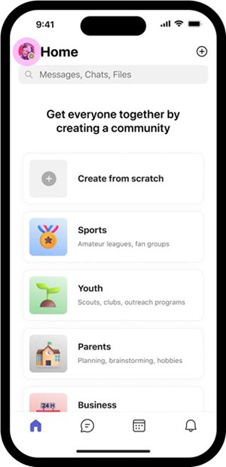
When signed in to the Teams app, tap your profile icon (or initials) in the top-left corner.
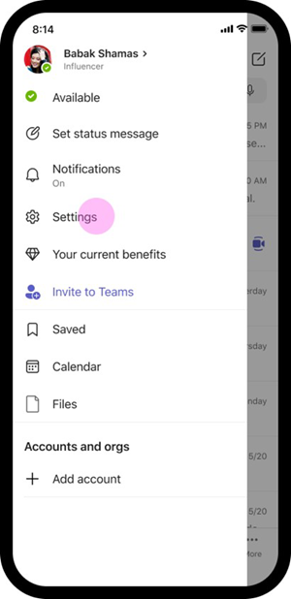
Select Settings via the left panel on your Teams profile screen.
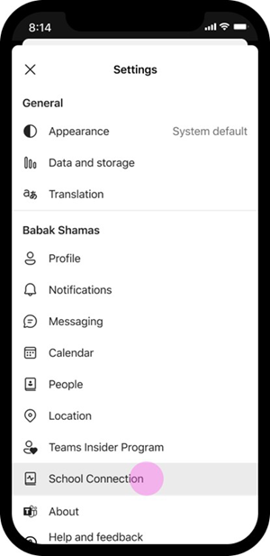
On your Teams Settings screen, tap School Connection.
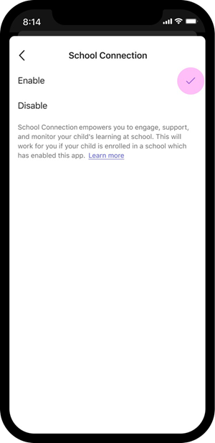
On the School Connection screen, tap enable.
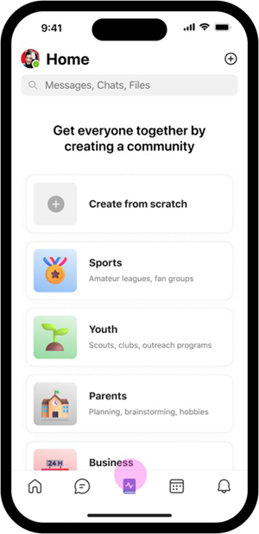

When you open Teams, you will now find School Connection pinned for easy access.
That’s it. Now you’re ready use the features available in the School Connection app.

