Prefects’ Handbook

CONGRATULATIONS!
If you are reading this it is because you have been selected to be a School Prefect.
Being given the title and position of School Prefect is an honour and a privilege and we hope that you will look back on your time in this role with a sense of provide, particularly in future years when you move on from Academy@Worden to college, university or the world of work.
As a School Prefect, a weight of responsibility rests on your shoulders. Teachers will ask you to take on extra duties in addition to your normal studies and extra-curricular activities and expect you to behave in an exemplary manner at all times, setting the standard by which the other pupils measure themselves. You will play a crucial role in ensuring that the ethos of the school carries across to all areas of school life.
The pupils will look up to you and will follow your example, therefore, it is important that you set a good example. Your actions, and the way you conduct yourself, are especially important and will have a big impact on life at Academy@Worden. You will need to treat all pupils equally and fairly and work to ensure that the pupils you represent are cared for and supported. At times they will need you to listen to them and they will need your help and advice to work through their problems. There may be new pupils who feel alone or left out and it is your responsibility to make these pupils feel welcome and included in all aspects of school life.
In essence, being a School Prefect is not about you, it is about the pupils you represent.
In performing your duties as Senior School Prefects, you will be expected to
- Observe the school rules at all times
- Be dressed appropriately at all times
- Maintain an excellent attendance record
- Be punctual for your duties
- Be positive and enthusiastic
- Be able to encourage and motivate fellow pupils
- Be cooperative, helpful, well-mannered, trustworthy, and responsible
- Be respectful toward teachers, your peers, and the school environment
- Display leadership qualities: confidence, initiative, problem solving skills
- Be willing to work independently and complete tasks without supervision
- Maintain a good academic record
- Be a good ambassador for the school

Senior Prefect Job Descriptions
Head Prefect | - Late duty in the morning  - Prepare duty rota for prefects and make sure they are carried out  - Open Evening, open mornings. Be prepared for special duties including speeches  - To attend Parents’ Evenings to register parents and help with refreshments  - Find out and understand the problems and views of the school and represent them to SLT and staff e.g. by chairing School Council meetings  - Hold regular prefects’ meetings
Deputy Head Prefect | - Late duty in the morning  - Be prepared to deputise and support the Head Prefect in all of the above duties, as required.  - Helping with the seating of pupils at whole school assemblies  - Help with rotas and monitoring duties that are being done  - Write the minutes of meetings and circulate them  - To attend Parents’ Evenings to register parents and help with refreshments
Head Sports Captain | - Assist the Head of P.E with teams, matches and training  - Deliver a sports report in whole school assemblies  - Support and encourage the school teams, wherever possible  - Actively contribute to the extra-curricular activities by leading or assisting in clubs
Head Faith Prefect | - Assist the Chaplain with whole school worship  - To lead the faith reps in their roles in school
Head Nurture Prefect | - Assist the Head of Year 7 and Year 7 form tutors where necessary.  - To help with the school well-being lead
Head Service Prefect | - Assist in organising prefects to attend parent’s evenings.  - Assist in whole school events during school and after school.
Head of Student Council | - To assist staff with leading student council.  - To hold one lunch drop in a month for pupils to speak to you about any issues they have.
Prefects | - To complete break and lunchtime duties where necessary this will include junior toilets, junior yard, senior yard, and canteen  - To help with Parent’s Evenings.
Sports Captain | - Deliver a sports report in whole school assemblies  - Support and encourage the school teams, wherever possible  - Actively contribute to the extra-curricular activities by leading or assisting in clubs

Academy@Worden Prefects’ Requirements

Qualifications and experience
- Good academic record
- Behavioural record must be exemplary, including attendance record
Personal skills and aptitudes
- Self-confident: be bold and assertive
- Ability to speak in public, to pupils and adults
- Team working skills
- Be organised and resourceful
- Be polite, honest, reliable, punctual and hardworking
Accountability
- Prefects are ultimately responsible to the SLT and Head of Year
- On a day-to-day basis Prefects are responsible to the individual member of staff running the activity or duty.
Responsibilities
- Prefects must adhere to the school rules at all times
- The main duty of Prefects is to maintain an atmosphere of friendly cooperation, discipline and unity in the school
- Prefects should serve as counsellors to junior pupils
- Prefects must liaise and collaborate with each other, as a team, to ensure efficiency and smooth running of their own area of responsibility and of the school as a whole
- Prefects’ academic and behavioural standards must be maintained
- Prefects will always work in the interest of the school
- Prefects will be given specific roles and responsibilities
Limits to authority
- Implementation of discipline is carried out by members of staff only. Staff can use the services of Prefects for supervision only.

Removal from post
- Prefects who fail to adhere to Prefect Code of Conduct and to maintain the role and responsibilities of Prefect will be given a notice of intention to remove their status. Pupils failing to address the area/s of concern will have their prefect status removed.

Roles and Responsibilities

Prefects play a vital role in the running of Academy@Worden; assisting and supporting both staff and pupils.
The role of a Prefect falls into four main categories:
- Maintaining discipline
- Helping staff
- Supporting younger pupils
- Organising events
You may be a Prefect for one particular area in the school, but you will also be required to cover other areas. It is important you, and the whole school community, are very clear about your role and responsibilities:
1. Provide a role model to which other pupils should aspire
2. Meet the highest standards of politeness, courtesy, dress, attendance and punctuality
3. Represent the school at important events throughout the year e.g. Open Evening, New Intake days, Awards’ Evening, Parents evenings, School productions etc
4. Attend meetings with the Pastoral staff as appropriate
5. Help to lead promotional activities for the school, including charity events.
6. Carry out regular duties at lunch and breaktime as required:
7. Be proactive in assisting the smooth running of the school outside lesson times
8. To act as a specific supportive role model to allocated tutor groups and assist with the delivery of registration activities
9. Act as a buddy to pupils who have asked for help and support
10. To report any issues to the Senior Prefects
Additional Duties
All prefects are required to perform duties either at break time or at lunchtime. It is important that you know where and when you are on duty. It is vital that you always turn up for your duties on time, that you execute your duty to the best of your ability and that you do not leave until the end of your duty time. If you fail to turn up to your duty you are letting yourself and fellow prefects down and weakening the Prefect system. Prefects that persistently fail to turn up to their duties will forfeit their right to be a prefect. If you know in advance that you are unable to do your duty, it is your responsibility to ensure that the duty is undertaken by arranging a swap with another prefect.
Additional Duties
You might not see a direct link between leadership and being a prefect, but there is one. You will have been chosen as a prefect based on certain skills and qualities that you already have or for the potential that has been recognised in you. Many of these skills are and qualities are common with leadership, such as: confidence, decisiveness and the ability to communicate effectively.
The Basic Skills of Outstanding Leadership
- Integrity
Integrity means honesty and more. It refers to having strong internal guiding principles that one does not compromise. It means treating others as you would wish to be treated.
Integrity promotes trues, and not much is accomplished without trust.
- Communication
Communication in the context of leadership refers to both interpersonal communications between the leader and the followers and the overall flow of needed information throughout the organisation.
Leaders need to learn to be proficient in both the communication that informs and seeks out information (gives them a voice) and the communication that connects interpersonally with others.
- Relationships
Networking is also a relationship skill. Relationships develop good interpersonal and group communication skills.
A leader who likes dealing with people issues, who can initiate and deepen relationships with others, has a great leadership advantage. This is a leader who can build a team and achieve impressive results.
- Persuasion
The ability to influence others and cause them to move in a particular direction is a highly important skill in leadership. Your ability to be persuasive is directly related to how much people trust you and how good your communication and relationships are.
- Adaptability
Adaptability and flexibility in not being bound by a plan are important success factors.
The leader must move easily from one set of circumstances (the plan) to the next (if the plan is not going as expected) and take them all int their stride, even when the circumstances are unexpected.
The good leader has to embrace change and see it as opportunity.
- Teamwork
Team work is an important and often neglected part of being a prefect. A school does not simply have a number of individual pupils who are identified as prefects. There is more to it than that; it has a team of prefects who are part of a prefect system.
- Decision-making
A leader must be able to wade through information, comprehend what is relevant, make a well-considered decision, and take action based on that decision. Making decisions too quickly or too slowly will impeded your leadership effectiveness.

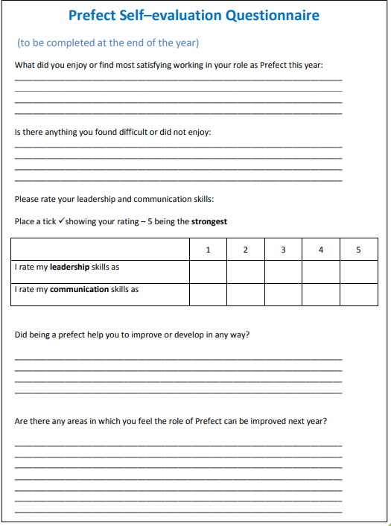

Prefect Contract
Prefects have to sign a ten-point contract and this is then kept with Mrs Cairns. If any prefect reneges on the contract, their badge and office will be taken away.
Code of Conduct
I accept my badge as a prefect at Archbishop Temple Church of England High School for this year. I agree to carry out the following duties and responsibilities.
To maintain a high standard of behaviour and conduct and to wear my prefect’s badge with pride.
To obey the school rules in their entirety and without question.
To help members of the teaching staff.
To take an active part in school affairs and lead others by example.
To take an active part in school functions, helping and organising whenever I am asked.
To represent the school at any public function whenever I am asked.
To take part in all whole school activities, leading by example.
To help new pupils, especially new pupils during their introduction to the school.
To maintain a high standard of cleanliness and tidiness throughout the school.
Over and above this code of conduct it is expected that all Archbishop Temple pupils will be ambassadors of the school.
I, have read and understood the Prefect’s Code of Conduct and I agree to carry it out to the best of my ability.

School Prefect Mrs Cairns, Assistant Headteacher

