Teacher: Laura Hall Term: Summer 24 Class: Seedlings
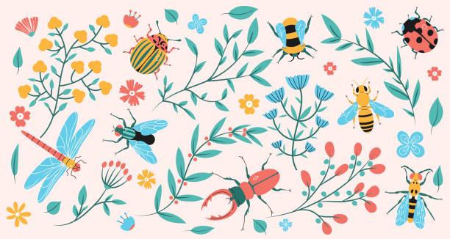
We will be leanring about the following this term: .
Physical Development – Gross motor movements – ball skills – throwing/bating/passing/rolling/catching and fundamental skills. Waving streamers, flags and creating large scale movements.
Movement and music sessions – developing coordination and control.
Fine motor Manipulating the playdough. Working on pushing, pummelling, squishing, rolling with malleable materials. Threading and target-based toys.
Baking using tools. Developing mark making skills.
Show further skill development with their dressing skills and managing buttons/zips.
Developing mark making as a pre-cursor to pre-writing skills and fluid letter formation.

Bugs and buds
Literacy: Focus: The very hungry caterpillar; The bug ball
Working on ORT scheme – on story/setting and characters. Naming and finding the characters. Phonics – environmental sounds/ phase 1 (some phase 2).
Developing sight reading for familiar words/names/nouns. Matching CVC words to images and starting to read in isolation. Looking at print in different formats. Developing writing skills and early letter formation.
Name work – sequencing letters.
Expressive Arts and Design
Exploring 3D making insects in playdough and salt dough.
Colour exploration – mixing colours for insects and flowers. Painting and drawing flower shapes and bugs. Making tissue paper flowers; coffee filter flowers. Exploring and handling different natural materials, objects, surfaces.
Instruments: action songs and movement to music. Exploring the sounds of instruments. Following stop and go.
PSED – developing relationships; making comprises and learning how to manage differences when sharing.
Begin some toilet training. Manage their own belongings. Start to use language/symbols/communication aids etc to indicate they need help. Follow and understand the rules, with less adult support.

Communication and Language:
Listening to and using vocabulary associated with the topic. Naming. Participating in attention activities sessions (AA stage 2 moving towards 3). Developing use and understanding of symbols: ALI boards at snack time/stories/provision-based play; PECS phase 2. Singing familiar songs. Listening to adults modelling language and talking to others in activities and play.
Mathematics – counting bugs, flowers, and objects.
Patterns and matching petals and bugs. Counting spots on insects
Grouping and matching objects to similar criteria.
Adding objects to 10 – bugs, leaves and flowers, using addition vocabulary.
Use prepositions to describe where the mini beast are.
Understanding the world – looking at insects and their natural habitats. Explore the outdoor areas and the local park. Looking for mini beasts; flowers and at plants.
Observing mini beasts and talking about their features. Learning about caterpillars and butterflies and their life skills.
Using our senses to listen to, observe and smell the natural world.
Plant seeds and care for them – planting beans and cress. Understand the life cycles of plants and that what is needed to help them grow (link to Jasper’s Beanstalk).

