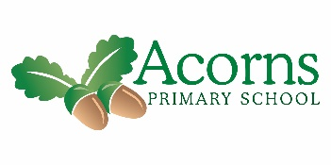
W/B 11th January 2020

Seedlings Weekly News

This week… We’ve had another lovely week in Seedlings. Although things have been different we are so proud of how all the children have coped and how they all have still had a positive attitude to school and their learning.
We are continuing with our topic bears and we are focusing on Goldilocks’s and the three bears.
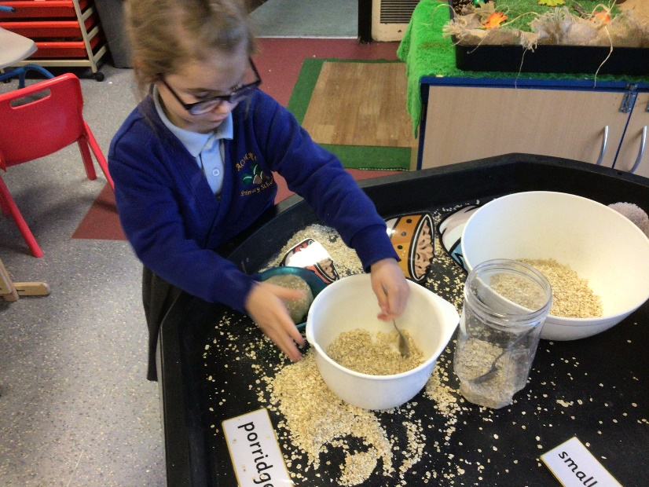

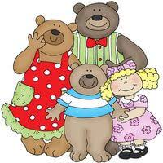
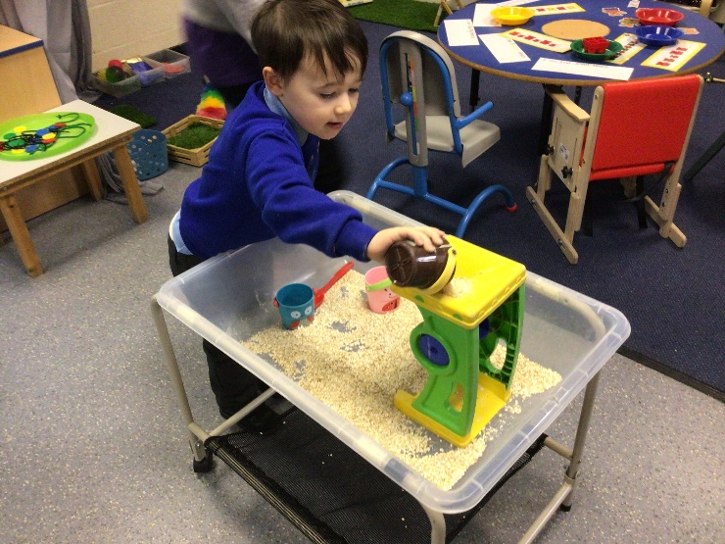
We focused on the porridge part of the story this week. In our sensory tray we had oats and objects for exploring capacity, emptying, filling and pouring.
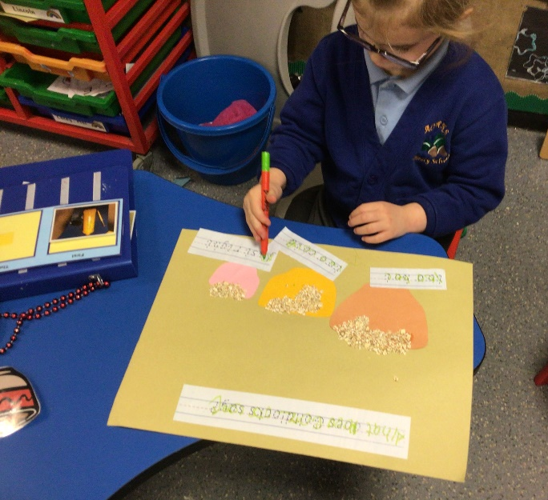
We have talked about the sequence of the story and worked on sequencing some familiar parts and also recalled what Goldilocks says in the story.
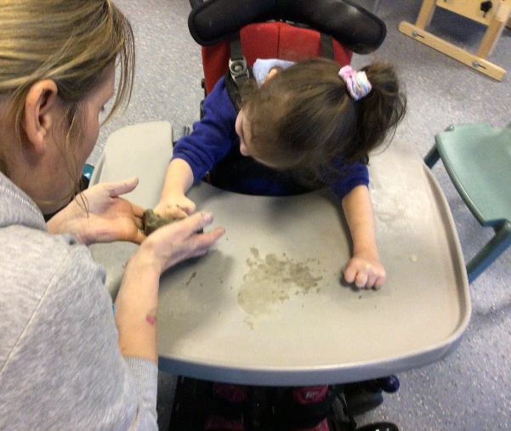
We made clay bowls. The children all tried really hard with this and with some support formed and made their own bowl for the bears.
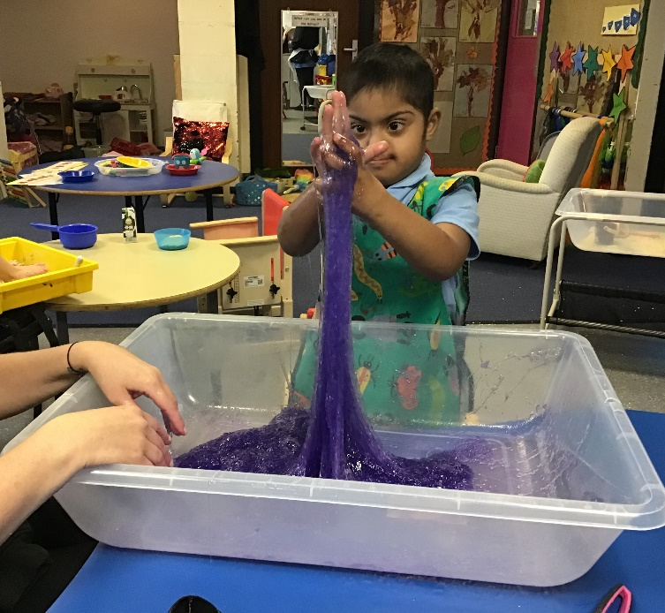
Messy play was very slimy this week – we mixed the oats with water to make sticky play porridge and we had some glitter slime. The children explored with their hands and feet!
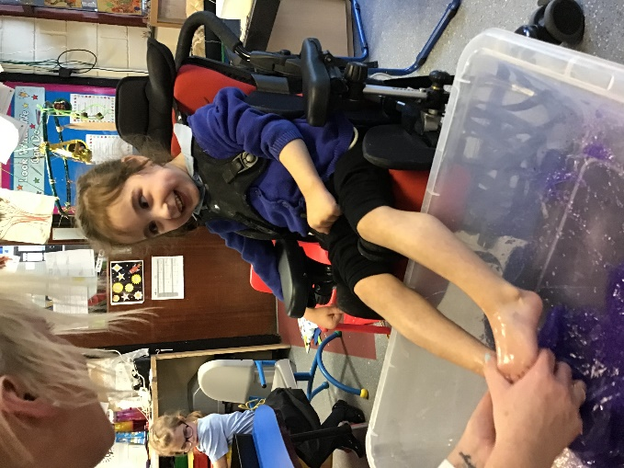

During baking we made porridge, but not many of the children were keen to taste it!
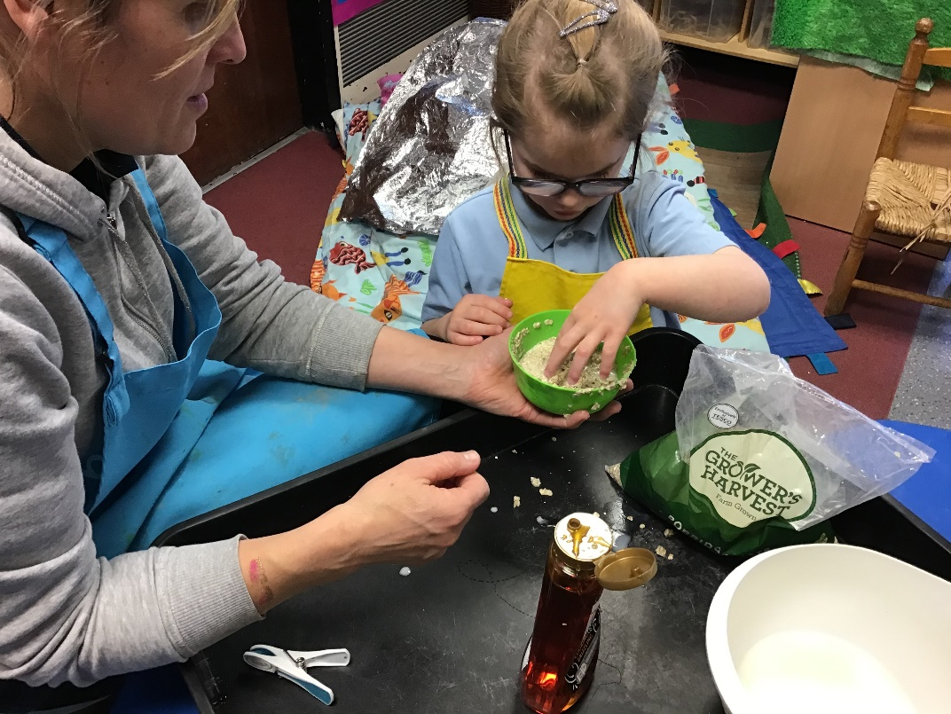
The role play area is currently as home corner. All the children have been in to have a play and explore. Some of the chidren are demostrating scanario play.
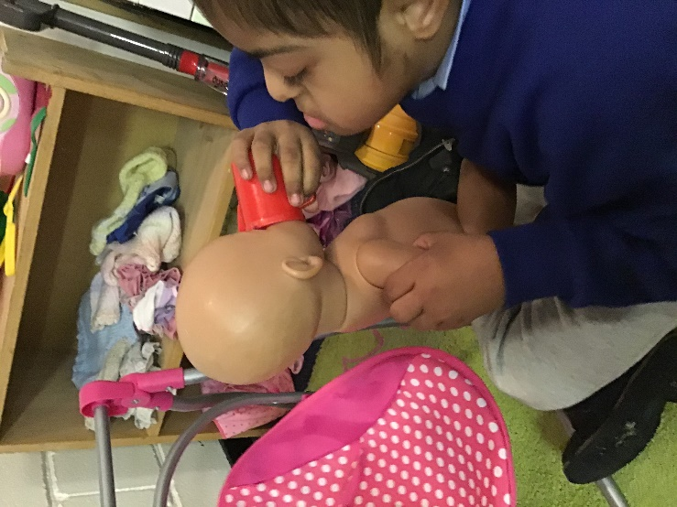
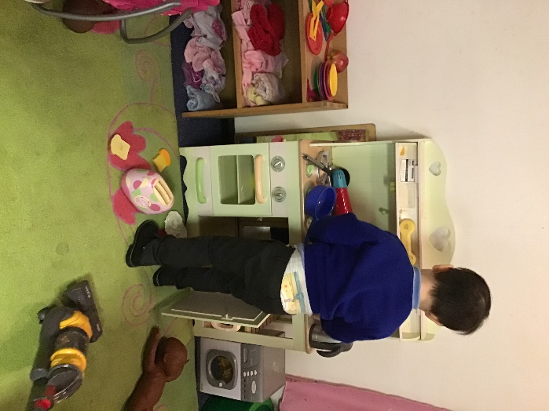

In one of our EAD/PD craft activities we are painting paper plates to make a bear, Goldilocks and a bowl of porridge.
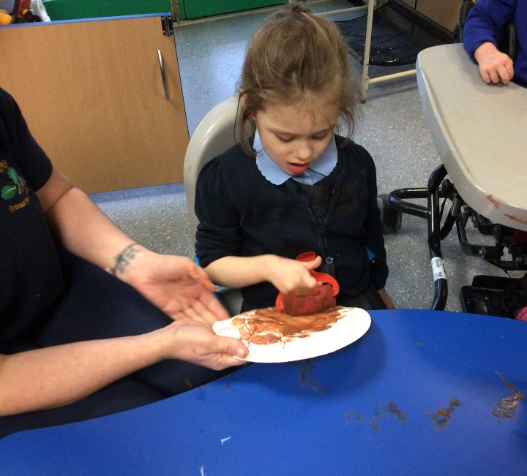

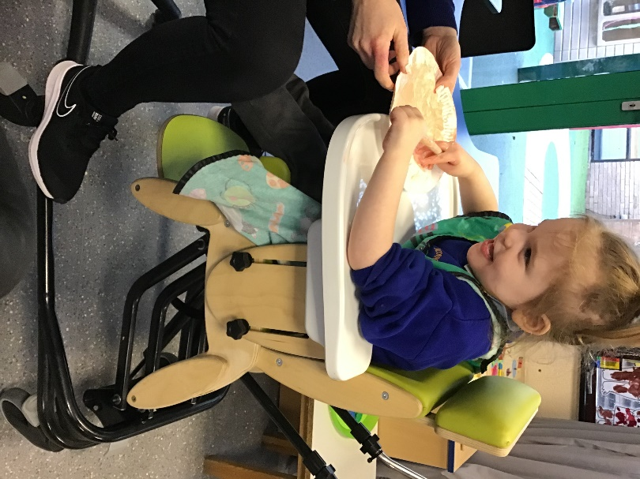

The children have also been working on colouring sorting and matching. We have been working with the compare bears to organise them into groups.

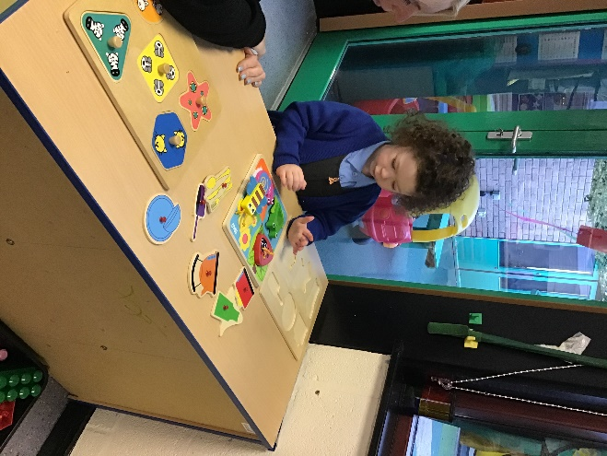
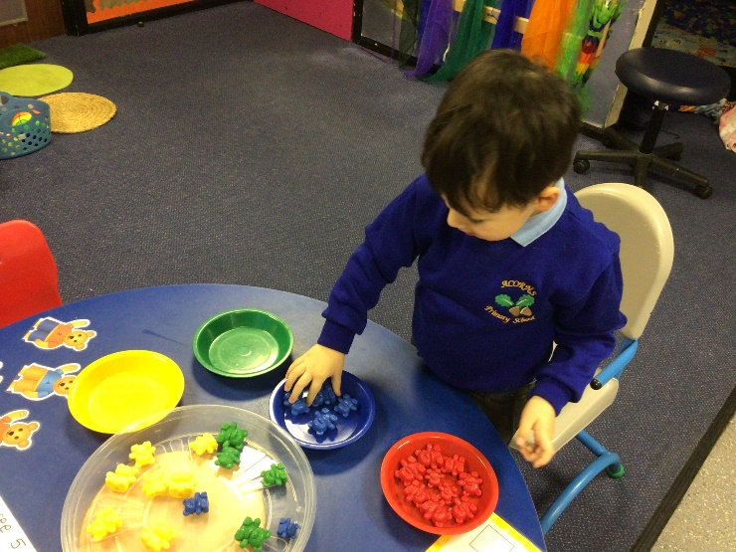

Have a lovely weekend. The home learning packs have been sent home and two videos will have been shared with you via email.

