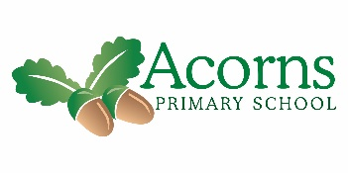

**W/B 22nd February 2021**

Dates for the diary – 19th March We will be celebrating Red Nose Day by doing something silly! Details will be sent out soon.

It has been lovely to see you all after half term. We have made a start on our new topic ‘Down In The Woods,’ beginning our sensory story ‘Once upon a Picnic’ and ‘A journey into the woods.’ We’ve explored natural objects and enjoyed being in our Woodland sensory corner.

Next Thursday, 4th March, is World Book Day. Children can come into school earing pyjamas ready for their bedtime story, they can also bring their favourite book to share in class. We are decorating our class door with our story ‘Once Upon and Picnic’ and some of the staff have recorded their favourite stories for you to share at home, we will send the links out next week!

Woodland Class’s Weekly News

It will be our last Zoom session next Friday (hopefully!) We are planning a story and will send our resources next week.

**And finally… Well dome to Luca for being our star of the week. Luca has just been a chatterbox all week!**

Luca has been a chatterbox all week, here he is shouting at the leaves!

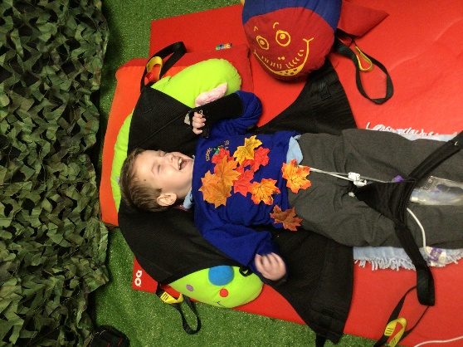

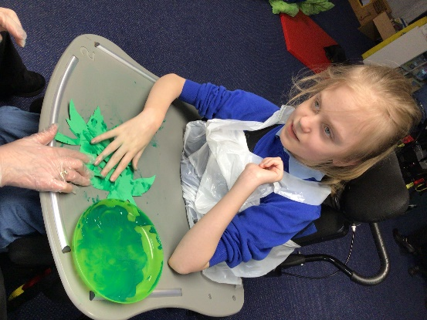

Zuzanna has been painting leaves for our sensory corner.

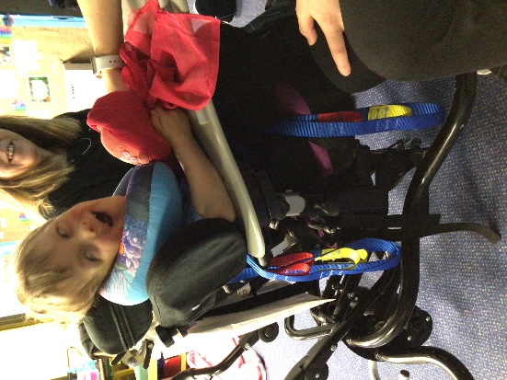 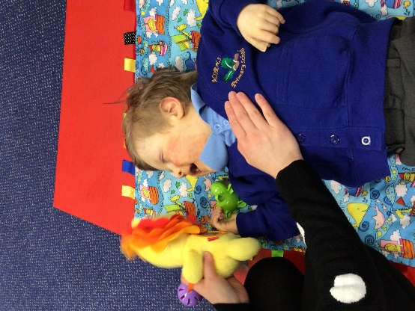

Rory is holding Little Red Riding Hood for our Once upon a Picnic story.

Rory has been joining in registration, he loves his lion toy!

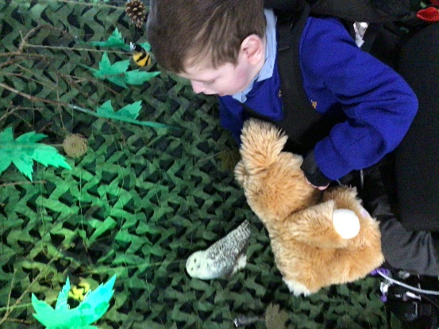

Luca has explored the Woodland sensory corner!

Myles is exploring the green fibre optics.

