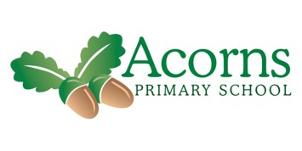
Name: Louise Gaffing Term: Spring 1 Class: Woodlands
Social, emotional, and mental health

We are focussing on our feelings and emotions. We will share lots of different activities and resources and find those which make us happy and sad.
We will also have joint activities with pupils from other classes and build awareness of other places.
Independence and self help

RSE/ PSHE – We will be exploring and responding to different stimuli on our bodies through a colours massage story.
We will all be working on being as independent as we can be through daily routines, feeding, exploring independently and using our communication skills.
Communication and Interaction

We will be working on our individual communication targets through the Wow said the Owl sensory story and colours and flowers massage stories.
We will continue to follow our daily routines including registration and collective worship, using Objects of Reference, Makaton signing and body signs.
RE

We will explore Christianity and the activities and songs used to celebrate Easter.
Physical and Sensory

We will develop our physical and sensory skills through Spring music and movement sessions, Spring story massage, nature senseology and sensory story sessions.
We will take part in vestibular, physical regimes and MOVE.
The topic this term is based on the story ‘Wow! Said Owl’ by Margaret Mayo. We have a range of activities planned both around the story, colours and Spring. We will be going into our outdoor area and for visits in the park when it is warm enough.
Cognition and Learning

We will be taking part in outdoor learning sessions and bringing the outdoors into class to explore a sensory trail.
We will develop our cause-and-effect activities through switch toys and activities.
We will also complete colour and growing art activities.
Topic: Colour my World

