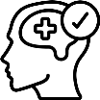
It is good for children's mental wellbeing.

School is the best place for them to learn.

What has changed?
June 1st
Key workers and vulnerable children
Year 12
Year 10
It is good for children to socialise with other children.

From June 1st we will welcome back children, but only from Year 10 and Year 12. School will still be open for key workers’ children and vulnerable children.

What about their brothers and sisters?

Only children in the year groups above.

They can keep using Oak Academy [Add school set home learning]
Children in years 7 - 9 and 12 need to stay at home

We will check for risks
before school is open.
Everyone will wash their
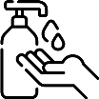
hands regularly.

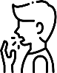
If a child or family member is sick they can not come to school.
School will be cleaned regularly.

There will be less children
in a room together.
To do this we will need to make changes to the school day.

Does my child have to come to school ?

If your child is well and in one of the groups asked to attend they should.
There will be no fines if your child does not go to school.

Will my child be temperature tested ?

Yes, if your child shows symptoms of Coronavirus they will be temperature tested.

7
days

The person with symptoms must self isolate for 7 days.

14
days
The people the live with must self isolate for 14 days.

14
days

If anyone at school tests positive, the whole class must self isolate for 14 days.

What else might change?

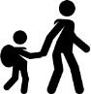
The time you drop off and pick up your child.

They may not have all their normal lessons.
Your child may have a different classroom & teacher.

We will change how we serve lunch.

