CST Guidance and Response to questions: 06-01-2022

This week we have received a number of questions from CST members asking for clarification on matters relating to lateral flow and PCR testing. We have been urgently following these up with the DfE. Ordinarily we would include responses in our scheduled briefings, but we thought you would appreciate having these as soon as possible so have written this special briefing today. We will write to you with our usual Friday briefing tomorrow.

One thing to be aware of is that these DfE responses do not provide full details of the implications of yesterday’s government announcement that confirmatory PCR tests will not be required from 11 January. We will provide more information on this as soon as possible.

What is the position of individuals without symptoms returning after 10 days if their lateral flow is still positive?

· They may return to their education setting and should not take any more LFD tests after the 10th day of their isolation period even if they have a positive LFD test result.
· This is because they are unlikely to be infectious after the 10th day of their isolation period. If they still have a high temperature after 10 days or are otherwise unwell, they should stay at home and seek medical advice.
· Please follow the Stay at home: guidance for households with possible or confirmed coronavirus (COVID-19) infection - GOV.UK (www.gov.uk)

Can you clarify when staff and pupils can return after negative LFD tests?

- Staff and pupils can take an LFD test from 6 days after the day their symptoms started (or the day your test was taken if they did not have symptoms), and another LFD test on the following day. The second LFD test should be taken at least 24 hours later. If both these test results are negative, and they do not have a high temperature, they may end self-isolation immediately after the second negative test result.

- They should stop testing after they have had 2 consecutive negative test results and can return to their education setting on the 7th day if they have tested negative in the morning.

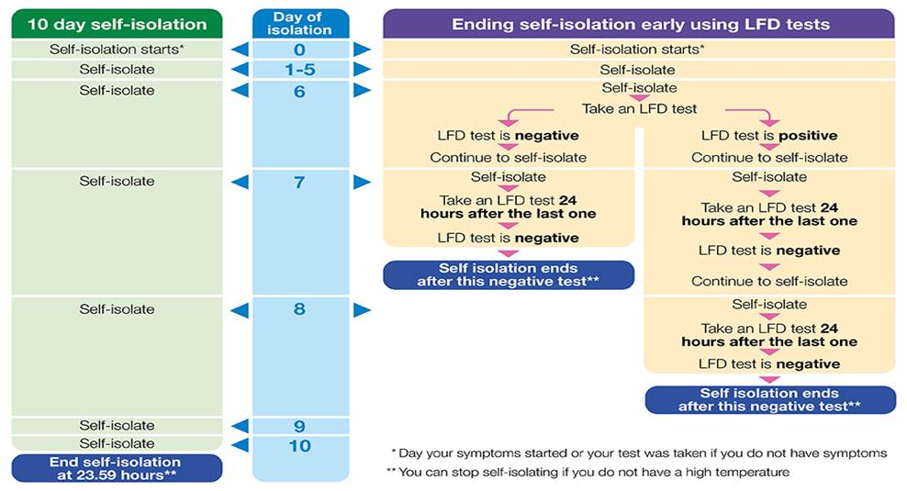

The general guidance for the public says that people ending isolation from day 7 should limit close contact with other people outside their household, especially in crowded places. What is the situation for individuals in schools who end their isolation from day 7?

If staff and pupils have tested on the morning of day 7, they are able to end self-isolation, and return to their education setting.

We know that face to face learning is incredibly important for children and young people’s education and wellbeing. Education settings have infection control measures in place, including enhanced hygiene measures, ventilation and a regular asymptomatic testing programme that helps to reduce the risk of transmission.

Furthermore, from Tuesday 4 January, it is recommended that face coverings are worn in classrooms and teaching spaces where pupils in year 7 and above are educated. The advice is short term only, to support pupils and teachers as they return to their education setting this term and builds on the existing proportionate guidance that recommends face coverings for all adults and students in year 7 and above in communal areas of all settings. We have updated our guidance to reflect this. This advice will be reviewed on the 26 January, in line with the review on Plan B measures.

Has there been a change to previous advice that said individuals who had covid in the past 90 days should not do LFD/PCR tests? If so, why?

Even if someone has tested positive for COVID-19 within the last 90 days, they are strongly encouraged to take part in LFD testing on-site via ATS or at home once they have completed their isolation period for their prior infection.

This is a change to the previous position because we know people can be infected with Omicron even when they have previously been infected with COVID-19. We will update our FAQs on this point on the document sharing platform.

If an individual who had Covid within the last 90 days tests positive on an LFD should they isolate at home and do a PCR?

It was announced today that confirmatory PCR tests following a positive lateral flow test result are to be temporarily suspended from Tuesday, 11 January. This will mean that anyone who receives positive lateral flow results for COVID-19 will be required to self-isolate immediately and won’t be required to take a confirmatory PCR test.

We will provide more details and guidance shortly.

The DfE email to schools said individuals who’d had Covid in the past 90 days should still do LFD testing this week as part of the ATS programme, but it didn’t explicitly say to include these individuals within the ongoing twice weekly testing programme moving forward. Should they?

Even if someone has tested positive for COVID-19 within the last 90 days, they are strongly encouraged to continue twice weekly at home once they have completed their test on-site via ATS as long as they have completed their isolation period for their prior infection.

Is there any reason why primary schools shouldn’t ask their pupils to test weekly or twice weekly, if families are willing to do so and the school’s risk assessment suggests that would be beneficial?

Public health advice from UK Health Security Agency advises that there are limited public health benefits attached to regularly testing younger children with LFD coronavirus (COVID 19) tests. We therefore don’t suggest routine asymptomatic testing of primary aged pupils. Local health teams can agree with primary schools to advise their students/pupils who are identified by NHS Test & Trace as close contacts to undertake daily LFD testing. Testing primary aged children is left to parental discretion, and test kits for primary aged pupils can be accessed via gov.uk or their local pharmacy.

