RESPIRATORY SPREAD
The virus lives in your respiratory system.
When you breathe, talk, cough or sneeze, respiratory droplets containing the virus pass out of your body and into the air around you.
These droplets can then be inhaled by people close to you or settle on surfaces near you.

 | Respiratory Spread | Control Measures
High Risk | Coughing / Sneezing | Cover mouth and nose with a tissue, arm or or face covering.  Catch it, Bin it, Kill it  Wash / sanitise your hands.
Medium Risk | Talking / Breathing | Stay above the head height of any child you are talking to - DO NOT get down to their level.  Where possible, keep 2m apart from adults/pupils in your bubble.  DO NOT talk to people outside of your school bubble - communicate using technology rather than in person.  Keep 2m apart (or behind a screen), if you HAVE to talk to someone not in your bubble and preferably talk OUTSIDE.  Ventilate indoors spaces - doors and windows open.
Lower Risk | Transitional contact  (e.g. passing in the corridor) | Pass by each other quickly, do not stop to be polite or chat.

PPE - DO NOT GET COMPLACENT

Wearing a “face covering” DOES NOT stop you from breathing in the virus (only specialist “face masks” can do this), but they can reduce the amount of respiratory droplets you spread.

FFP2 “face masks”, when fitted properly, stop 95% of particles >0.3 microns in size - these are what medical staff are wearing to prevent catching the virus. Respiratory droplets can be as small as 5 microns in size. 1 micron = 0.001mm

Look through a T-shirt into the light - you can see lots of holes - the virus is small enough to be sucked through these when you breath in - “face coverings” DO NOT protect you.

Stay 2m apart even when wearing a face covering.
SURFACE SPREAD
Respiratory droplets containing the virus will fall onto surfaces.
If you touch surfaces with your hands and then touch your face, the virus can get into your body through your mucus membranes (eye, mouth and nose).

 | Surfaces (Fomites) | Life of virus | Example | Control Measures
High Risk | Shiny/very smooth surfaces | 6-9 days | Metal  Glass  Smooth plastics  (inc book covers) | Internal doors wedged open.  Personal resources - stationery, white boards, etc.  Personal working space - do not share desks/chairs during the day - clean before next person uses.  Cleaning of these surfaces regularly throughout the day - warm soapy water and/or bleach
Medium Risk | Rougher surfaces | 12-24 hours | Card  Paper | “Holding state” for 24 hours before handling.
Lower Risk | Very rough surfaces | 6 hours | Carpets Clothing | Remove unnecessary soft-furnishings/equipment from classrooms.  Wear clean clothes daily.  Hoover carpets at the end of the day.

We all touch our faces 100s of times a day and it’s very difficult to stop.

There are ideas online of how you can reduce face touching,
but the best thing to do is
WASH YOUR HANDS regularly.

CORONAVIRUS & FAECES (POO)
If a person has the virus, it will be present in their faeces (poo / stools).

It can last for up to 30 days in poo.

The transmission rate from poo to your respiratory system is high.

It is essential that you follow these Toileting Support Steps:

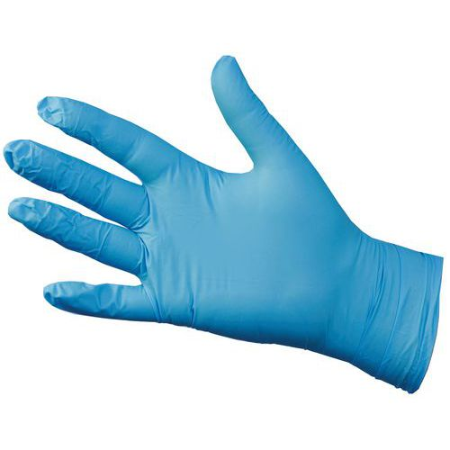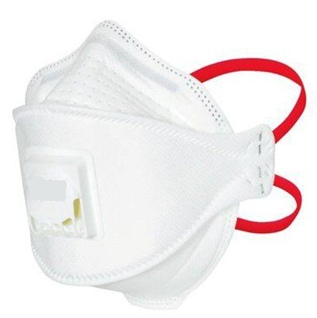  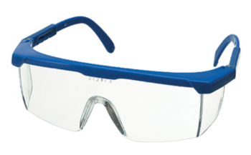 | 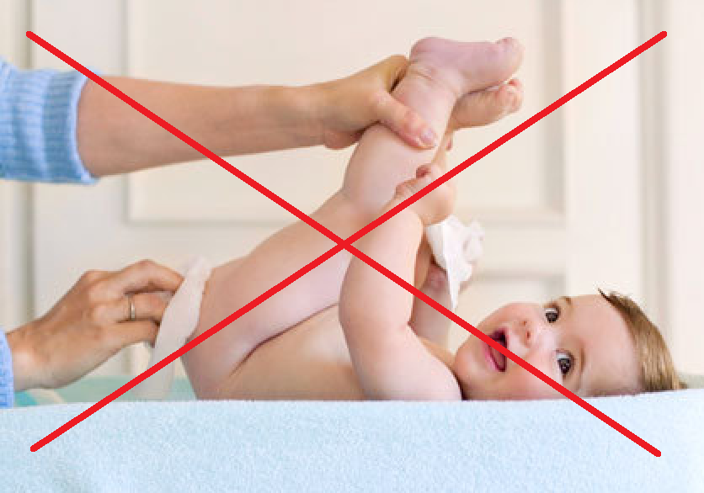 | 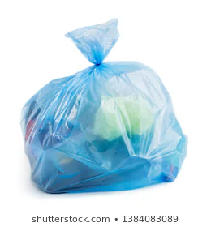 | 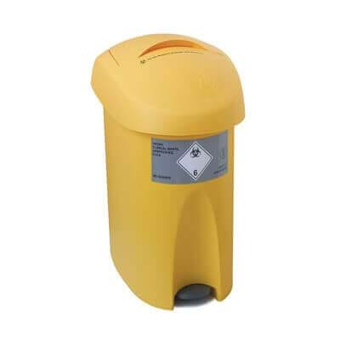
1. ALWAYS wear gloves, a mask, and safety glasses or a visor. | 2. Do not put your face inline with the child’s anus - if they fart, you may breathe in particles of faeces containing the virus.  Work from the side and/or above. | 3. Bag & tie up contaminated clothing. | 4. Dispose of nappies and wipes in “yellow bin”.
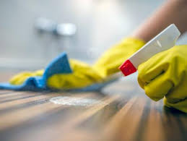 | 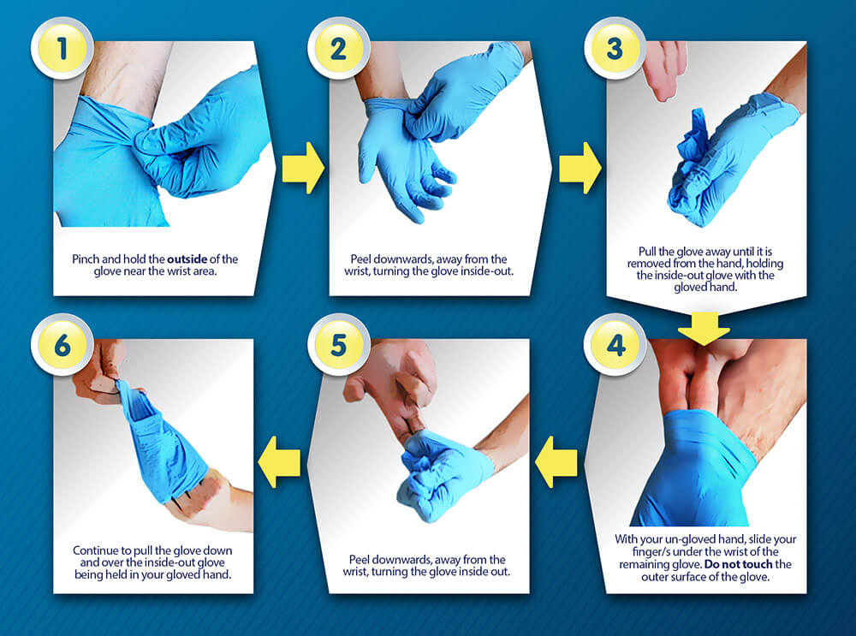 | 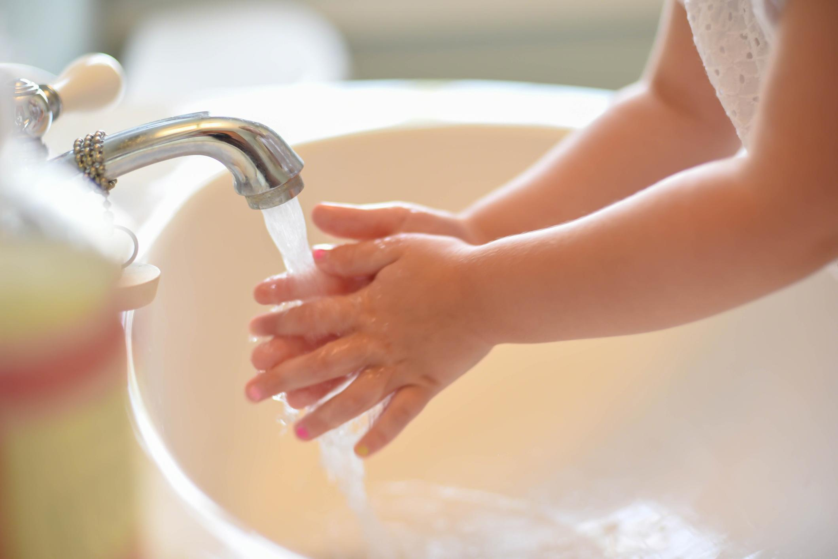 | 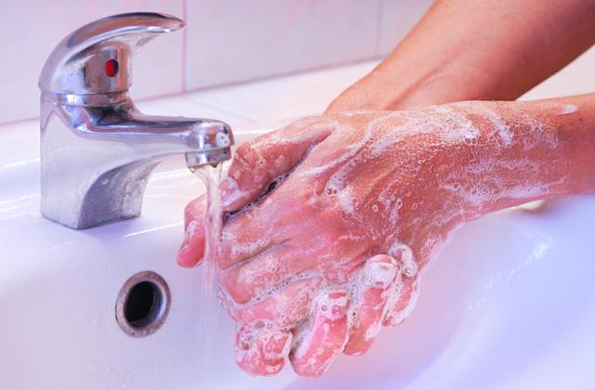
5. Thoroughly clean area after use. | 6. Remove gloves safely and dispose of in “yellow bin”. | 7. Help the child to wash their hands | 8. Wash your hands.

