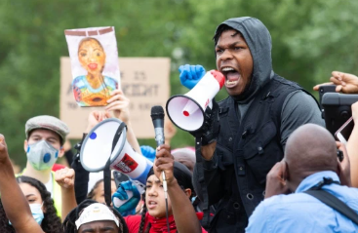
John Boyega - Actor from Star Wars - Hyde Park in London at a George Floyd protest June 3
First of all, I want to thank every single one of you for coming out. This is very important. This is very vital. Black lives have always mattered, we have always been important, we have always met suffering, we have always succeeded, regardless. And now is the time. I ain’t waiting. I ain’t waiting.
Today is about innocent people who were halfway through that process. We don’t know what George Floyd could have achieved. We don’t know what Sandra Bland could have achieved, but today we’re going to make sure that that won’t be an alien thought to our young ones. I’m sure you all came today, you left your kids, and when you see your kids, they’re aimlessly playing. They don’t understand what’s going on. Today’s the day that we remind them that we are dedicated, and this is a lifelong dedication.
Guys, we don’t leave here and stop. We don’t leave here and stop. This is longevity. Some of you are artists. Some of you are bankers. Some of you are lawyers. Some of you own shop stores, you are important. Your individual power, your individual right is very, very important. We can all join together to make this a better world. We can all do it together to make this special. We can all join together.

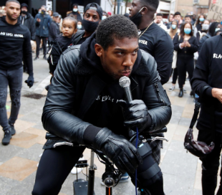
Anthony Joshua – Professional Boxer – Watford, London at a Black Lives Matter march June 6
"We stand united against the virus that has been instrumental in taking lives, lives of the young, old, rich and even poor. A virus that is not apologetic, a virus that spreads across all sectors of our communities, sports, education, churches, entertainment, the media and even the government. Not just in the UK, but across the world. The virus has been declared a pandemic. It is out of control. And I'm not actually talking about Covid-19.
The virus I'm referring to is called racism. How long are we going to allow racism to spread through our communities - and right now we are in the community - and affect our lives without using the vaccine you already have in your possession? What is the possession? Me and you. You are the vaccine. I am the vaccine. We can no longer, from today onwards, be proud, we can no longer sit back and remain silent on the senseless and unlawful killings, sly racism of another human being based only on what? Their skin colour.
I'm going to be real with you about gang culture. I'm down to ride 100 per cent, but what you have to realise is it's done, it is done, trust me, unless you want to be sitting in jail spending years upon years of your only life that you have thinking about 'Yeah they can lock the locks but they can't stop the clocks.’
That's all done because there's too much cameras, too much intelligence, all the OGs that I know are telling me, 'Bro, it's finished. It's finished'. Gang life is finishing, that's what we're saying, I know that, I'm not promoting no gangster business. I'm a legit straightforward hustler, that's just in my DNA and in my blood. I know I've taken my street knowledge and put it into the corporate world and I've gained a lot of respect in that sense. Gang culture is done. […] Let's inject the vaccine. Every life matters. 100 per cent I agree with that, but that includes black lives and that's why we're here today […]
We must unite as a human race and that's what we're doing here today.”
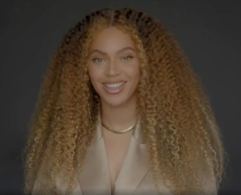
Beyonce – Actress/Singer – “Dear Class of 2020” speech - YouTube
And congratulations to the Class of 2020. You have arrived in the middle of a global crisis, a racial pandemic, and worldwide expression of outrage at the senseless killing of yet another unarmed Black human being. And you still made it. Thank you. We're so proud of you, for using your collective voice and letting the world know that Black Lives Matter.
The killings of George Floyd, Ahmaud Arbery, Breonna Taylor, and so many others have left us all broken. It has left the entire country searching for answers. We've seen that our collective hearts, when put to positive action, could start the wheels of change. Real change has started with you. This new generation of high school and college graduates who we celebrate today.
The entertainment business is still very sexist. It's still very male-dominated. And as a woman, I did not see enough female role models given the opportunity to do what I knew I had to do. To run my label and manage my company. To direct my films and produce my tours. That meant ownership. Owning my masters. Owning my art. Owning my future, and writing my own story. Not enough Black women had a seat at the table, so I had to go and chop down that wood and build my own table. Then I had to invite the best there was to have a seat. That meant hiring women, men, outsiders, underdogs, people that were overlooked and waiting to be seen.
Many of the best creatives and business people, who although supremely qualified and talented, were turned down over and over as executives at major corporations because they were female or because of racial disparity. And I’ve been very proud to provide them with a place at my table. One of the main purposes of my art for many years has been dedicated to showing the beauty of Black people to the world, our history, our profundity and the value of Black lives. I’ve tried my best to pull down the veil of appeasement to those who may feel uncomfortable with our excellence.
To all those who feel different. If you’re part of a group that’s called ‘other,’ a group that does not get the chance to be center stage, build your own stage and make them see you. Your queerness is beautiful, your blackness is beautiful. Your compassion, your understanding, your fight for people who may be different from you, is beautiful. I hope you continue to go into the world and show them that you will never stop being yourself. That it’s your time now, make them see you."
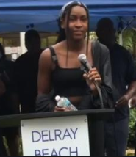
Coco Gauff – Tennis Professional – Speech at protest in Del Ray, Florida June 3
My name is Coco and I’ve just been speaking to my Grandma. I think it’s sad that I’m stood here protesting the same thing she did 50 plus years ago. So I’m here to tell you guys that me must first love each other no matter what. We must have the tough conversations with my friends, I’ve been spending all week having tough conversations. Trying to educate my non-black friends about how they can help the movement. Second, we need to take action. And yes, we’re all stood here protesting and I’m not of age to vote. But it’s in your hands to vote for my future, for my brothers future and for your future. So, that’s one way to make a change. Third, you need to use your voice no matter how big or small your platform is, you need to use your voice. I saw a Dr King quote that said “the silence of the good people is worse than the brutality of the bad people.” So, you need to not be silent because if you are choosing silence, you’re choosing the side of the oppressor. I’ve heard many things this week and one of them is that “it’s not my problem” so this is what I have to tell you. If you listen to black music, if you like black culture and you have black friends, then this is your fight too.

