Alder Community High School: Modern Foreign Languages Project
To prepare for your Spanish lessons in September and for the chance to win a prize, try to earn as many points as possible!
Collect minimum of 7 points for an Alder Point. Bonus prizes will be given to the highest number of points.
¡SUERTE! GOOD LUCK!
You can work on paper and bring it to your first Spanish lesson, or work on the computer and email it to e.thorley@alderchs.uk
Task title:

Personal details | Write “my name is ...” in Spanish. | Write your name and age in Spanish. | Write a paragraph giving your name, age and birthday. | Write a short email about you including your name, age, birthday and extra details.
Numbers | 1-10 in Spanish (with correct spellings). | 1-20, know them English to Spanish and Spanish to English. | 1-30, confident when asked out of order. Show your knowledge in a creative way. | 1-100, demonstrate you know the higher numbers and can spell them correctly.
Colours | Design a simple picture (eg flowers) and label 5+ colours in Spanish. | Find a Spanish picture and label all colours in French. | Make a colours word search, puzzle, card sort, or game to practise colours in Spanish. | Create 5 sentences in Spanish with colour and noun. (*word order and adjective agreement)  Eg. La manzana es roja.
Animals | 5 animals, create a match up game with the Spanish words. | Learn and spell 10 animals. | In a creative way show you know 10-15 animals. | Research more animal names in Spanish. You could make a zoo!
Life In Spain | Present 5 (or more) really interesting facts about Spain or another Spanish-speaking country. | Label a map of a Spanish-speaking country with towns, cities and natural geographical features (eg hills, rivers) | Research a place in Spain we could consider for a school trip. Explain what we would see and why it would be a good idea. | Find out about a custom or tradition in a Spanish-speaking country. It could be a festival, a historical event, or something else!
Own category | You pick a topic area ... | And show your knowledge... | In a creative and interesting… | Way ...
Remember to label your work with your name, the task title and points number so we know which it is.
4 points
3 points
2 points
1 point
To help you could use websites such as:  www.funwithlanguages.vacau.com/  www.euroclubschools.co.uk  https://pollylingu.al/es/en  https://www.bbc.co.uk/bitesize/subjects/zfckjxs | 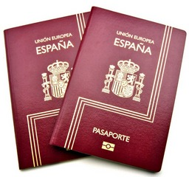  PASaPORTE  COLEGIO ALDER  IDIOMAS (MFL)  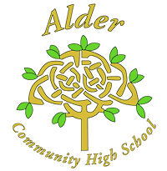  NOMBRE:  CLASE:  ESCUELA PRIMARIA:

