**The Elizabethan Age – 1558-1603**

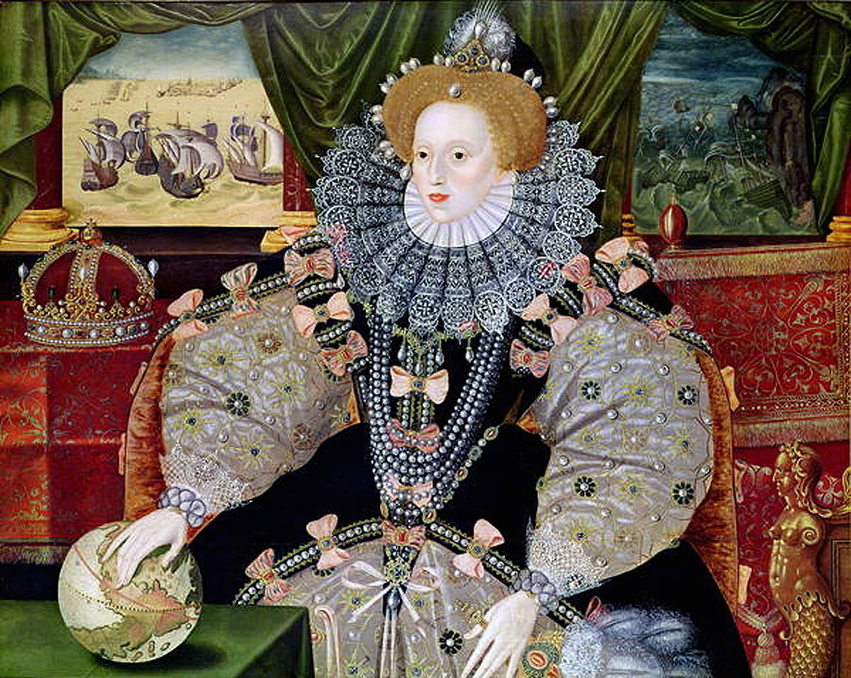

**Themes in this unit:**

**Theme 1 – Elizabethan government**

**Theme 2 – Lifestyles of rich and poor**

**Theme 3 – Popular entertainment**

**Theme 4 – The Catholic threat**

**Theme 5 – The problem of religion**

**Theme 6 – The Spanish Armada**

**Theme 7 – The Puritan threat**

**Theme 1: The Elizabethan Government**

**KEY QUESTIONS – ELIZABETHAN GOVERNMENT**

**What was it like when Elizabeth became queen: The coronation and popularity of Elizabeth;**

**How was England governed: The Royal Court, Privy Council and councillors; Local government;**

**What was the role of Parliament; taxation and freedom of speech**

|  |  |
| --- | --- |
| **Key Words** | **Definition** |
| **Monarch** | Name for a King of Queen |
| **Secretary of State** | Elizabeth’s most important Privy Councillor. The person she was closest to in government. |
| **Courtiers** | The people who lived in or near the same **palace** of Elizabeth. They were her key advisors, servants or friends. |
| **Privy Council** | **Senior** men of the court and advisors.  Mainly noblemen  Approx. 19 members of the Privy Council (all chosen by Elizabeth)  They met at least 3 times a week |
| **Parliament** | Made up of the **House of Lords** (which included bishops) and the **House of Commons**. They passed laws and offered advice to Elizabeth. |
| **Coronation** | Ceremony when the monarch is crowned |
| **Patronage** | This meant giving nobles important positions in the government and in return Elizabeth could keep them loyal and supportive. |
| **Faction** | A group at court. |
| **Lords Lieutenant** | Every county had one of these.  They were members of the nobility and many were on the Privy Council  They were in charge of raising local people to fight as soldiers if necessary and were part of the local government (militia) |
| **Justices of the Peace (JPs)** | They were large landowners who kept **law and order.**  They were unpaid. |
| **Militia** | A military force of ordinary people who agreed to **fight** in an emergency |
| **Sheriff** | Responsible for legal affairs; every county had one |
| **Parish Constable** | Helped with policing (see information below!) |
| **Night Watchman** | Patrolled streets at night looking for criminals |
| **Royal Progesses** | Tours of the countryside; to increase popularity |

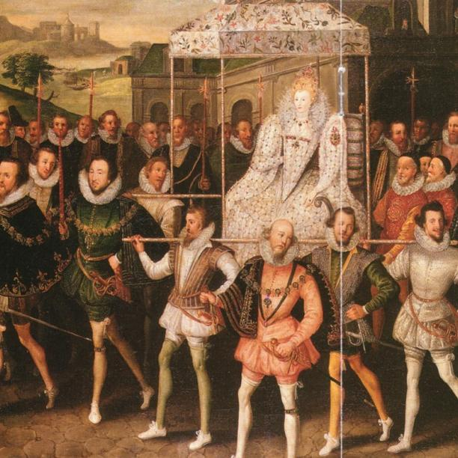**Elizabeth’s Coronation**

* Greeted with optimism, it was a **fresh start** for England
* Hope that Elizabeth **would be more tolerant than Mary**.
* **Ceremonies lasted several days** - Elizabeth travelled from Whitehall to the Thames on a ceremonial barge.
* There were **processions; pageants; musicians; finally crowned in Westminster Abbey**.

**How did she increase her popularity?**

**Portraits:**

* **Projected an image of royal authority**; propaganda; to **show she was a strong and successful ruler**.
* **Portraits used symbolism to show her power** e.g. pearls = purity; crown = power

**Royal Progresses:**

* **Tours of the countryside**; staying in the houses of nobles in the south-east and midlands never ventured up north). Took place in summer.
* **Propaganda**; made sure she was seen by her subjects; helped Elizabeth keep a watchful eye over the powerful noble families.

**Character:**

* Elizabeth was **well read**; studied theology;
* She **realised the importance of majesty and power** and **took pride in her appearance**.

**The Royal Court**

This was the centre of all political power! **Main residence was at** **Whitehall Palace**, London.

**Privy Council**

* **Group of advisors and ministers**, chosen from **nobles and the gentry**.
* **Met 2-3 times a week** in the early part of Elizabeth’s reign and when it was necessary e.g. 1562 when queen’s life was threatened by smallpox.
* Elizabeth kept many members of Mary I’s Privy Council to ensure continuity.
* **Extremely important to Elizabeth**! **Responsible for royal finances**, courts of law and national security. **Had considerable influence**.
* BUT factional rivalry might have made it less influential. Its members changed frequently, which meant it was not static. Also, **Elizabeth did not have to accept its advice**.
* Elizabeth kept her power and ensured loyalty in her ministers by operating a system of **patronage.**

**Factions**

* Different factions (groups) in Elizabeth’s court **became rivals for her attention**.
* She successfully **played them off against each other**.
* One chief rivalry was between **William Cecil and Robert Dudley who argued over religion and managing government**.

**Local Government**

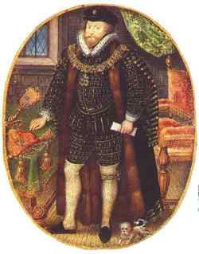Travel and communication was slow in 16th century England and it could take many days for messages to cross the country so **Elizabeth relied on local government to help her rule** the country effectively.

**Lord Lieutenant**

* **Wealthy landowner**; Privy Councillor; one appointed for each county.
* **Kept the queen informed** about what was happening in that area.
* In charge of **local militia** and **JPs.**
* Reported back to the Privy Council.
* Had deputy lieutenant to share the workload.

**Sheriff**

* **Mainly in charge of legal affairs** e.g. delivering prisoners, to court or helping to collect taxes.
* Not as an important job as it had been in medieval times.

**Justices of the Peace**

* MAIN PERSON RESPONSIBLE FOR LAW & ORDER.
* Between 30 – 60 per county.
* Workload increased considerably during Elizabeth’s reign.
* Usually **wealthy country gentlemen**.
* Unpaid but **gave men power and status**.
* Had to administer justice for minor crimes; oversee maintenance of the highways; give out relief to the poor; sit in the courts; completed legal documents for apprenticeships; supervise the **parish constable.**

**Law and order was carried out by lesser officials:**

**Parish Constable**

* Appointed from tradesmen or farmers living in the area.
* Had to hold the unpaid post for 1 year.
* Worked under the JP.
* Duties included: prevent trespassing and poaching; keep the peace; keep order in inns and taverns; carry out punishments e.g. whipping

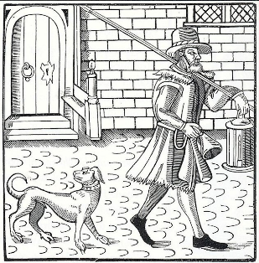**Night Watchman**

* Patrolled streets at night looking for criminals

**Overseer of the Poor**

* Organised and collected the Poor Rates (a local tax) from everyone in the parish and gave out this money to those who needed charity.

**The Role of Parliament**

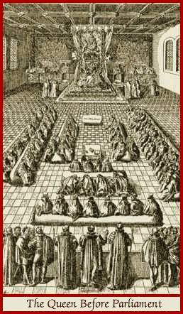In Elizabeth’s reign, **Parliament was much less powerful than it is today**. It was only called (met to discuss things) when the queen called it (usually for financial reasons). For 26 years there were no sessions of parliament at all.

**House of Lords** – not elected; about 100 lords, bishops and judges

**House of Commons –** 450 MPs who were elected by wealthy landowners. Mainly gentlemen, some lawyers.

**Why did Elizabeth call Parliament?**

* Only **parliament had the power to raise money through taxes** and give the revenue (£) to the Crown
* She needed to pass Acts of Parliament
* She needed the **support and advice** of MPs on important issues.

**Examples of Elizabeth calling Parliament:**

* 1559 to discuss the Religious Settlement
* 1571 – to decide what to do with Mary, Queen of Scots
* 1593 – to discuss the war in Ireland
* MPS in theory had freedom of speech to debate what they wanted.
* The **Speaker of the House of Commons** decided what topics were to be debated.
* BUT the Queen made it clear that some topics such as foreign policy and religion were to be discussed by the Privy Council and not Parliament.
* In 1571 she refused to discuss the issue of her marriage! In some instances she was prepared to limit freedom of speech.



Tudor monarchs were expected to pay for the cost of running the country from their own finances. Their income came from rents from royal estates and customs duties on good sold and brought into the country and taxes. See below for how successfully Elizabeth managed this!

|  |  |  |
| --- | --- | --- |
| **How successful was the government of Elizabeth?** | | |
| **PROBLEM** | **SOLUTION** | **How successful?** |
| **Finance**  Didn’t have much money (costly wars before she became queen)  £227,000 in debt when she became queen | Cut back government spending  Called all debts in.  Capped court salaries  Sold off Crown lands, bringing in £600,000 | Very successful.  Paid off Marian debt (Mary’s debt!)  Built up a reserve fund by 1585  BUT had to rely on parliament to raises taxes frequently |
| **Privy Council**  Crucial – needed a loyal team to run the country | Made **William Cecil** Secretary of State  Cautious and sensitive choices  Thanked past councillors for their work to keep their support  Did not make **Robert Dudley** – close friend a councillor until 4 years later so as not to cause jealousy  Kept high-ranking councillors who had served under Mary so as not to offend them.  Managed to control different factions and keep nobles loyal with **favours.** | **One of the greatest successes of her reign**  Elizabeth used **patronage** to keep political stability. |
| **Parliament had to be kept in check** | Elizabeth relied on her Privy Councillors instead. Only used Parliament to raises taxes (apart from when she asked for advice on Mary, Queen of Scots); limited freedom of speech and didn’t allow Parliament to discuss issues like religion | Elizabeth successfully used Parliament to her own ends and rarely called sessions. |
| **Elizabeth’s Personality – she had to convince the public and her peers that a woman could be a strong ruler.** | Royal progresses, propaganda portraits and a glittering coronation helped to cement her popularity.  Volatile temper – ensure that nobles were kept in check! |  |
| **Local Government had to be controlled** | Enlisted loyal, unpaid volunteers to help her keep law and order around the country e.g. JPs etc. | Very effective in maintaining law and order. Crucial to Elizabeth’s success. |
| *For much of her reign, Elizabeth was a strong monarch, and maintained political stability, particularly during the 1570s and 80s, when she ruled at the height of her powers.* | | |

**Theme 2 – Lifestyles of rich and poor**

**KEY QUESTIONS – LIFESTYLES OF RICH AND POOR**

**The contrasting lifestyles of rich and poor;**

**Homes and fashion;**

**Causes of poverty;**

**Unemployment and vagrancy;**

**Government legislation including the 1601 Poor Law**

|  |  |
| --- | --- |
| **Key Words** | **Definition** |
| **poverty** | being extremely poor |
| **nobles and lords** | Great landowners (only about 50 families in the country) |
| **gentry** | Lesser landowners (income of up to £2000 per year) |
| **merchant** | Someone who buys and sells goods |
| **yeoman** | Someone who owned their own property, had a few servants and farmed some land |
| **artisan** | Someone with a trade; a craftsman |
| **Dissolution of the Monasteries** | When Henry VIII shut down the monasteries (this had a huge effect on the poor people) |
| **dowry** | money paid by the father of the bride on her marriage |
| **wattle and daub** | the in-fill between the timbers of a house |
| **doublet** | Elizabethan shirt |
| **jerkin** | jacket |
| **hawking** | sport of training falcons |
| **poor relief** | action taken by government and the church to help the poor |
| **‘impotent poor’** | Poor people who were genuinely unable to work e.g. disabled |
| **‘able-bodied poor’** | Those considered capable of work but who were either unable or unwilling to find employment |
| **alms-house** | house for the poor paid by charity |
| **rack-renting** | charging extortionate amounts for rent |
| **vagabond** | homeless beggar who wandered the country |
| **clapper dudgeon** | tied arsenic to their skin to make it bleed, hoping to attract sympathy when begging |
| **Abraham man** | man who pretended to be mad to get more sympathy when begging |
| **poor relief** | action taken by the government to help the poor |

**The Elizabethan period in England had a daily life based on social
order: the monarch as the highest, the nobility as seco...Elizabethan society was deeply divided and there were huge differences between rich and poor.**

20-30% of population lived on the edge of starvation

**Lifestyles of the Rich Nobility**

Many **landowners increased their wealth** in Elizabethan times:

* 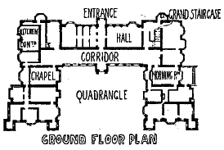**Buying land** after dissolution of the monasteries
* **Changing to sheep farming**, which was more profitable
* **Mining their land** for coal or lead
* **Marrying the daughter of a wealthy landowner** (and receiving a large **dowry**)

Wealthy built rich homes – ‘The Age of the Great Rebuilding’

Wanted to entertain Elizabeth on her royal progresses

Large; Great Hall was for servants dining room or formal events e.g. banquets

Latest fashion

Expensive tapestries

Defensive features – e.g. narrow winding staircases

Clear divide between owner and servant; designed in shape of letter E or H

Made of stone, wattle and daub or even brick

Long gallery for recreation; to exercise in bad weather; listen to music and dance

Family and servant wings

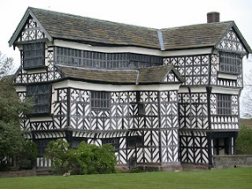**RICH HOMES**

Hardwick Hall, Speke Hall near Liverpool

Elizabethan mansion houses

Landscaped gardens provided food and used for pleasure. purposes

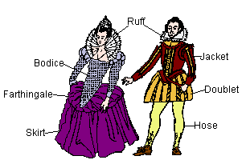**Fashion**

* Rich Elizabethans wore the **finest materials and the latest fashions**.
* **Ladies wore pearls** and rings to advertise their wealth and status.
* When going outdoors, men wore a clock of velvet and **carried a dagger** for protection.

**Education**

* **Sons of wealthy nobles were tutored at home**. Learnt the Classics, French, Latin; social etiquette; hunting; hawking and dancing. Men.
* **Daughters taught to run the house**.

**Women**

* **Supervised the day-to-day running of the of the household** e.g. producing everyday items such as bread, ale, salting meat and fish, making jam, soap, candles.

**Lifestyles of the Gentry**

**Not as wealthy as the nobility** but attempted to copy their changes in home and living accommodation – just not on such a grand scale.

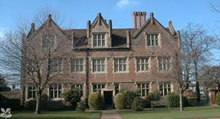 **Homes**

* **Rented out part of their land** to farmers to secure a regular income.
* **Copied fashion of the nobility**. New houses built of stone, brick or half-timbered.
* Walls were panelled with oak or plastered and decorated with tapestries.
* Oak staircases built to connect the great hall with the upper rooms; glass added to windows; large open fireplaces installed.

**Fashion**

* **Copied nobility but lacked fine threads of gold and silver** in their clothes. Fashion takenvery seriously as it was a status symbol.

**Education**

**Sons often attended grammar school**. By end of Elizabeth’s reign number of grammar schools increased to 360 – one in every large town. Key features of schools:

* Taught Greek and Latin
* Shown how to be the ‘perfect Tudor gentleman’
* Strict – ‘flogging’ was common
* 6am – 5pm with lunch break
* Some boys went to Oxford and Cambridge university afterwards or Inns of Court in London to study law
* Gentlemen also educated in social etiquette and good table manners.
* Hunting, fencing, music, dancing

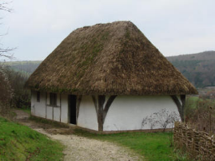**Lifestyles of the Lower Classes**

**Homes**

* **Poor man’s cottage usually had one room,** sometimes shared with animals.
* **Earth floor; timber frame** with wattle and mud infill; thatcher roof; few pieces of furniture.

**Working Day**

* 5am – 5pm; breaks at 7am and 11am for **bread and cheese**; main meal usually vegetables (could not afford meat).
* **Low life expectancy**; only a few infants survived past the age of 5; many died of disease.

**Fashion**

* Poor people wore **simple, loose-fitting clothes** made from woollen cloth.
* Most men wore trousers made from wool and a tunic which came down to just above their knee. Women wore a dress of wool that went down to the ground.

**Education and Leisure**

* No education; little leisure time. Visiting inns, cock-fighting, gambling, bear-baiting, betting on dice.
* Some poor people did attend village school and were taught the basics in reading and writing. Most left very early to work.

**Why did poverty increase in Elizabethan times?**

**Population**

* Grew by 35%. London was the fastest growing city in England.
* Food was grown in the countryside and brought into the towns. Prices of food rose especially bread.

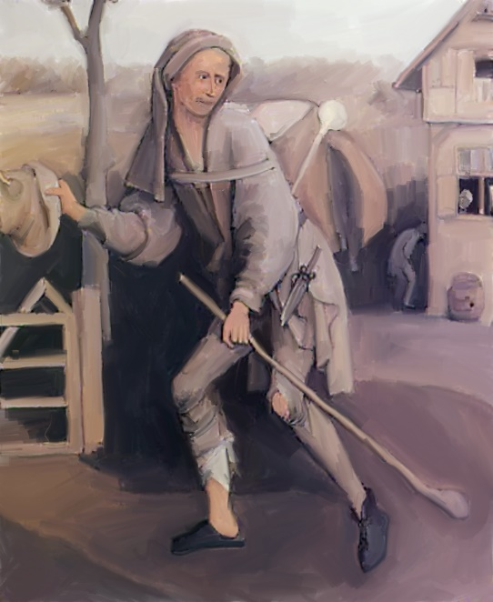**Enclosure**

* Some farmers started to enclose their land with hedges.
* This meant replacing large, open fields that were farmed by lots of villagers with small fields that needed fewer labourers. More people lost their jobs as a result

**Enclosure**

* Sometimes, the common land in the village was enclosed.
* This was vital for survival! Caused a great deal of anger and resentment.

**Changes in farming methods**

* English wool accounted for 81.6% of England’s exports during Elizabeth’s reign.
* The price of wool increased as there was more demand for cloth.
* Landowners increased their flocks of sheep.
* Needed fewer people to work land = unemployment grew

**Dissolution of the monasteries**

* Less food and shelter for the poor; caused a rise in unemployment (among monks, servants etc.)

**Poor harvests**

* Between 1556 and 1600. This caused food shortages and the price of bread rose.

**Rack-renting**

* Population growth = demand for land increases = landowners charged higher rents.
* Charged an entry fee for new people taking over land. Some tenants were evicted (thrown off the land).

**Costly foreign wars**

* France, Scotland – raised taxes to pay for them.
* Also, when the wars ended, there were more unemployed soldiers who wandered the countryside looking for work
* Led to increase in **vagabonds (sturdy beggars)** and crime. Classified into **able-bodied poor** and **impotent poor**

**People feared vagabonds because:**

* Seen as idle and lazy
* Too many turned to a life of crime as a solution
* By wandering the country they helped spread disease (especially plague)
* People resented the increase in taxes to pay for Poor Rate

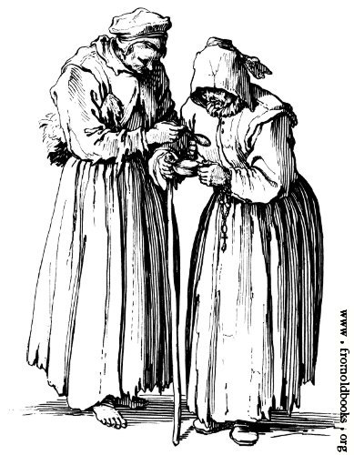

**Types of vagrants:**

* **Clapper Dudgeon**
* **Doxy**
* **Abraham Man**
* **Counterfeit Crank**

Henry VIII – 1536 – ordered vagabonds to be whipped

Edward VI – 1547 – vagabonds branded with letter ‘V’

Elizabeth passed a series of Acts of Parliaments which built on existing laws. These led to the **Elizabethan Poor Laws of 1601**.

|  |  |  |  |
| --- | --- | --- | --- |
| **Year** | **Act** | **Details** | **Impact** |
| **1572** | Vagabonds Act | Harsh punishments (death penalty for 3rd offence)  JPS to keep register of **Poor Rate**  **Overseers of the Poor** to help collect this | Government accepted that some people needed support BUT did not remove the causes of poverty |
| **1576** | Act for the Relief of the Poor | JPs to build two **Houses of Correction** in every county  JPs kept materials in every town to provide work for those unable to find a job | Some help for able-bodied vagrants  BUT did not remove the causes of poverty |
| **1598** | Act for the Relief of the Poor | 4 Overseers appointed to each parish.  Work to be found for able-bodied men and women  Poor children to learn a trade or craft  All people pay a Poor Rate | Did help those in need of support  Did try to provide jobs  Remained in force until 1834 |
| **1598** | Act for the Punishment of Rogues | Houses of Correction for rogues and vagabonds  Begging strictly forbidden – whipped and returned to place of birth | Helped to contain poverty and vagrancy  Reduced the risk of social unrest |
| **1601** | **Act for the Relief the Poor** | Made the 1598 Poor Law permanent.  Known as the **Elizabethan Poor Law** | Realisation that the government had a responsibility towards the poor.  Set up a legal framework to tackle poverty |
| **Poor laws did not end poverty but they introduced an organised system to look after the poor.**  **Poverty continued to rise, they did not always tackle the causes of poverty BUT they reflected a change in attitude. Thousands of people were helped, the risk of rebellion and social unrest was reduced and Elizabeth’s system continued for the next 200 years.** | | | |

**How did people try to deal with the poor in Elizabethan times?**

**Theme 3 – Popular entertainment**

**KEY QUESTIONS – POPULAR ENTERTAINMENT**

**The importance of popular entertainment; cruel sports;**

**Entertainment enjoyed by the rich; the Elizabethan theatre; design, plays; attitudes towards the theatre**

|  |  |
| --- | --- |
| **Key Words** | **Definition** |
| **bear-baiting** | Bears (or bulls) chained by the neck; dogs released to make it angry and bets places on which dog the bear would kill last when released |
| **cock-fighting** | Usually two birds; fight to death; spectators bet on who would win |
| **hawking** | teaching hawk to fly off a trainer’s arm, kill a selected bird of prey and then return |
| **bands of strolling players** | toured the countryside performing plays |
| **Christopher Marlowe** | Famous playwright, wrote *Doctor Faustus* |
| **William Shakespeare** | Most important playwright of Elizabethan times |
| **Archery** | Shooting with a bow and arrow |
| **Viol** | String instrument |

**Why was entertainment so popular?**

* **Most people had very little time off work** (Sundays, few religious festivals)
* **Life was hard**; high death rates, so entertainment was an escape
* **Wanted to enjoy what little free time** they had

**Types of entertainments:**

**Cruel sports – animals are made to fight each other for entertainment**

**Bear-baiting**

* Arenas like ‘Bear Garden’ in London.
* Could hold up to 1000 people; circular building with staged seating (similar to theatre).
* Elizabeth went to shows during royal progresses (tours of the country).
* People would bet on which animal would win

**Bull-baiting**

* Also popular as bulls were more common than bears….

**Cock-fighting**

* Also popular.
* Passion for cruel sports was dying out towards the end of Elizabeth’s reign

**Entertainment enjoyed by the rich:**

**Hunting**

* deer; wealthy nobles had their own deer parks; on foot or on horseback

**Archery**

* Men over 24 expected to practice on a Sunday after church.

**Entertainment enjoyed by all:**

**Dancing**

* Popular amongst all classes.
* Upper classes paid musician to play popular foreign tunes. One dance, **the volta**, seen as too disgusting by some as the lady had to leap into the air!

**Singing**

* Recorder, lute, viol all popular instruments. Some English composers like Morley were famous across Europe

**Ball games**

* Tennis, bowls, skittles (football popular among the lower classes – no goals, no pitch and no limit to number of players on a team!
* Winner had to get the ball across the opposite team’s finishing line. Very rough, few rules and led to the occasional death!)

**The Development of the Elizabethan Theatre**

* 1558 = no theatres.
* By 1603 they had been **built across London and in many towns**.
* Bands of **strolling players**: common in early Tudor times.
* Would erect a portable stage – very popular!
* **Common theme was adventures of Robin Hood** (poor people triumphing over the rich!) – many in authority wanted them banned!
* Fear that subject matter of some plays would encourage people to rebel.
* Fear that players could spread disease like the plague.
* Many **players were classes as vagrants**.
* 1572 – law passed - strolling players could not tour the country and had to get a licence.
* This led to the formation of theatre companies – financial support from wealthy noblemen. E.g. **Earl of Leicester’s Players** formed in 1574.
* Many **performed for the queen** at Court and in stately homes.
* As **performance got more popular**, the courtyard inns became too small and so **permanent theatres were built**.
* 1576 – James Burbage built ‘The Theatre’ in Shoreditch. Instant success!
* Followed by The Curtain the following year and The Globe in 1599 (Shakespeare). Concerns over public health law and order and Puritan complains about sinfulness meant many theatres were built outside the city walls.
* More theatres = bigger audience. Popularity of theatres soared.

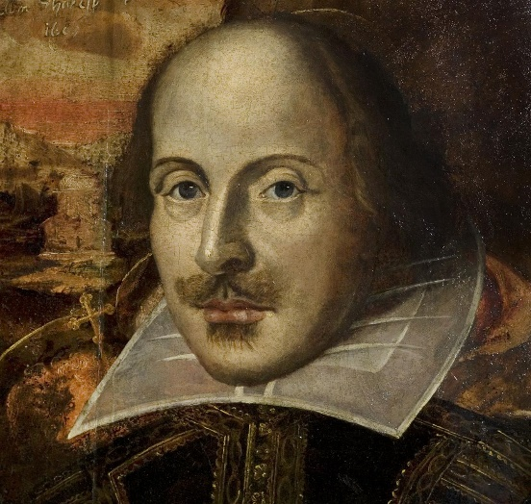

**William Shakespeare** – born in Stratford-Upon-Avon. Wrote at least 37 plays.

**Christopher Marlowe** – played a leading role in developing the ‘tragedy’ play. Most famous work was **Doctor Faustus**, a play set in Germany

**Design of the Elizabethan Theatre**

Outside, plain limewashed walls and thatched roof. Inside – colourful!

Flags were flown to tell people that a play was about to begin

Round shape, with an open shape in the centre, into which jutted a raised stage

Above the stage was the canopy which symbolised heaven in plays. The centre of the ceiling had a trap door from which could descend a god if the play required

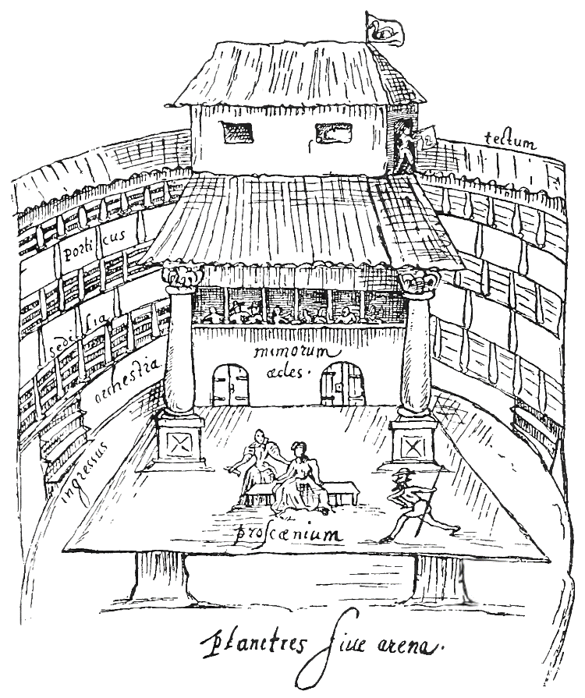

Back of the stage had a roof to protect actors in wet weather

Thick oak pillars, painted to look like marble supported the stage

Actors appeared on stage through doors in the back wall or through a trap door

Back of stage had painted panels but this was the only scenery! So actors had to tell the audience where they were and what time of day it was

No lights so plays had to be performed in the afternoon

Low prices so poor people could go.

Cheapest tickets were standing up in the pit

For a few pennies more, you could sit in the galleries, with a roof!

Professional actors developed from the theatre companies. Women were not allowed to act so their parts were taken by male actors.

Actors had to take on many different roles, be able to sing, dance and play musical instruments

* New theatres demanded new plays to satisfy Elizabethan audiences.
* Elizabeth’s reign became known as the ‘Golden Age’ of Elizabethan drama, during which some playwrights emerged whose works are still performed today.

**Attitudes to the Theatre**



|  |  |
| --- | --- |
| Popular form of cheap entertainment for all classes  Queen Elizabeth loved the theatre and was an important patron  Playwrights produced dramas with gripping storylines.  Plays could be used by the authorities as propaganda – e.g. many of Shakespeare’s plays delivered the strong message that obedience and loyalty to the queen was essential for law and order. Many plays had a strong moral message  Watching plays stopped people from being idle and drinking instead! | Some argued that it was a waste of money for poor people  Encouraged disease – this was spread more easily in large crowds e.g. plague  Many Puritans thought the topics of plays were too shocking. They thought they encouraged people to be sinful and were too rude.  Authorities didn’t always like people gathering in large crowds and beggars and pickpockets saw their opportunity during plays; they objected to theatres opening so close to the city centre |



**Theme 4 – The problem of religion**

**KEY QUESTIONS – THE PROBLEM OF RELIGION**

**Religious problems in 1559;**

**Aims of the Religious Settlement; the ‘Middle Way’,**

**Acts of Supremacy and Uniformity; reactions to the Settlement**

|  |  |
| --- | --- |
| **Key Words** | **Definition** |
| **Protestant** | Member of the Christian church who separated from Rome |
| **Catholic** | Member of the Christian church who saw the Pope as their head |
| **Puritans** | Extreme Protestants They wanted to rid England of all Catholic traces and persecute Catholics who refused to convert. |
| **illegitimate** | A child born to unmarried parents |
| **Frances II** | Catholic King of France |
| **King Phillip II** | Catholic King of Spain |
| **Religious Settlement** | Elizabeth’s religious ideas which was put in place to bring religious peace to the country |
| **appease** | To try and satisfy someone |
| **devout** | Having a deep or strong religious faith |
| **excommunicate** | To kick out of the Roman Catholic Church (this means that person would not get into heaven) |
| **recusant** | A person who refused to attend the Church of England |
| **Marian exiles** | Protestants who fled abroad when Mary Tudor became queen |
| **‘middle way’** | Elizabeth’s religious settlement tried to meet in the middle and please everybody |
| **Act of Supremacy** | Act that established Elizabeth’s control over the Church of England |
| **Act of Uniformity** | Act that explained how people should worship in the Elizabethan church |
| **Royal Injunctions** | Provided a set of instructions to the clergy to make sure there was uniformity in the way people worshipped and behaved |
| **The Visitations** | 125 commisioners who were appointed to enforce the two Acts. They had to tour the country and make the clergy take an Oath of Supremacy. |
| **Act of Exchange** | Allowed Elizabeth to take lands and buildings belonging to the Church and force bishops to rent land to her. |
| **Episcopacy** | Bishops |

**Religion in England**

When Elizabeth was crowned queen, she faced a number of problems. **One of the most pressing was the fact that the country was bitterly divided over religion**. Having been Roman Catholic for over 1000 years, England’s religion had witnessed three major changes before Elizabeth came to the throne.

**Henry VIII**

* Ended the pope’s authority by making himself head of the church of England
* Did not change church services but introduced an English bible
* **Remained Catholic but by the end of his reign, many in England were Protestant**

**Edward VI**

* **Heavily influenced by Protestant advisors**
* Introduced a new Protestant prayer book
* Church services had to be in English, not Latin
* Allowed priests to marry

**Mary Tudor**

* Made the Pope head of the church again
* Restored Catholicism

**CATHOLIC VIEWS:** Many Catholics thought that Elizabeth had no right to be queen. They thought Henry’s marriage to Anne Boleyn was not valid and Elizabeth was **illegitimate**.

Support from this came from **Francis II**, the Catholic King of France. HE said that **Mary Stuart,** Queen of Scotland, was the rightful queen.

Many Catholics wanted to get rid of Elizabeth and replace her with a Catholic queen.

She had to face a number of Catholic plots against her

* **Began to persecute Protestants**

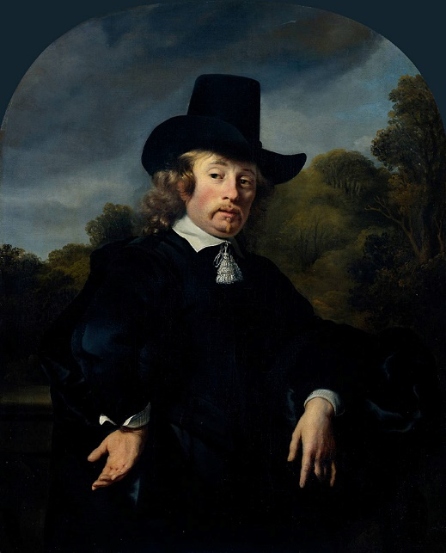

**PROTESTANT VIEWS:** Extreme Protestants, known as **Puritans**, were also a threat to the new queen.

* At the start of the 16th century everyone in Wales and England was Catholic.
* However, some argued that the C**atholic Church had become too wealthy, corrupt and had moved away from the Bible.**
* Martin Luther's protest in Germany against these issues started the Protestant Reformation which soon spread across Europe.
* Therefore when Elizabeth became Queen, **both Protestants and Catholics were eager to see what religion she would follow and whether religious persecution would take place**.
* **She therefore aimed to create her own form of religion, known as the Religious Settlement, in which she hoped to satisfy the demands of both elements.**
* The Settlement became known as the Via Media or 'middle way'.

**Aims of the Religious Settlement**

**One problem Elizabeth had was that she had to unite a country that was deeply divided over religion and appease lots of different groups.**

**Foreign powers**

* **FRANCE** - Francis II was married to Mary, Queen of Scots. Had to be careful that Francis did not attack to make Mary queen
* **SPAIN** - King Philip II of Spain was a **devout** Catholic who had been married to Mary Tudor, Elizabeth’s sister.
* **SCOTLAND** - Many of the powerful nobles who ruled Scotland were Protestants who did not want to see Catholic power grow.
* **THE POPE** – if he chose to **excommunicate** Elizabeth, this could encourage other Catholics to attack England.

**England**

* Majority of MPs were Protestant in the House of Commons but many in the House of Lords were Catholic
* **Marian Exiles** had fled during Mary’s reign and now wanted to return and take up posts in the government. They wanted Elizabeth to make the country more Protestant
* Most of the ordinary people were quite conservative in their religion

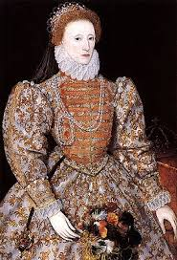

**ELIZABETH HERSELF:**

Understood how important religion was

Protestant upbringing

Disliked the authority of the Pope

BUT did believe in some parts of the Catholic faith e.g. she liked ornaments and decorations in Church

**Main priority was to unify the country!**

**The ‘middle way’**

* Majority of population were conservative in their religion and **preferred ceremonies that came with the Catholic church**.
* Elizabeth did not want to cause resentment and wanted to avoid the extreme policies of Edward and Mary.
* She wanted **tolerance** and with her **‘middle way’** hoped to please both Catholics and Protestants.
* **Protestantism was the official religion**
* **New prayer book, priests could marry, simple churches**
* **Refused to give way** to extreme Protestants
* **Kept some aspects of the Catholic Church** e.g. bishops and cathedrals; churches could use crosses and candles
* **Did not persecute Catholics** but did fine them for not attending Church

**The Act of Supremacy - 1559**

* This made **Elizabeth the Supreme Governor of the Church**.
* The term ‘Supreme Head’ was avoided because Christ was seen as Head of the Church.
* There was a **strict prohibition of foreign leadership in the English church**, so denying Elizabeth’s position in the Church was considered treason.

**The Act of Uniformity - 1559**

* This made **Protestantism England’s official faith** and set out rules of religious practice and worship in a **revised prayer book**.
* This **kept some Catholic traditions** which Elizabeth hoped would make a good compromise and keep her people happy.
* There was **a lot of support for the new Settlement** and very few refused to take the oath of loyalty to the queen.
* **Elizabeth’s tolerant approach seemed to have worked on the whole**, but it did not keep everyone happy **and she faced numerous threats.**
* Opposition came not only from **Catholics**, but also from more **extreme Protestants, known as Puritans**, who objected to any compromise with Catholic ideas.

**The Royal Injunctions ordered clergy:**

* Observe and teach the royal supremacy
* Condemn Catholic practices e.g. ban ‘fake’ miracles
* Report **recusants** to local JPS and fine them a shilling for each time them did not attend church on Sundays
* Make sure the congregations bowed at the name of Jesus and kneel when in prayer
* Make sure each parish had a copy of the Bible in English
* Priests could marry but only if they had permission from a bishop and two JPs

**Reactions to the Settlement**

* 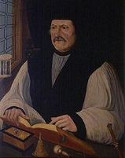By the mid-1560s **most people in England and Wales had come to accept the new church**.
* Matthew Parker, **new Archbishop of Canterbury was a moderate Protestant and commanded respect**
* Most of the **clergy took an oath of loyalty**. Less than 3% of the priests refused to accept the changes and lost their jobs
* Majority of the devout Catholics from Mary I’s reign resigned and were replaced by loyal Protestants
* Fines for **recusancy** were not properly enforced
* Opposition to parts of the Settlement only emerged later in the reign **(Vestments controversy)**

**Reactions abroad:**

* **France was drifting towards civil war** and showed no interest
* **King Phillip of Spain wanted to stay civil with England** and hoped the changes would not be permanent
* **The Pope voiced little criticism at first** and hoped it would change
* Only later that attitudes started to harden and some people challenged the Settlement.

**Summary – How successfully did Elizabeth deal with the problem of religion?**

|  |  |
| --- | --- |
| **She dealt with it very well** | **She dealt with it less well** |
| To a large extent the Religious Settlement was a success  Compromise – acceptable to the vast majority  Settled the issue of who was in charge of the church  Most people accepted it  Less than 3% or priests refused it  Foreign powers did not react strongly | Did not bring about an end to active religious persecution and discrimination  Catholics and Puritans still displeased  1580s and 1590s – more extreme reactions to the Settlement would emerge |

**Problem 1: Marriage**

**Why was marriage important to Elizabeth?**

* Needed an **heir** to the throne
* 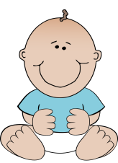**Elizabeth’s father had divorced his wife to marry Anne Boleyn (Elizabeth’s mother).**
* Some committed Catholics thought she did not have a **legitimate** claim to the throne (didn’t think she had the right to be Queen). Marrying would make her position stronger.
* A queen who ruled on her own was very unusual in the 16th century. It was thought that she would need a **man to rule for her**, especially since the monarchs were supposed to lead troops into battle.
* **Mary I** seemed to prove that women could not rule. Her reign had seen lots of problems e.g. losing war with France, poor harvests.

**Why did Elizabeth decide not to marry?**

* **Parliament** could not decide who she should marry
* Marrying an English nobleman could cause **anger and jealousy amongst other English nobles**
* **Archduke Charles** was a possibility later on but he was a Catholic and was opposed by **Protestants**

**Theme 5 – The Catholic threat**

**KEY QUESTIONS – THE CATHOLIC THREAT**

**Early toleration of Catholics;**

**Excommunication in 1570;**

**Rebellion of Northern Earls;**

**Catholic Plots – Ridolfi, Throckmorton, Babington;**

**Role of Mary, Queen of Scots**

|  |  |
| --- | --- |
| **Key Words** | **Definition** |
| **recusant** | Person who rebelled against Elizabeth’s Religious Settlement by refusing to attend church services. |
| **seminary priests** | Priests trained in Roman Catholic colleges |
| **Jesuits** | Roman Catholic priests who belong to the ‘Society of Jesus’ |
| **treason** | The crime of betraying your country. |
| **Mary Stuart** | Also known as Mary, Queen of Scots. Catholic queen of Scotland, Elizabeth’s cousin |
| **Papal Bull** | A letter published by the Pope |
| **Francis Walsingham** | Elizabeth’s chief spy |
| **Excommunicate** | To throw someone out of the Catholic Church |

**Background**

* The **Elizabethan Religious Settlement of 1559 was meant to provide religious stability to Wales and England, and to a considerable extent it did so** in the 1560s.
* Elizabeth had been shocked by the opposition to her plans by Catholic nobles in the House of Lords.
* **She realised many people were still Catholic**, possibly the majority, so she trod carefully in the years following the Settlement.
* As a result, **a policy of toleration towards Catholics was followed**.
* However, by the late 1560s, a s**eries of events began to challenge Elizabeth’s policy of toleration, resulting in a harsher stance being taken**.
* This would be the main threat to Elizabeth for the next 20 years.

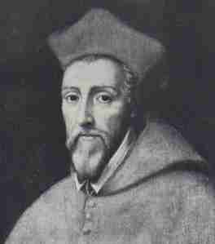**William Allen**

* Set up a college in Belgium to train English Catholics.
* These priests were taught that it was their duty to return to England and re-establish the Catholic faith.
* Their arrival fuelled suspicion that Catholics could not be loyal to the Crown. 438 seminary priests were sent to England.

**Jesuits**

* Members of a specific missionary.
* Their chief aim was to destroy Protestantism!
* They swore an oath of loyalty to the Pope and were prepared to die for their cause.
* They began to arrive in England in disguise in 1580, spreading the message of Catholicism.

**EDMUND CAMPION**

One of the most famous Jesuit priests, sent to England. Preached in the homes of rich Catholic families in London. Tortured, found guilty of treason and executed in 1581.

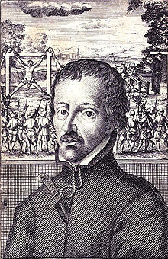

**1585 –Act of Parliament –** all Jesuits had to leave or be put to death. Anyone helping or hiding a priest could also be put to death. 98 priests killed.

**1593 –** Act forbid large gatherings of Catholics and known Catholics were confined to within 5 miles of their homes

**1581 –**Fines increased to £20

Any attempt to convert people to Catholicism punishable by death

**Government Response**

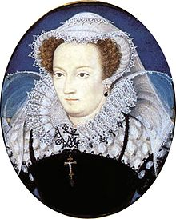 **Mary, Queen of Scots**

* **Scottish Queen**
* Arrived in England 1568; the Scottish lords wanted to execute has she was thought to have been involved in the murder of her husband, Lord Darnley.
* She wanted Elizabeth to protect her and had fled to England– *Elizabeth initially decided to keep her under house arrest*
* She was half-French and Catholic

**Why was she a threat?**

* She was a **figure-head for Catholics** who saw her as the rightful queen of England
* France or Spain could ally with her to take the throne of England

**Was the death of Mary, Queen of Scots the end of the Catholic threat?**

* Many of Elizabeth’s Privy Councillors and MPs hoped that the event would signal the end to Catholic plots.
* However some MPs like **Sir Christopher Hatton** believed that the threat was reduced but not completely gone. In reality, the execution only had a limited impact.

1. No backlash from English Catholics
2. No further plots for the rest of Mary’s reign
3. King Henry III of France did nothing as he wanted to be on friendly terms with Elizabeth
4. Spain – King Phillip was already planning an invasion so the execution made no difference

|  |  |  |  |  |
| --- | --- | --- | --- | --- |
| **What were the main Catholic threats to Elizabeth and how serious were they?** | | | | |
| Date | Who? | Events | Why did it fail? | Outcome |
| 1569 | **Revolt of the Northern Earls** – leading Catholic nobles – Northumberland and Westmorland  Also known as the **Northern Rebellion!** | Ordered their tenants to join their army and march south to restore Catholicism and put Mary Q of Scots on the throne  In Durham – destroyed protestant features of the Cathedral | Eliz moved MQ of S to another prison to avoid a rescue attempt  Eliz’s government kept control of all the major northern towns  Eliza moved MQ of S to another prison to avoid a rescue attempt  No foreign support ever arrived from Spain, as was expected | Royal army reached the River Tees in December 1569 and the rebels fled.  There had been no enthusiasm to replace Eliz as she was still a popular queen  Eliz executed over 450 rebels.  **FAILED!** |
| 1570 | **The Pope excommunicates Elizabeth** | Papal Bull issued saying Elizabeth was not the rightful queen of England and called upon all loyal Catholics to remove her from the throne. |  | Parliament passed the **Treason Act** – made it treason to say that Elizabeth was not the true queen or to publish the Papal Bull |
| 1571 | **Ridolfi Plot**  Italian banker – aimed to overthrow Eliz and replace her with M, Q of Scots | Ridolfi aimed to get support from Spain and wrote letters to the Duke of Alva in the Netherlands and Philip in Spain.  A coded document outlining the plan was left with the Duke of Norfolk | Elizabeth’s spies found out about the plot  Duke of Norfolk’s servants betrayed him under interrogation | Duke of Norfolk beheaded.  Ridolfi stayed free abroad  Elizabeth expelled the Spanish ambassador |
| *After the Ridolfi plot, most Privy Councillors wanted Elizabeth to execute Mary but she refused. She was reluctant to kill her cousin and a queen (chosen by God). She had no absolute proof that Mary was involved in the plots and was worried about angering France, Spain and the Pope even further* | | | | |
| 1583 | **Throckmorton Plot** | Francis Throckmorton, an English Catholic plotted to free M, Qu of Scots as the rightful queen with money from Spain and the support of the French army. | Intercepted by Walsingham before anything happened | Elizabeth expelled the Spanish ambassador.  Throckmorton was executed. |
| 1584-84 | **Assassination attempts** | The leader of the Dutch Protestants, William of Orange was shot dead by an assassin. In 1583 Eliz was threatened when **John Somerville** and English Catholic tried to shoot her. | Somerville was sentenced to death. | Parliament now v. concerned for Queen’s safety. Network of spies actively hunted traitors. 1585 – war with England and Spain made them even more worried. |
| 1586 | **Babington Plot** | Antony Babington wrote coded letters to M, Qu of Scots, plotting against Elizabeth. | Intercepted by Walsingham.  There was evidence that Mary had written back to Babington, encouraging the plot | Babington and 2 other plotters executed.  Mary Qu of Scots put on trial and executed in 1587. |

**Theme 6 – The Spanish Armada**

**KEY QUESTIONS – THE SPANISH ARMADA**

**Reasons for the Armada; war in the Netherlands;**

**Course of the Armada**

**Events in the Channel, Calais, ‘fireships’ and return to Spain;**

**Results of the Armada**

|  |  |
| --- | --- |
| **Key Words** | **Definition** |
| **armada** | A fleet of warships |
| **Duke of Medina Sidonia** | Commander-in-chief of the Spanish Armada |
| **Francis Drake** | English explorer who helped defeat the Spanish Armada |
| **Privateers** | A private ship that could be called up by the government to fight an enemy |
| **‘sea dogs’** | A name given to privateers in Elizabethan times |
| **galleon** | A sailing ship |
| **Calais** | Major town in France. |
| **Tilbury** | Place where Elizabeth gave her speech to the troops before the Armada |
| **fireships** | A ship that was deliberately set on fire and sailed into enemy troops |
| **Spanish Main** | Area of American that belonged to the Spanish |
| **Battle of Gravelines** | A battle between Spanish and English fleets |
| **Invasion** | attack |

**Reasons why the Armada was sent**

* During this period, Spain was the most powerful country in the world.
* It had grown extremely wealthy due to its conquests in the New World (Central America), an area that was known as the Spanish Main.
* It was also strongly Catholic, and although England and Wales enjoyed good relations with Spain at the start of Elizabeth’s reign, there were many reasons why they worsened, eventually resulting in war.

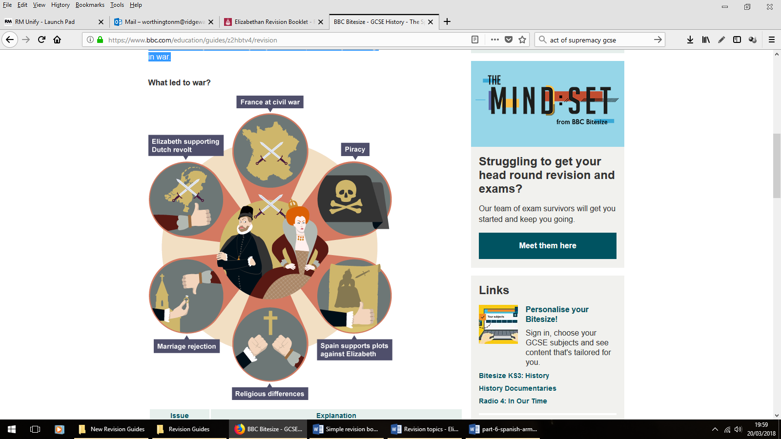

**Religious differences**

**Spain was a Catholic country and England a Protestant country** – meaning that the two rulers had conflicting spiritual outlooks and allegiances.

**Marriage rejection**

King Philip II of Spain had been married to Elizabeth’s sister, Mary I. When Mary died he offered to **marry Elizabeth but she rejected him**.

**Piracy**

**English sailors like Hawkins and Drake attacked and stole treasure from Spanish ships** in the New World. King Philip was furious but Elizabeth encouraged and rewarded adventurers.

**The civil war in France**

**France was the traditional enemy of both England and Spain**, meaning that they **united together against the country**. Now France was in civil war it was preoccupied with its own issues and no longer posed a threat – so **the alliance between Spain and England was not necessary anymore.**

**Spain supported Catholic plots**

There was evidence of **Spanish support for plots to restore Catholicism to England**, particularly involving getting Mary, Queen of Scots on the throne and Elizabeth off.

**The Dutch Revolt**

Protestants in the Netherlands began a revolt against Spanish rule in 1572. Elizabeth secretly supported the Dutch rebels because she knew the Dutch revolt would keep the Spanish too busy to threaten England.

**Elizabeth’s army joined the Dutch rebels**

In 1585, **Elizabeth sent an army to help the Dutch rebels fight Spain. For the first time English and Spanish armies were fighting each other**. England and Spain were now at war.

**The importance of the Netherlands**

* At this time, the Netherlands were ruled by Spain, but it was also an area that was geographically close and vital for English trade, especially wool and cloth.
* By 1572, Protestant ideas had spread in the Netherlands and Protestant Dutch rebels began a campaign for independence from Catholic Spain, leading to the Dutch Revolt.
* King Philip II of Spain was determined to crush the rebellion.
* He sent an army to defeat the rebels, who were led by William, Prince of Orange.
* However, after the assassination of William in 1584, Elizabeth was persuaded to help the Protestant rebels and sent an army of 7,600 men to the country.
* This amounted to a declaration of war with Spain.
* This, combined with the other factors such as English piracy, led to Philip finally deciding to invade England, by means of the Spanish Armada.
* Philip’s plans for the invasion of England were quickly prepared, but when they were leaked to the English, Sir Francis Drake sailed for Cadiz, Spain in May 1587.
* He destroyed all of the ships in the harbour and this helped to delay the departure of the Armada. He also destroyed the wood supplies leaving the Spanish with little to rebuild their fleet with. The Spanish fleet finally sailed in July 1588.

**What was the plan?**

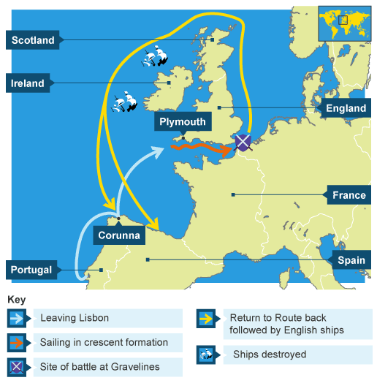

3. **Land at Margate in Kent, go up the Thames to London, capture the city and overthrow Elizabeth!**

The Spanish army would land and English Catholics would rise up in rebellion

1. **Anchor at Calais (France)** Pick up 17,000 Spanish soldiers from the Netherlands; led by Duke of Parma.
2. **Sail north from Lisbon**, destroying the English fleet in the channel

**Serious Flaws in the Plan!**

* **No harbours in the Netherlands deep enough for big Spanish ships** to dock
* **Problem of how to transport Parma’s army across the Channel**. Would need large barges which would have to be built on the spot and if the weather was rough, they might sink
* **Feb 1588 – the admiral in charge of the Armada died and Philip chose the Duke of Medina Sidonia to replace him**. (The duke himself felt he was not qualified and was easily **seasick**!)
* Shortly after the Armada set ail from Lisbon **it ran into a dreadful storm** and was blown off course. It had to take refuge in Corunna (Spain) to make repairs.

**Why was the Armada a threat?**

130 galleons and supply ships

[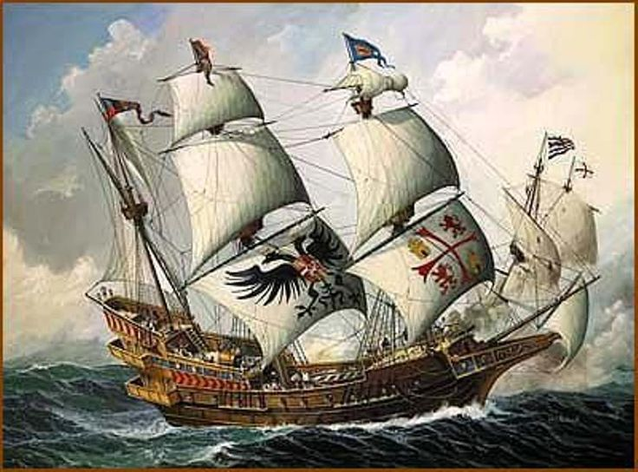](https://www.google.co.uk/url?sa=i&rct=j&q=&esrc=s&source=images&cd=&cad=rja&uact=8&ved=0ahUKEwiE1OCfwNDQAhXMbxQKHY-EC54QjRwIBw&url=https://www.pinterest.com/pin/86905467782036152/&psig=AFQjCNFh1SJL9ZdW-MZtkqI-rjDNCQ9W_A&ust=1480596048372207)

Extensive supplies of food and drink

30,000 men (experiences sailors, well-trained troops)

17000 well-trained soldiers led by the Duke of Parma waiting to join in the Netherlands

**How did the English prepare?**

* **Warning beacons** set up along the coast
* **Church bells** would be rung if Armada sighted
* Elizabeth raised a force of about 20,000 men (organised into 3 armies)
* English navy would be main line of defence – had 54 battleships that were light and fast-moving compared to Spanish galleons
* 140 merchant ships



**1)** 6 Aug – **the Armada anchored off Calais, France.** News came that the Duke of Parma’s **forces would not be ready for another week** as they were attacked by Dutch forces. The **English used this opportunity to attack with fireships**

**2)** 8 Aug – **English warships attacked the scattered Armada at the Battle of Gravelines**. After 8 hours of fighting, the English began to run out of ammunition and were forced to pull back. 3 Spanish ships lost but no English. 1000 Spanish killed – 50 English.

TURNING POINT: **The Spanish plan to join with Parma’s army had been defeated**. The English had some breathing space BUT the Armada were still a threat.

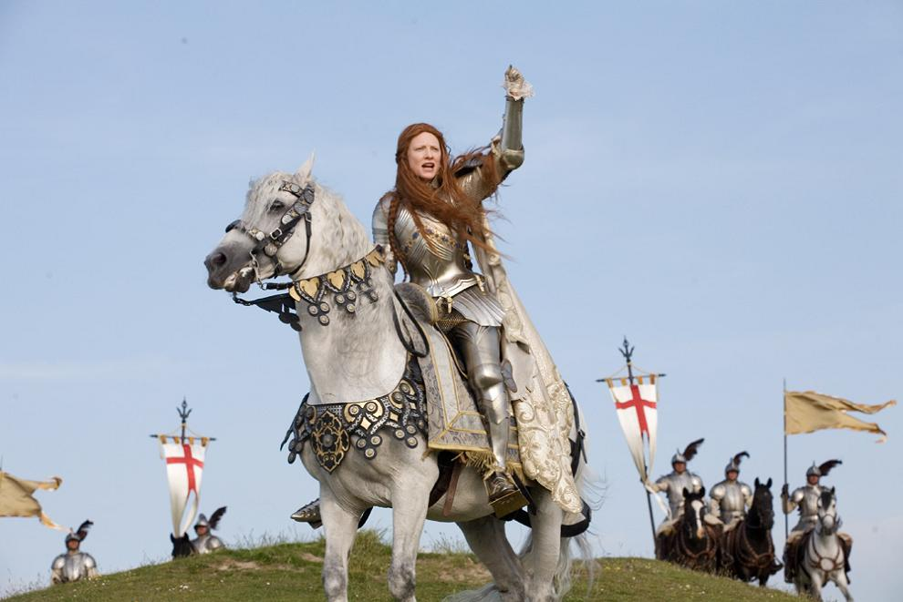

9 Aug – Elizabeth gave a rousing speech to the troops at Tilbury!

* On 9 August **the wind changed direction** and the Armada sailed into the North Sea; **it would not be able to return to Spain through the English Channel** and would have to go round the coast of Scotland and Ireland.
* The English fleet followed it past Scotland but then had to turn back; it was short of ammunition and food and many sailors were sick.
* The **Spanish then lost more of their fleet through shipwreck caused by severe storms** around Scotland and Ireland than it did through actual fighting. Only about 67 ships returned to Spain.

**Reasons for the failure of the Armada**

**English ships**: smaller, faster, heavier firepower, long-range cannons.

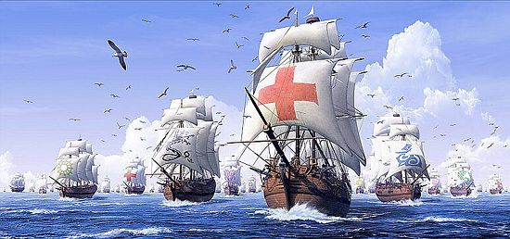

**Spanish weaknesses:** Cannons ineffective (the shot was made of poor-quality iron); Duke of Medina Sidonia inexperienced; Duke of Parma did not arrive on time (made it possible for English to attack at Calais)

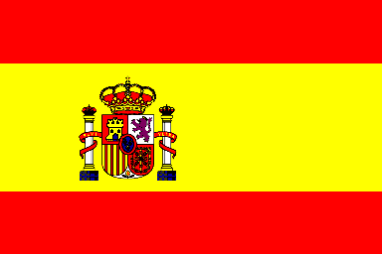

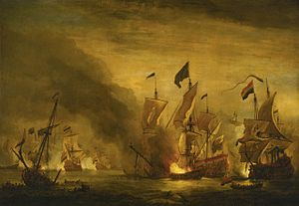

**English Tactics:** After the Spanish formation was broken in Calais, the use of fireships to break up the Armada made it impossible for the Spanish to keep control of the fleet



**Weather:** important after Battle of Gravelines – blew the scattered fleet northwards. The Spanish did not have maps and many died on the rocks,

**What Were The Consequences of The Defeat of The Armada?**

* The **threat of a Spanish invasion had now completely disappeared**
* **England would remain a Protestant country**. English Catholics had not risen up to support the Spanish
* **England was starting to become the greatest naval power** in Europe
* The Netherlands were encouraged by the failure of the Armada and felt more inclined to keep up their fight against their Spanish overlords.
* This was a **heavy blow to Spain's pride**. Spain had lost its status of "Super Power’
* There was still a risk of Spanish invasion and within a short time, Philip would send a new armada (on both occasions it was driven back by storms

|  |  |
| --- | --- |
| *How much of a threat was the Spanish Armada?* | |
| SERIOUS: England was isolated as a Protestant power and the Armada’s size made it difficult to attack.  English had difficulty in attacking crescent formation  Weakness of English land forces  Had it been successful in picking up Parma’s army, the consequences could have been severe for England.  England did not have a strong army. | Several factors helped Elizabeth:   * Duke of Medina Sidonia’s inexperience * Large, slow ships * English had superiors ships * Superiority of English naval commanders * Weather |
| The use of fireships at Calais was a turning point which reduced the Spanish threat.  The Battle of Gravelines and the deterioration in the weather saw the real threat of the Armada pass. | |