Admissions Arrangements for applications in the academic year of:
2026/2027
Alderman White School is a member of The White Hills Park Trust, and complies with the School Admissions Code and the School Admissions Appeals Code. All applications to join Alderman White School should be made through Nottinghamshire County Council.
The yearly Published Admission Number (PAN) for Alderman White School is 145 students. Alderman White School is currently full in all year groups and operating a waiting list.
The information below relates to admissions for academic year 2026-2027.

Standard admission Criteria for Year 7
Applications must be made through your home local authority. For Nottinghamshire residents, this can be found on the Nottinghamshire County Council website and applications should be completed by the closing date for applications as stated in the Nottinghamshire Coordinated scheme.

In-year Admissions
The White Hills Park Trust participates in Nottinghamshire County Council's in-year coordinated scheme. Please see our In-Year Admissions page for further information.

Special consideration for all year groups
Special consideration may be given to applications that are supported by written evidence from a doctor, social worker or other relevant professional giving reasons why the school is the only school which could cater for the child’s particular needs. This might include medical needs, mobility support needs, special educational needs or other social circumstances. The evidence must be presented at the time of application. The Directors will consider the written evidence provided to decide whether the application may be processed as special circumstances. Admission under special circumstances will have priority over all but the first numbered criterion.
The White Hills Park Trust have adopted the Home Local Authority’s stance on Fair Access Protocols. Local Authorities are required to have Fair Access Protocols in order to make sure that unplaced children who live in the home Local Authority, especially the most vulnerable, are offered a place at a suitable school as quickly as possible. This includes admitting children above the published admissions number to schools that are already full.

Oversubscription Criteria
In the event of oversubscription, the following criteria will be applied, in priority order, to decide which applications will be granted once places have been allocated to pupils who have a statement of special educational needs or an Education, Health and Care Plan which names the school provided that the school can meet their needs:
- Looked after children and those children who have been previously looked after, including those who ceased to be looked after through adoption or special guardianship order. This includes children adopted from state care outside England.
- Children who live in the catchment area at the closing date for applications and who, at the time of admission, will have a brother or sister attending the school.
- Other children who live in the catchment area at the closing date for applications.
- Children who live outside the catchment area but who are attending a linked primary phase school on the closing date for applications and who, at the time of admission, will have a brother or sister attending the preferred secondary school.
- Children who live outside the catchment area and who, at the time of admission, will have a brother or sister attending the preferred secondary school.
- Children who live outside the catchment area but who are attending a linked primary phase school on the closing date for applications preceding admission to secondary school.
- Other children.
In the event of oversubscription, within any criterion, preference will be given to children who live nearest to the school as the crow flies.

Looked after children or previously looked after children
The School Admissions Code 2021 states that all admission authorities must give the highest priority to LAC and PLAC. It states:
All schools must have oversubscription criteria for each ‘relevant age group’ and the highest priority must be given, unless otherwise provided in this Code, to looked after children15 and all previously looked after children, including those children who appear (to the admission authority) to have been in state care outside of England and ceased to be in state care as a result of being adopted16. Previously looked after children are children who were looked after but ceased to be so because they were adopted17 (or became subject to a child arrangements order18 or special guardianship order19). All references to previously looked after children in this Code mean such children who were adopted (or subject to child arrangements orders or special guardianship orders) immediately following having been looked after and those children who appear (to the admission authority) to have been in state care outside of England and ceased to be in state care as a result of being adopted.

Home Address
The child’s place of residence is taken to be the parental home, other than in the case of children fostered by a local authority, where either the parental address or the foster parent address may be used. Where a child spends part of the week in different homes, their place of residence will be taken to be their parent or parents’ address. If a child’s parents live at separate addresses, the address where the child permanently spends at least three ‘school’ nights (i.e. Sunday, Monday, Tuesday, Wednesday or Thursday) will be taken to be the place of residence. Addresses of other relatives or friends will not be considered as the place of residence, even if the child stays there for all or part of the week. Evidence that a child’s place of residence is permanent may also be sought and this should prove that a child lived at the address at the time of the application.
Informal arrangements between parents will not be taken into consideration. The Directors may also seek proof of residence from the courts regarding parental responsibilities in this matter.
For families of service personnel with a confirmed posting to the area or crown servants returning from overseas to live in the area, the Directors will accept a unit postal address or quartering area address for a service child.
In all cases all those with parental responsibility must be in agreement with the preferences made.
In the event of two distances being equal, lots will be drawn and independently verified.

Parents
- The mother of the child.
- The father of the child where he was married to the mother either when the child was born or at a later date.
- The father of the child if (since 1 December 2003) he was registered as the father on the birth certificate.
- An adoptive parent.
- Any other person who has acquired ‘parental responsibility’ through the courts. We may require evidence of this.
The person making the application must hold parental responsibility.

Siblings (brothers or sisters)
- A brother or sister who shares the same parents.
- A half-brother, half-sister or legally adopted child living at the same address.
- A child looked after by a local authority placed in a foster family with other school-age children.
- A stepchild or children who are not related but live as a family unit, where parents both live at the same address as the child.

Multiple Births
Where one child of a multiple birth can be admitted, the other child/children will also be admitted.

Catchment Area
The catchment area for Alderman White School is shown in the shaded area to the south of the A52 in the map below.
If you would like to learn more about our catchment area, see a detailed map and see which schools serve your home address, you can do so on the Nottinghamshire County Council website here.
(Click to enlarge)
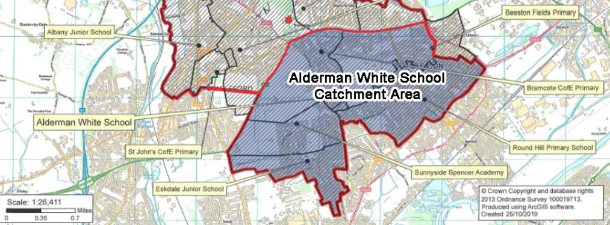

Linked Primary Schools
- Beeston Fields Primary and Nursery School
- Bramcote C of E Primary School
- Eskdale Junior School
- Round Hill Primary School
- Sunnyside Spencer Academy

Late applications (to Year 7)
Late applications received from the closing date up to the date specified within Nottinghamshire’s coordinated arrangements will be dealt with in accordance with the scheme. They will be considered as on time if the applicant can provide evidence that there were exceptional reasons for missing the closing date, for example family bereavement, hospitalisation or family trauma. Applications received after that date will be considered as late and processed after the national offer date.

Waiting lists
Waiting lists are held where the number of applications received is greater than the number of available places in the intake year group. The order of places on a waiting list is decided by the admission oversubscription criteria for the school. No reference will be made to the date we receive your application or whether you have chosen to appeal. Your position on a waiting list may change if any late applications are received which have a higher priority within the admission oversubscription criteria. These applications will be placed higher than those who have been on the list for some time, this is in line with the coordinated scheme. If your child is offered a place at a higher preferred school, their name will be removed from any waiting lists for lower preferences. The waiting list will be maintained for the remainder of the current academic year.
The White Hills Park Trust will notify the Home Local Authority when to write to offer a place to the applicant at the top of the waiting list if the number of allocated places falls below the published admission number for the school. Children’s names will only be added to a school’s waiting list if they are refused a place.

Application for Places outside the normal age group
Parents may seek a place for their child outside of their age group. For both primary to secondary transfer and in year admissions parents should submit a request in writing to their Home Local Authority’s school admissions team as early as possible. In all cases decisions will take into account the age group the child has been educated in up to that point and will be made on the basis of the individual circumstances and in the child’s best interests.

How do I appeal?
The appeals process for Alderman White School is run by Nottinghamshire County Council.
If you wish to appeal against a decision to refuse a place for your child at this school you can appeal online or in writing (paper form attached below). Please view the guidance on the Council's website here, where you will find:
- advice and explanations of the appeals process
- timetables, key dates and deadlines
- links to the appeals portal and forms
You can also call 0300 500 80 80.
In Year and Transfer Appeals
For other appeals such as transfer and in-year admissions (moving from one school to another during the school year) please return your form to Nottinghamshire County Council within 4 weeks of the date of your refusal letter. These appeals will be heard within 30 school days of receipt of your appeal.
Decision letters are sent out within 5 school days of the hearing wherever possible.

