Maths KS3 Curriculum Overview

This document provides detailed information of the intended learning outcomes of pupils in years 7 & 8 Maths at Alderman White, following a mixed ability, quality-first or Mastery-based approach with carefully sequenced topics. Some pupils will not reach desired outcomes, and some will exceed them, but they are a benchmark for teachers to work with when planning lessons and considering the needs of pupils in their groups. The cyclical nature of our curriculum offers opportunities to revisit topics to deepen understanding, alongside intentional retrieval strategies via starter activities and homework. Our SOLs are reviewed and adapted annually.
Our aim is for all* pupils to learn the skills that they will require to pass their GCSE Maths qualification and to prepare them to be competent in the mathematical skills that they will require in later life, and to challenge them to achieve the best outcomes of which they are capable, through igniting in them a passion for the subject.
This document can be used by pupils/parents/tutors in conjunction with the publicly available corbettmaths website https://corbettmaths.com/contents, using the contents page to access tutorial videos and worksheets with solutions.
Pupils are encouraged to take ownership of their progress and learning in Maths, identifying their own strengths and weaknesses to build useful revision habits in preparation for GCSEs. They have a topic tracking card in their books to do so.

*This aim is not realistic to a minority of pupils, whose experience will be adapted by teachers, with the aim for them to feel included and valued in mainstream lessons, with opportunities to collaborate, to engage, to succeed and to enjoy Maths lessons, and to benefit from excellent role-modelling of pupils around them.

Joel Haigh
Head of Mathematics, Business Studies & Economics

Year 7
Scheme of Learning:
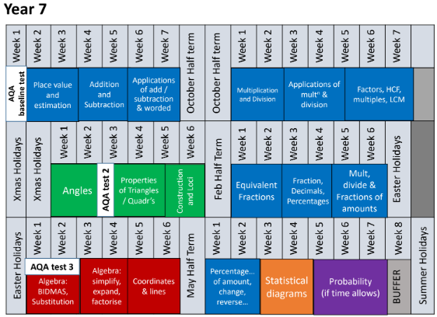

Place Value & Estimation
- Understanding and using Place Value [222],
- Rounding [276 to 280],
- Estimation [215],
- Ordering decimal numbers [95].

Addition & Subtraction
- Methods of addition and subtraction with integers [6 & 304],
- Addition and subtraction of directed numbers (negative numbers) [205],
- Addition and subtraction of decimal numbers [90 & 91].

Applications of Addition & Subtraction
Applications of addition and subtraction skills, Worded problems, Perimeter problems, Money problems.
- Video 209 Negatives real life,
- Video 242 Perimeter on a grid,
- Video 241 Perimeter.

Multiplication & Division
- Multiplication methods [199 to 202],
- Division methods [98 to 100 & 103],
- Multiplying and dividing with negative numbers [206, 207],
- Multiplying and dividing with decimal numbers [92 to 94, 101, 102 & 204]

Applications of Multiplication & Division
Applying multiplication and division to problems,
- Calculating the area of rectangles [45],
- Calculating the area of triangles [49],
- Solving wordy problems,
- Calculating the mean average of a set of numbers [53 (& 54=optional)].

Factors & Multiples
- Understand what Prime numbers are and be able to recall them [225],
- Know what the multiples of a number are [220],
- Find the lowest common multiple (LCM) by listing [218],
- Find all of the factors of a number [216],
- Find the highest common factor (HCF) by listing [219],
- EXTENSION: Find the HCF and LCM by using a prime factor tree [224].

Angles
- Drawing and measuring angles accurately using a protractor [28 & 31],
- Naming the types of angles [38],
- Know and use angle facts to find unknown angles including;
--- Angles on a straight line [35],
--- Angles around a point [30],
--- Vertically opposite angles [39].
Triangles & Quadrilaterals
- Know the names and features of common polygons (2D shapes) [1 & 2]
- Identify and describe line symmetry [316],
- Identify and describe rotational symmetry [317],
- Know and use properties of triangles, including their interior angle sum [327 & 37],
- Know and use properties of quadrilaterals, including their interior angle sum [2 & 33].

Construction & Loci
- Accurately construct angles and shapes using ruler, compasses and protractor [81 & 82]
- Accurately copy diagrams using only a ruler and compasses [68 - 71, 73 & 83]
- Construct the perpendicular bisector of a line [78],
- Construct the perpendicular at a given point on a line [80],
- Construct a perpendicular from a given point to a line [79],
- Bisect an angle [72],
- Use constructions to solve Loci problems [75 - 77].

Equivalent Fractions
- Show the fraction of a shape [143]
- Express one number as a fraction of another [136],
- Simplifying fractions [146],
- Using equivalent fractions to sort and order fractions [135, 144],
- Convert between Mixed numbers and improper fractions [139 & 140].
Fractions, Decimals & Percentages
- Converting between equivalent Fractions, Decimals and Percentages [121 to 129].

Multiply, Divide, Fractions of Amounts
- Multiplying fractions [142],
- Dividing fractions [134],
- Finding fractions of amounts [137],
- Finding the original amount (reverse fractions) [138].

Algebra (BIDMAS & Substitution)
- Using the correct order of operations (BIDMAS/BODMAS) [211],
- Using algebraic notation [19],
- Substituting values into Algebraic expressions [20].

Algebra (Simplify/Expand/Factorise)
- Simplifying expressions (sometimes called collecting like terms) [9 & 18],
- Expanding (or multiplying out) brackets [13],
- Factorising (putting brackets into expressions) [117].

Coordinates and Lines
- Plotting and reading coordinates [84, 87],
- Plotting linear graphs [186].

Percentages
- Calculating percentages of an amount (with or without a calculator) [234 & 235],
- Expressing a quantity as a percentages of another [237],
- Calculating percentage increases and percentage reductions [238],
- Calculate the original amount given a percentage increase or decrease (reverse percentages) [240].

Statistical Diagrams
- create and interpret pictograms [161/162],
- tally charts and frequency tables [321],
- create and interpret bar charts [147/148].
- create and interpret line graphs [160],
- create and interpret pie charts [163/164],

Probability
- Understand and use the vocabulary of probability [251],
- Express probabilities as a number between 0 (impossible) and 1 (certain), either as a decimal, fraction or percentage [245],
- Understand that outcomes are equally likely if there is the same chance of each outcome occurring,
- Calculate the theoretical probability of a desired outcome,
- Calculate the probability of an event not happening [250],
- Represent and analyse outcomes of probability experiments[248],
- Use tables and frequency trees to organise outcomes [246, 252 & 253].

Year 8

Scheme of Learning:
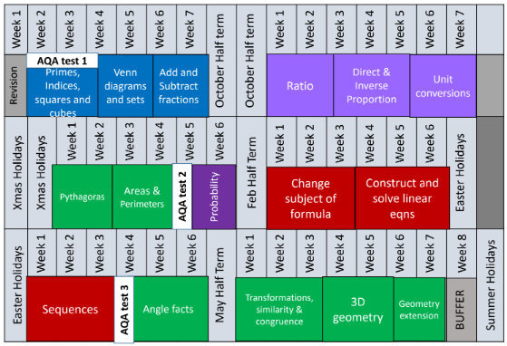

Primes, Indices, Factors
- Prime Numbers [225],
- Indices [172],
- Factors [216],
- Product of prime factors [223],
- Common factors and HCF [219],
- Square Numbers [226].

Venn Diagrams & Set Notation
- Understand and use set notation [379],
- Complete Venn Diagrams and use them to answer probability questions [380].

Add & Subtract Fractions
- Equivalent fractions and simplifying fractions [135 & 146],
- Converting between mixed numbers and improper fractions [139 & 140],
- Adding and subtracting fractions [132 & 133].

Ratio
- Use ratio notation to write ratios and to simplify [269 & 271c],
- To divide quantities into two or more parts given a specific ratio [270],
- To solve ratio problems where one part is given [271],
- To solve ratio problems where the difference is given [269a].

Direct & Inverse Proportion
- Solve direct & inverse proportion problems using the unitary method [255a],
- Solve recipe type questions [256],
- Solve best buy type questions [210],
- Use graphs to solve direct proportion problems [151 & 152],

Unit Conversions
- Converting metric units [349a, 349b, 349c],
- Converting times [322],
- Converting speed units (e.g. m/s to km/h)
- Convert Currency [241a]

Probability
- Understand and use the vocabulary of probability [251],
- Express probabilities as a number between 0 (impossible) and 1 (certain), either as a decimal, fraction or percentage [245],
- Understand that outcomes are equally likely if there is the same chance of each outcome occurring,
- Calculate the theoretical probability of a desired outcome,
- Calculate the probability of an event not happening [250],
- Represent and analyse outcomes of probability experiments[248],
- Use tables and frequency trees to organise outcomes [246, 252 & 253].

Pythagoras' Theorem
- Knowing how to square a number and how to find the square root of a number [226, 227 & 228],
- Rounding numbers to an appropriate level of accuracy (decimal places or significant figures) [278 & 279a],
- Using Pythagoras' Theorem to find the missing length of any side of a right-angled triangle [257],
- Using Pythagoras' Theorem to solve problems involving RATs [260],
- Using Pythagoras' Theorem to determine whether or not a triangle has a right angle [261].

Area & Perimeter
- Calculate the Perimeter of simple shapes (e.g. rectangles, triangles, parallelograms and trapezia) [241 & 242],
- Calculate the Perimeter of composite shapes [241],
- Calculate the Area of simple shapes (e.g. rectangles, triangles, parallelograms and trapezia) [43, 49, 44, 45 & 48 ],
- Calculate the Area of composite shapes [41 & 42].

Change the Subject
- Algebraic manipulation [9, 13, 18],
- Substituting into Formulae [20],
- Changing the subject of a formula [7 & 8],

Construct & Solve Equations
- Forming equations [115],
- Solving 1 and 2 step linear equations [110],
- Solving linear equations with brackets and unknown on both sides [113].

Sequences
- Continuing a sequence of patterns [290]
- Describing the rules for sequences [286/287],
- Finding the nth term of a sequence [288],
- Recognising special sequences [287a].

Angles
- Know and use basic angle facts to find unknown angles including;
--- Angles on a straight line [35],
--- Angles around a point [30],
--- Vertically opposite angles [39],
--- Angle sum of a triangle [37],
--- Angle sum of a quadrilateral [33].
- Know and use the angle properties of parallel lines including;
--- alternate angles, co-interior angles, corresponding angles [25],
- Calculate the sum of the interior angles of any polygon [32],
- Calculate the size of a single interior angle of a regular polygon [32],
- Use the fact that the sum of the exterior angles of any polygon is 360 degrees [32],
- Calculate the size of a single exterior angle of a regular polygon [32].

Transformations
- carry out, identify and describe reflections [272 to 274],
- carry out, identify and describe translations [325 and 326],
- carry out, identify and describe rotations [275],
- carry out, identify and describe enlargements with integer scale factors [104, 104a, 105, 106 & 109],
- Understand what it means for two shapes to be mathematically similar [291],
- Understand what it means for two shapes to be congruent [66],
- Carry out, identify and describe enlargements with fractional or negative scale factors [107 & 108],
- Calculate the length of sides in similar shapes [292].

Geometry
- naming 3D shapes [3],
- drawing and recognising the nets of 3D shapes [4],
- understanding what faces, edges and vertices are [5],
- calculate the volume of a cuboid [355],
- calculate the volume of prisms and composite shapes [356-358].

Further Geometry
- Circumference and area of a circle [59 and 60]
- Volume of cylinders and cones [357 and 359]
- Including rounding and significant figures [278 and 279a]

*This information can also be found, alongside useful resources, activities and post-tests with solutions, on pupils’ pink Maths year group Google Classroom.

