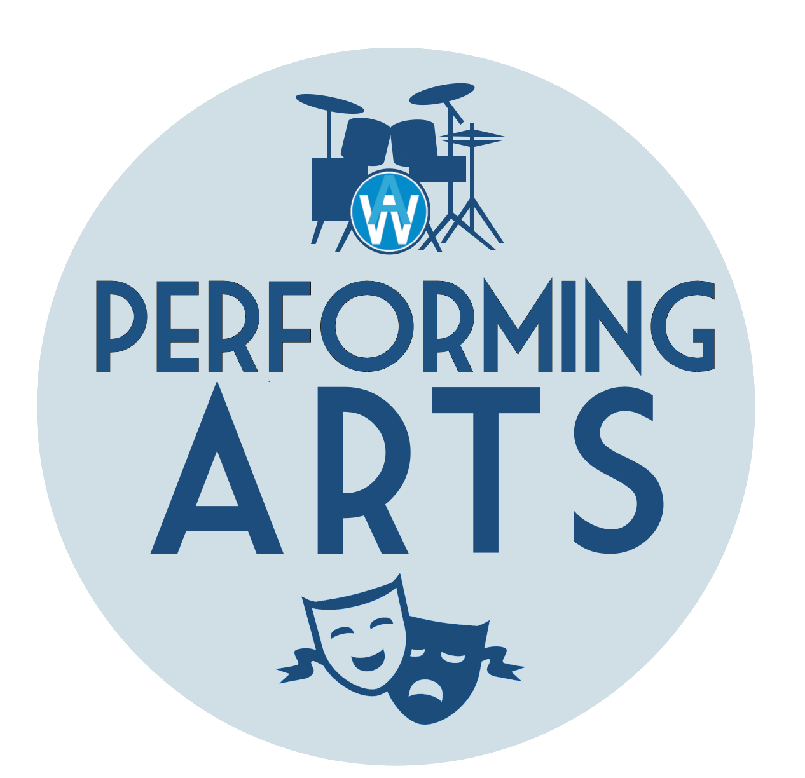
Music Development Plan
Alderman White School
Detail | Information
Academic year that this summary covers | 2025-26
Date this summary was published
Date this summary will be reviewed | June 2026
Name of the school music lead | Zoe Armitage-Giles  (Curriculum Lead for Performing Arts)
Name of school leadership team member with responsibility for music (if different) | Karsten Stephan
Name of local music hub | Nottinghamshire Music Hub
Name of other music education organisation(s) (if partnership in place) | Inspire Music  Music Mark

Music is a thriving part of the Alderman White School culture; both as a part of the core curriculum as well as an integral part of our extra curriculum offer. Music is currently staffed by one full time teacher of Music, who also leads on music enrichment, a part-time teacher of Music and the Curriculum Lead for Performing Arts. We pride ourselves on our excellent links within the community and our developing partnerships with other agencies and schools. We are pleased to hold the Music Mark for quality music education and enrichment.

Part A: Curriculum Music
This is about what we teach in lesson time, how much time is spent teaching music and any music qualifications or awards that pupils can achieve.
Students in Key Stage 3 are taught in tutor groups and have one double period per fortnight (1 hour and 40 minutes) plus opportunities to participate in additional workshops throughout the year, for example as part of Culture Day.
Our Performing Arts curriculum offers a broad experience for our students and allows them to explore music from around the world as well as the social and historical contexts that have influenced it. In Year 7 and 8 lessons focus on learning the elements of music, key vocabulary, composition key genres and being able to express an opinion about the music they listen to. In Year 9 students are also introduced to Music Technology and how to utilise this to create and edit their own compositions.
In lessons students play keyboards, sing and create group compositions using djembes. There is also the chance for those who already play an instrument to utilise this within their creative process, both solo and as an ensemble.
In Key Stage 3 students are assessed in three strands: creating, performing, and evaluating.
At Key Stage 4 we offer OCR GCSE Music and the NCFE VCERT in Music Technology. Both courses are delivered over two academic years and include NEA and examined assessments. We have a lower minimum group size for Music GCSE.
We have developed good working relationships with local secondary schools to share good practice and standardisation opportunities as well as The University of Nottingham Music Department and Confetti College and regularly offer trips to these for our Key stage 4 students as part of our aim to ensure our students have clear vocational and academic pathways within the Music and Performing arts industries.

Part B: Extracurricular Music
This is about opportunities for pupils to sing and play music, outside of lesson time, including choirs, ensembles, and bands, and how pupils can make progress in music beyond the core curriculum.
We are immensely proud of the opportunities that our students have to participate in Music beyond lesson time. All students have the opportunity to participate in 1:1 or small group instrumental tuition through Inspire in an instrument of their choice; we currently have over 90 students taking weekly lessons. For students who receive Free School Meals these lessons are offered free of charge. Instrument loan is also available through Inspire and we have a wide variety of instruments within department. Students can arrange own rehearsals utilising the practice rooms outside of lesson time. Through these lessons students can complete graded music examinations if they wish to.
The instruments available for tuition currently include:
- Voice
- Piano
- Percussion
- Guitar/Bass Guitar
- Strings: Cello, Violin, Double Bass
- Brass: Trumpet, Trombone, French Horn
- Woodwind: Saxophone, Clarinet, Flute
Each week we run rehearsals for our ensembles which include:
- Choir (open to all, including staff!)
- Concert Band (currently has over 50 members and is open to all students with experience of playing an instrument)
- Orchestra (more experienced instrumentalists)
- Jazz Band (an invited group of musicians who play regular community events)
- Show Band and performance rehearsals (to support the needs of our school productions)
- Showtime Club (a Performing Arts club where students get the opportunity to use lighting and Music Technology to support performances)
- Drop in rehearsals for student coordinated bands/projects.
Participation in groups is open to all students at no cost. Each group performs at least once per academic year to a public audience. These performances are often used to fundraise for resources to support inclusivity and opportunity for all in our enrichment offer.
Students in Year 10 can apply to be Performing Arts Leaders and take an active role in organising and coordinating events as well as shaping our extracurricular programme.

Part C: Musical Experiences
This is about all the other musical events and opportunities that we organise, such as singing in assembly, concerts and shows, and trips to professional concerts.
We believe that being able to watch and listen to live music is an essential part of musical education as well as cultural enrichment and we strive to offer a wide programme of activities and trips across the school year.
Recent performance events have included:
- Choir and Jazz band performances within the community including Mayoral ceremonies, Holocaust Memorial Day and regular care home and Memory Cafe events
- Termly ensemble concerts
- Annual Vocal Night and Piano Night for individual and group performances
- Twice yearly school production including a band and vocalists
- Annual Performing Arts Tour including music performances (2024 France, 2025 Cornwall, 2026 Belgium)
- Battle of the Bands (Coordinated by Performing Arts Leaders)

These performances are open to all students to attend free of charge with parents and families paying a small fee for tickets.
The department offers frequent trips and experiences including:
- Trips to University of Nottingham Music Department
- Annual London Musical Theatre trip
- Peggy’s Skylight jazz nights (jazz band members)
- National Youth orchestra trip
- Recitals at Nottingham Concert Hall
All students should be able to access trips and not be prohibited by cost. Pupil Premium students are given priority and financial support is available to all students and can be applied for by completing an assistance form. When it is not possible for us to organise a trip, we will promote events of interest to students and regularly share details of performances, events, and groups that students may wish to participate in through our online learning portal.

In the future
This is about what the school is planning for subsequent years.
As a school we are always striving to provide the best possible opportunities for our students and to improve our own knowledge and connections to ensure that the provision we provide meets the needs of our students and reflects the society we live in. As such our current development plans include:
- Strengthen partnership links within the WHP Trust through the development of a local hub for sharing good practice
- Departmental review of Key Stage 3 curriculum, including Pupil voice to refine practice and increase opportunities to explore Music Technology
- Streamlining resources to improve accessibility and reduce our environmental impact
- Increased opportunities to watch and collaborate with professional musicians: all of Year 8 to see a live ensemble, alumni connections, and University of Nottingham.

Target | Action | Purpose | Date
Increase opportunity for Key Stage 3 students to sing | Build into SoWs in Year 7 | Accessible to all students  Increase oracy skills in line with whole school development plan | January 2026
Review Key stage 3 curriculum including Pupil Voice | Pupil Voice feedback  Departmental review and refinement  Explore what other schools do: share good practice | Reflect current world issues  Improve student’s knowledge of Music Technology in relation to Key Stage 4 curriculum | December 2025
All Key Stage 3 students to see at least two live musical performances. One to be in a professional venue | Research opportunities including liaising with University of Nottingham and local ensembles and Music Hub | Increase student’s understanding of music in practice and cultural experiences | July 2026
Develop professional and vocational links | Contact alumni: where are they now?  Develop links with local venues and professionals | Improve student’s knowledge of careers pathways in the Arts  Potential increase uptake at Key Stage 4 | July 2026
Narrow the gap in participation and outcomes for SEN, PP, and low attaining students (including within the IMP and Nurture groups) | Sessions in IMP and Nurture as well as promoting peripatetic sessions through Inspire. | Improve opportunities for those students we recognise as having had less exposure to live music and participation. | September 2026
Introduce Arts Award with Performing Arts Leaders | Trial Arts Award with small cohort in Summer Term with a view to role out as a voluntary option from September 2025 | Provide recognition for the work that the students do in leadership and contributing to performing arts delivery within the school | October 2026
Further develop performance opportunities | Develop multi-arts performances for a Summer festival  Explore possibility of a school musical (e.g. High School Musical) in Spring 2026  Review accessibility of ensembles and clubs and consider how reach can be improved  Offer trips to wider groups; some trips have previously only been offered to those in ensembles | Increase opportunity and participation across all groups within school and outreach to wider communities | April 2026
Evaluate quality of peripatetic lessons | Increase admin support to improve efficiency and communication  CL observation and pupil voice review | Improve retainment rate and communication between all participants and providers | June 2026
Upgrade facilities | Explore options for upgrading sound equipment in the Hall | Improve quality of sound in productions | May 2026
Links with other organisations | Build links with Music Hub lead school  Continue to build on links with Confetti, UoN and local schools  Staff CPD to visit other schools to look at good practice  Build WHP Trust Music network | Develop partnerships to share good practice and improve and offer CPD opportunities for staff  Improve opportunities and outcomes within WHP Trust schools | June 2026

Further information
The Department for Education publishes a guide for parents and young people on how they can get involved in music in and out of school, and where they can go to for support beyond the school.
Our local music hub also have a local plan for music education in place that includes participation opportunities. Nottinghamshire and Nottingham City have recently combined hubs so this should improve their reach and the range of activities provided.

